Next Steps Document- Kindergarten, Cluster 2
The intended purpose of this document is to provide teachers with a tool to determine student understanding and suggest instructional moves that may help guide a student forward in their learning of a concept or standard. This guide is not an exhaustive list of strategies.
Kindergarten: Cluster 2
Understanding the Relationship between Numbers and Quantities
NC.K.CC.1 Count to 100 20 by ones.

NC.K.CC.2 Count forward beginning from a given number within the known sequence, instead of having to begin at 1.

NC.K.CC.3 Write numbers from 0-to 20 (0-5 and then 6-10). Represent a number of objects with a written numeral 0-20 (0-5 and then 6-10), with 0 representing a count of no objects.

NC.K.CC.4 Understand the relationship between numbers and quantities.
● When counting objects, say the number names in the standard order, pairing each object with one and only one number name and each number name with one and only one object (one-to one correspondence).
● Recognize that the last number named tells the number of objects counted regardless of their arrangement (cardinality).
● State the number of objects in a group, of up to 5 objects, without counting the objects (perceptual subitizing).

NC.K.CC.5 Count to answer “How many?” in the following situations:
● Given a number from 1-20 10, count out that many objects.
● Given up to 20 10 objects, name the next successive number when an object is added, recognizing the quantity is one more/greater.
● Given 20 10 objects arranged in a line, a rectangular array, and a circle, identify how many.
● Given 10 5 objects in a scattered arrangement, identify how many.

NC.K.CC.6 Identify whether the number of objects, within 10, in one group is greater than, less than, or equal to the number of objects in another group, by using matching and counting strategies.

NC.K.MD.3 Classify objects into given categories; count the numbers of objects in each category and sort the categories by count.

NC.K.G.3 Identify squares, circles, triangles, rectangles, hexagons, cubes, cones, cylinders, and spheres as two-dimensional or three-dimensional.

Not Yet | Students that are consistently scoring “Not Yet” could have a variety of misconceptions including the rote counting sequence when they count aloud (K.CC.1) or misconceptions counting objects (K.CC.4, K.CC.5, foundation for K.CC.6 and K.MD.3).
Next Steps:
For students who are not yet able to rote count to 20 (K.CC.1):
- Provide opportunities for students to rote count to the teacher with access to a number line, number path, or written numerals to support students.
- Provide opportunities for students to count sets of objects and count out loud with the use of a number path.
- Work with students on the counting sequence by having them simultaneously hear the number orally, see the quantity, and the written number.

For students who are not yet able to count a set of 5 objects in a line, circle, or array (K.CC.4, K.CC.5 foundation for K.CC.6 and K.MD.3):
- Provide opportunities for students to count sets of objects within 5. Remind them to move counters one at a time as they count. Work with students to ensure that they are demonstrating tagging and one-to-one correspondence.
- Provide opportunities for students to count objects by placing counters/cubes on a number path or 10s chart (hundreds board with only numbers 1 to 10. Number paths and 10s charts are good resources since they include each written numeral which helps students to keep track of the number of objects they have.
- Play games that involve students pulling number cards (numbers and pictures) from a stack of cards and counting out that set with objects with the use of a number path or 10s chart. Discuss with students that when we count a set of objects the last number that we say is the total number of objects in that set. “When I counted the group I had 1, 2, 3, and 4. Since the last number I said was 4 that means that I have 4 counters.”
- Grab and count: Students grab 1 or 2 handfuls of cubes/counters. They count objects using any strategy they want (K.CC.5) and orally say the counting sequence (K.CC.1)
- As students develop more counting skills integrate in K.CC.6 and K.MD.3 activities as ways for students to apply their counting skills.
- Instructional and Assessment Task: Counting Objects and Writing Numerals
- NCDPI Games for Fluency and Understanding
- Tools4NCTeachers Math Centers

Progressing | Students who are “Progressing” are working on being able to count a group of 10 objects in a line, array, or circle and use their counting skills to explore sorting and counting quantities after they sorted.
Next Steps:
For students who are able to rote count to at least 10 but progressing on rote counting to 20 (K.CC.1):
- Provide opportunities for students to rote count to the teacher or a classmate. Students should have access to a number line, number path, or written numerals for support.
- Provide opportunities for students to count sets of objects and count out loud with the use of a number path.

For students who are progressing on counting forward from a given number (K.CC.2):
- Provide opportunities for students to rote count to the teacher or a classmate.
- What Comes Next? activity- students draw a number card (0-9) and start counting on from the number they draw until they make a mistake OR until they reach 20. More advanced students can keep counting until they reach a higher number.

For students who are progressing towards counting a set of up to 10 objects in a line, circle, or array and a set of up to 5 objects (K.CC.4, K.CC.5):
- Provide opportunities for students to count sets of objects within 10. Remind them to move counters one at a time as they count. Work with students to ensure that they are demonstrating tagging and one-to-one correspondence consistently.
- Provide opportunities for students to count objects by placing counters/cubes on a number path or 20s chart (hundreds board with only numbers 1 to 20. Number paths and 10s charts are good resources since they include each written numeral which helps students to keep track of the number of objects they have.
- Play games that involve students pulling number cards (numbers and pictures) from a stack of cards and counting out that set with objects with the use of a number path or 10s chart. Discuss with students that when we count a set of objects the last number that we say is the total number of objects in that set. “When I counted the group I had 1, 2, 3, and 4. Since the last number I said was 4 that means that I have 4 counters.”
- NCDPI Games for Fluency and Understanding
- Tools4NCTeachers Math Centers

For students who are progressing towards being able to compare two quantities (K.CC.6):
- Provide experiences for comparing two quantities using counters. Students can compare numbers by lining up counters where each set has a match. For example, if comparing four black cubes and three white cubes students may line them up and determine there are more more black cubes since there is one extra after matching them up.

- Build and compare: Students draw a number card and build that quantity with counters/cubes. Students draw a 2nd number card and also build that quantity. Students determine which quantity is larger and explain how they know.
- Find one larger, find one smaller: Students draw a number card and build that quantity with counters/cubes. Students then write a number that is smaller than that number and also write a number that is larger than that number.
- Lesson: More or Less

Meets Expectation | Students that are consistently scoring “Meets Expectation” in this cluster have met all standards with proficiency.
Next Steps:
For students who have demonstrated proficiency with concepts in this Cluster:
- Provide opportunities for students to work on counting with higher numbers (within 35 in a line, circle, array, or by allowing them to touch and move them as they count them).
- Provide opportunities for students to work on comparing written numerals (K.CC.7) as enrichment from K.CC.6.
- Provide opportunities for students to begin solving one-step addition word problems (K.OA.1, K.OA.2). Example: There are 3 birds in the nest. One more bird lands in the nest. How many birds are now there?

Five Frame

Ten Frame

Double Ten Frame

Primary Number Cards (Adapted from Investigations, TERC)

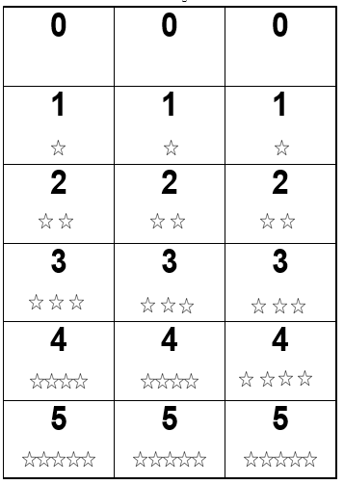

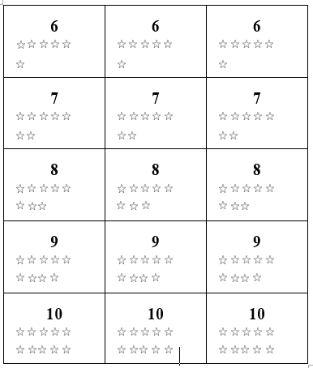

Number Path to 10 (Tens Chart)

1 | 2 | 3 | 4 | 5 | 6 | 7 | 8 | 9 | 10

Number Line

0 |  | 1 |  | 2 |  | 3 |  | 4 |  | 5 |  | 6 |  | 7 |  | 8 |  | 9 |  | 10

