Making Connections to the Standard Division Algorithm
NC.4.NBT.6

This document is intended to demonstrate the importance of using concrete, pictorial, and place value knowledge interchangeably when dividing before moving to the more abstract and procedural division algorithm. Students are not expected to master the standard algorithm for division until middle school in order to allow students time to gain conceptual understandings of division and these various methods.

Concrete Models  Students begin exploring division using concrete objects. They start with counters or blocks they can divvy or divide out one at a time by equally sharing among each person or group. They then move to place value blocks where they may need to use regrouping.  Example 1: 51 $÷$ 3 = ?  3 groups with 17 in each group  Example 2: 51 $÷$ 3 = ?  Students have enough tens to give each group one ten, but then they only have 2 tens left so they trade those for ones. Now the student has 20 ones plus the original one from 51 for a total of 21 ones. They fair share these 21 ones so each group has 7 ones. They count to see they have three groups of 17.  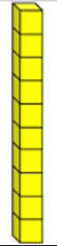  Students traded in two tens for 20 ones. |  | Multiply Up  Students build on their knowledge of multiplication facts to solve division problems. They can multiply up until they reach the dividend. This helps them see the connection between multiplication and division.  Example 1: 159 ÷ 13 = ?  In this example, the students multiplies by easy facts to find the answer. Once the student finds 10 groups of 13, they still have 29 left. They are able to take out two more groups of 13 and are left with 3. The student discovers that there are 12 groups of 13 in 159 with 3 leftover.  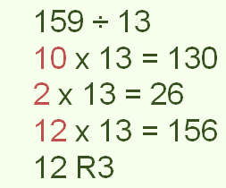  Example 2:  258 $÷$ 6  6 x 40 = 240  6 x 3 = 18  43 x 6 = 258  Notice in both examples, the students used their number sense to select a fact that gets them close to the dividend. Students can use their knowledge of basic multiplication facts to multiply up efficiently.
Repeated Subtraction  Students subtract equal-sized groups from the total until there is nothing left.  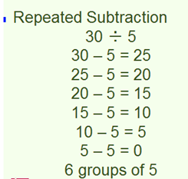  This example illustrates how there are 6 groups of 5 in 30. This is a great strategy to use during or after modeling problems with blocks to help build the concept of subtraction. Students should move to more sophisticated strategies once the concept is understood. | Rectangular Arrays/Area Model  Students can use a rectangular array or area model to divide or decompose the number into chunks. This model shows the connection to arrays in multiplication.  Example: 27 ÷ 3 = ?  ?  3  As the student draws the array, they distribute the boxes into 3 equal rows resulting in 9 in each row.
Open Arrays/Area Models  Example: 200 $÷$ 8 = ?  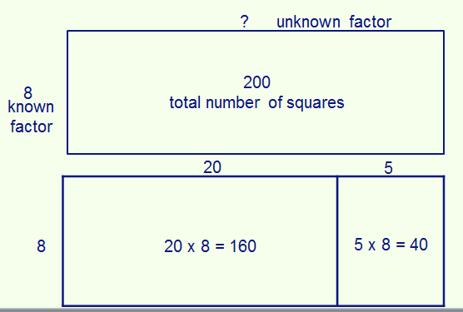  The first open array illustrates the problem, which can be thought of as 8 times something equals 200. The next open array illustrates the way the student chunked to find the missing factor. The student knew that 20 groups of 8 would get to 160, leaving 40. Knowing basic facts helps students know there are five groups of 8 in 40. 20 + 5 = 25, so 25 is the missing factor. Students can also use grid paper and count squares for this method to help build an understanding of this model and how it connects to division. | Partial Quotients  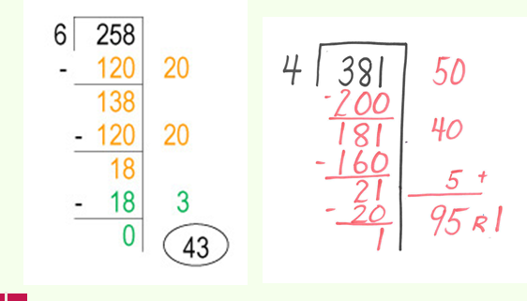  The partial quotients method is very similar to the standard division algorithm. However, students choose which chunks or groups they want to subtract or take out. Many students choose friendly numbers like 10 and 100 as partial quotients to make the subtraction easier.  Notice the larger the chunks taken out, the fewer steps in the problem. When students take out the largest possible number chunks, then they are using the standard division strategy. Students should be shown how this strategy connects and eventually leads to the standard algorithm.

