The intended purpose of this document is to provide teachers with a tool to determine student understanding and suggest instructional moves that may help guide a student forward in their learning of a concept or standard. This guide is not an exhaustive list of strategies.
Number and Operations in Base Ten
Multiplication and Division
NC.4.NBT.5 Multiply a whole number of up to three digits by a one-digit whole number and multiply up to two two-digit numbers with place value understanding using area models, partial products, and the properties of operations. Use models to make connections and develop the algorithm.
NC.4.NBT.6 Find whole number quotients and remainders with up to three-digit dividends and one-digit divisors with place value understanding using rectangular arrays, area models, repeated subtraction, partial quotients, properties of operations, and/or the relationship between multiplication and division.
Not Yet  Not Yet  Continued  Not Yet  Continued  Not Yet  Continued | Students that are consistently scoring “Not Yet” on multiplication and division tasks could have a variety of errors. Students in fourth grade are expected to make connections between models and written equations, but it is NOT necessary for fourth graders to use the standard algorithm. The standard algorithm is an expectation for fifth grade, not fourth grade. As long as students have a strategy that is efficient and effective in getting a product or quotient, and as long as it makes sense to the student, they can then build upon that strategy and its connections to models and written equations. Students consistently scoring “Not Yet” do not have any effective strategy for multiplication or division or are struggling with the difference between multiplication or division. The more comfortable students become with estimating the product or quotient the better they will be able to decide if their answer is reasonable.
Next Steps:
For students having trouble identifying the difference between multiplication and division:
- Review terminology for multiplication (factor(s), product, multiples) and division (dividend, divisor, quotient)
- Students may have a strong reliance on “key words” (i.e. times as much, each, total) which is a common misconception and is misleading to students as they solve word problems.
- Key words are counterintuitive to their problem-solving ability.
  - Have students to make models or pictorial representations of the problem.
  - After students can successfully make models, support students in recording an equation to represent what is occurring in their picture.
- Support students to create their own real-world situations in which multiplication and/or division would need to be used.
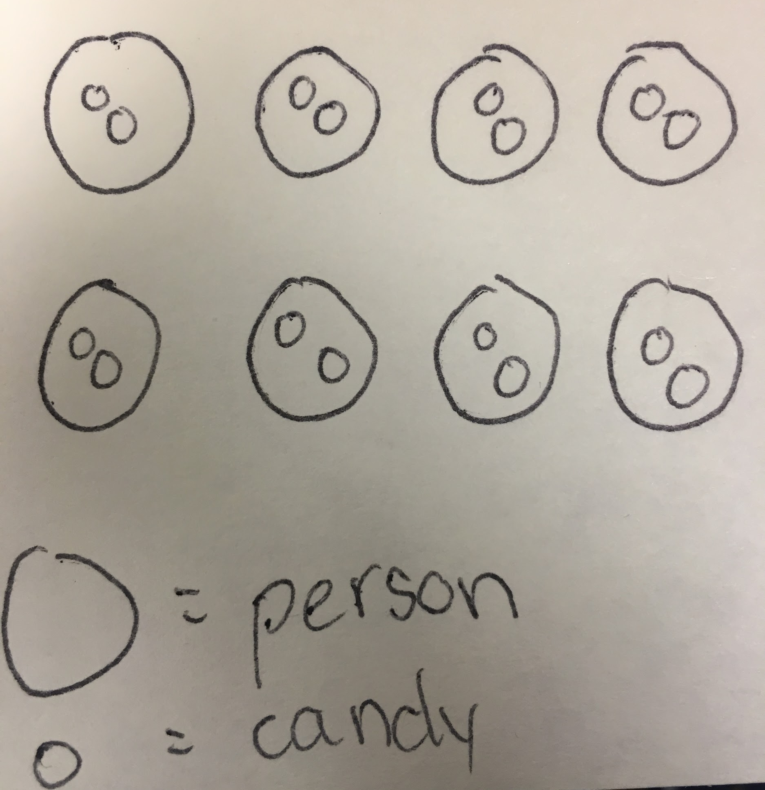
For students having difficulty using an effective strategy to multiply or divide:
- Move students back to one-digit numbers and have students solve a one-digit multiplication or division problem using their strategy. (i.e.: 6 x 8 = ? or the inverse 48 $÷$6 = ?)
- Start with models (using base ten blocks, Cuisenaire rods, counters), move to pictorials representations, and then move to symbols.
- Go back to the basics of addition and subtraction. Start by asking students: If I have eight people and they each receive 2 pieces of candy, how many pieces of candy are needed for all eight people to have two?
  - Pictorial representations should resemble the representation shown. Students should be able to articulate that if there are eight people that each receive two pieces of candy, that they would then be adding 2 eight times.
  - Have students then write their findings in an equation; resulting in the equation 8 x 2 = 16.
- If I have sixteen pieces of candy and want to give the same amount to eight people, how many pieces would each person receive?
  - Have students create a pictorial representation of this question as well. Ask students how they know that 16 $÷$8 = 2?
  - How can they show that in a model?
  - How does it relate to the previous question?
  - How does the picture they created with the multiplication equation compare to the picture they created for the division equation?
NOTE: Move into larger numbers after students have mastered the concept of one-digit by one-digit equations. If they have not mastered it, continue to give students equations like the one above to help them grasp the concept of multiplication and division. Remind students that multiplication is nothing more than a ‘more efficient’ manner for them to add the same number numerous times. Division is the inverse of multiplication and it goes hand in hand.

When moving into larger numbers, remind students of place value.
- What is the value of each digit? (i.e. In 52 – students should be able to say the 5 has a value of 5 tens or 50 and the 2 has a value of 2 ones or 2.)
- How can you decompose this number? How can you decompose this number another way? Students should be able to break down the number into different varieties. (i.e. 52 can be decomposed to five tens and 2 ones, 4 tens and 12 ones, 3 tens and 22 ones, 2 tens and thirty-two ones, one ten and 42 ones, or 52 ones.)
- After students understand the concept of place value, ask students how they would multiply 52 x 2.
- Students need to draw a pictorial example to show their understanding of multiplying 52 x 2.
  - Students should begin with decomposing the fifty two into fifty and two.
  - Ask students to explain their next step. How would they multiply a number that is decomposed? Can they multiply two times fifty? Can they multiply two times two? What happens once they’ve multiplied the two numbers by two? What do you do with the products? How do those products help to determine the overall product? Why is decomposing a strategy that helps with multiplication?
  - Have students talk through their strategy and how they solved the equation.
  - Students should be able to determine that 50 x 2 = 100 and 2 x 2 = 4, making the overall product 104.
  - Give students more problems just like this one and have them show their understanding of multiplication with decomposing.

Move into a division problem with larger numbers.
- If I have 110 pieces of candy and want to give the same amount to 5 different people, how many pieces of candy will each person receive?
  - Students will first write the equation that they will be solving: 110 $÷$ 5 =?
  - Students will then draw a pictorial representation of the division problem. Be sure to question students how they are setting up their representation. How many people are there? How many pieces of candy are their total? How would you go about solving their problem?
  - Have students then explain the concept of division and how their pictorial representation correlates to the division equation.
  - Can decomposition work with this equation?
  - How might you solve the equation using decomposition?
    - Students could break down the equation so it looks like the following two equations:
100 $÷$ 5 =?
10 $÷$ 5 =?
    - How does finding the quotient of the two equations help to understand the overall quotient?
    - What do you do once you find the quotients of the two equations?
    - How do understanding groups of tens and hundreds help to solve this equation? (Be sure to draw on background knowledge of place value when solving equations like these.)
    - Once students have solved these equations, have them put the two quotients together to get the final quotient for the whole equation.
  - Ask students how the decomposed equations help them to understand the overall equation of 110 $÷$5 = ?
  - Be sure to have students articulate their thinking and draw correlations to what they are doing pictorially as well as in equation form to the equation.
- Continue to work with students using these strategies to help them grasp the concepts of multiplication and division. Once students have grasped the larger numbers, they can move on to three-digit by one-digit multiplication and division problems.
- Always refer back to manipulatives. Students can use manipulatives to help them understand the concepts of multiplication and division. Students should be able to begin to solve multiplication and division problems using their manipulatives. When students have mastered using their manipulatives they can begin to connect their manipulative models to equations in order to visualize the connections to the equations.

Division
For students who don’t understand that division can be thought of in two different ways: fair sharing and equal grouping.
- Give students multiple opportunities with different numbers and have them practice modeling the different types of division problems with manipulatives. Practice sharing equally (fair share) and then grouping them equally (measurement division). Example: “There are 12 pencils and three students. How many should each student get?” Compared to “There are 12 pencils. Each student needs four pencils. How many students will receive pencils?”

For students having difficulty understanding division:
- Give students a quantity of tiles and a specific number of groups and have them divide equally (fair share) into groups to find the quotient; create an equation based on the representation.
- Give students square tiles to divide into equal rows and columns (relate to arrays) and/or use graph paper; create an equation based on the representation.
- Help students understand the quotient is either the number of equal groups or the number in each group; or the number of rows or the number in each row.
- Pose tasks that involve the action of repeated subtraction. Example: There are 20 birds in the park and they fly away in groups of 4. How many groups of birds flew away?

For students having difficulty with multiplication and/or division fluency:
- Product Compare Game: Students play with a partner. Each student pulls 2 number cards and finds the product. The student with the highest product wins a point. Keep playing the game for a set amount of time OR until a student has earned 10 points.
- Encourage students to build arrays for multiplication combinations that they have trouble recalling. Cut the arrays out so on one side it has the array and the dimensions and on the other side students can have both equations written, such as 4 x 3 = 12 and 3 x 4 = 12.

For students having difficulty solving two-step word problems:
- Allow students to use counters to “act out” what is really happening in the story. Read the whole problem, then reread the problem, stopping at each action. Have students create an equation based on the action and discuss what each number of the equation represents from the story. Continue until all steps are finished.

Step 1
Step 2
Solution
- Pose a word problem and have students retell the problem to a classmate or the entire class. Have students identify what the problem is asking and whether they will need 1 or 2 steps to determine the answer.
- Provide exposure to a variety of problems that used combinations of all 4 operations.
- Give students a set of one-step and two-step word problems and have them sort the problems into one-step or two-step word problems, justifying their sort.
- Solving two-step problems lesson.

NOTE: For students struggling with the concepts of multiplication, see Next Steps Documents for Third Grade in Cluster 4.
Progressing  Progressing  Continued  Progressing  Continued | Students that are consistently scoring “Progressing” have a strategy to use for multiplication and division; however, they have not mastered this strategy or may struggle with the difference between multiplication and division. Students also may not understand how to decide if their answer is reasonable and may need additional work with estimation strategies. The more comfortable students become with estimating the product or quotient, the better they will be able to decide if their answer is reasonable.
Next Steps:
For students having trouble identifying the difference between multiplication and division:
- Review terminology for multiplication and division.
  - Multiplication:
    - Product - the answer to a multiplication problem.
    - Factors - the numbers you multiply to get the product of a multiplication equation
  - Division:
    - Quotient - the answer to a division problem
    - Dividend - the number that is divided by the divisor
    - Divisor - the number you are dividing the dividend by
- Have students to make models or pictorial representations of the problem.
- After students can successfully make models, support students in recording an equation to represent what is occurring in their picture.
- Support students to create their own real world situations in which multiplication and/or division would need to be used.

For students struggling to keep their numbers organized:
- Model for students how to use a place value chart, grid paper, or notebook paper turned sideways. All of these provide grid lines for students to be able to ensure that each number is in its proper place.
- Have students label each place value above the column.

For students who are having trouble decomposing:
- Provide students with base-ten blocks so that they can see the different ways to decompose the numbers by place value.
  - Give students the following example: 52 x 46 = ?
  - Have students decompose the numbers to multiply correctly.
(50 + 2) x (40 + 6) =?
  - Have students then place the decomposed numbers in an array to help with better understanding of multiplication of the numbers.
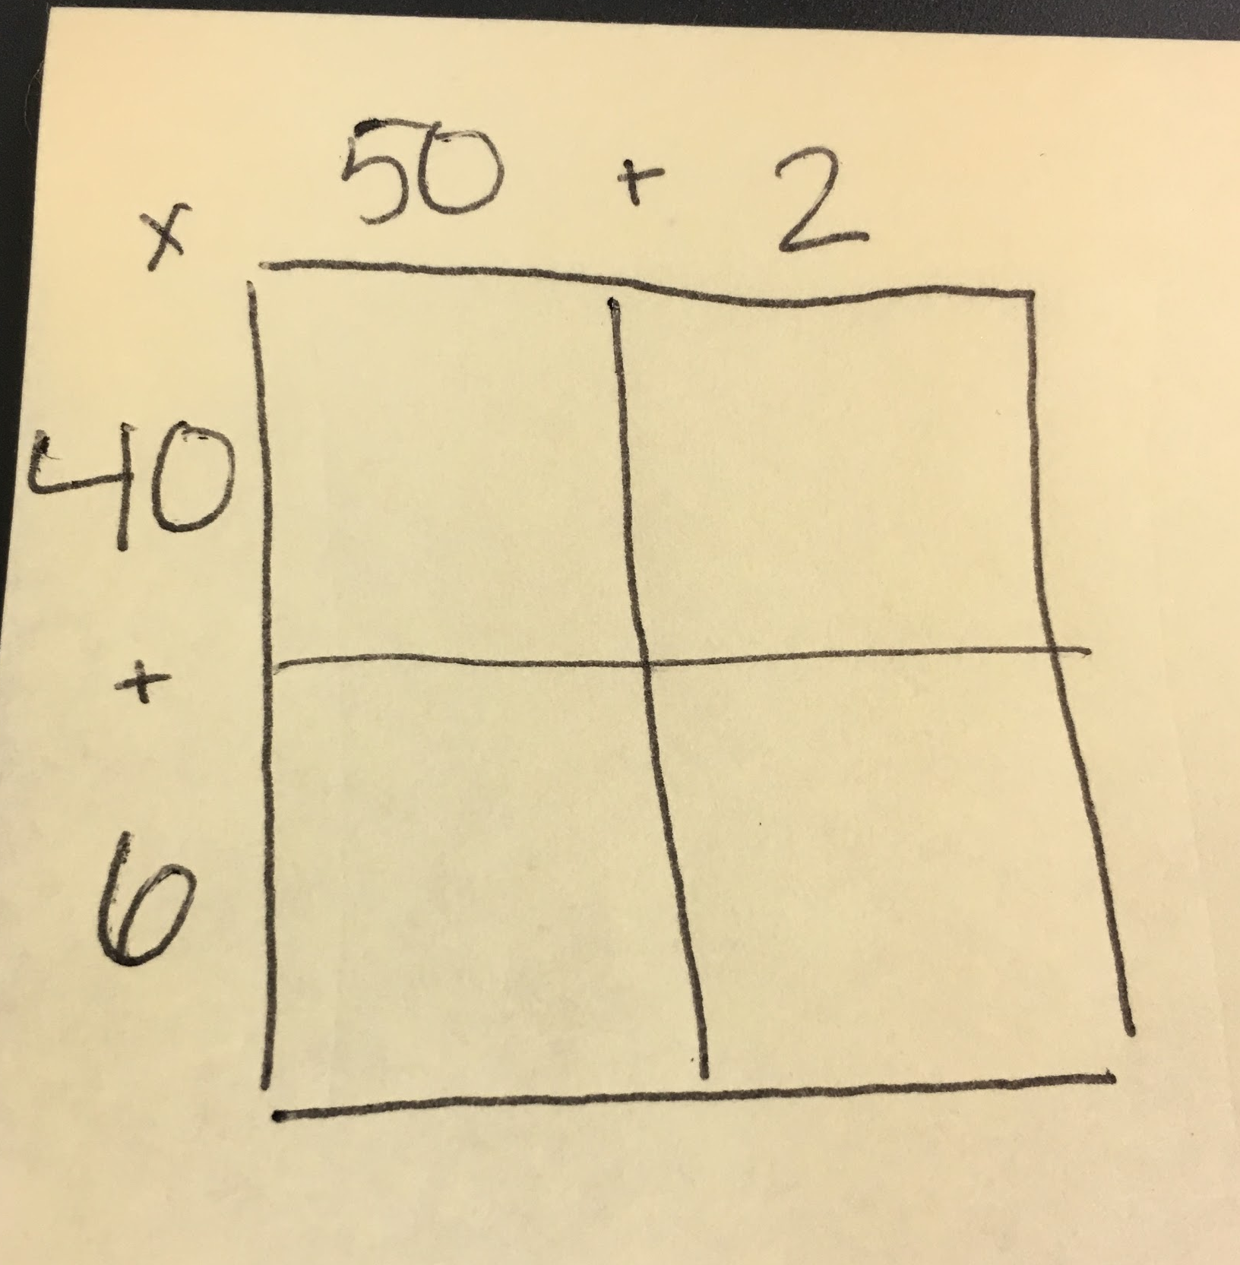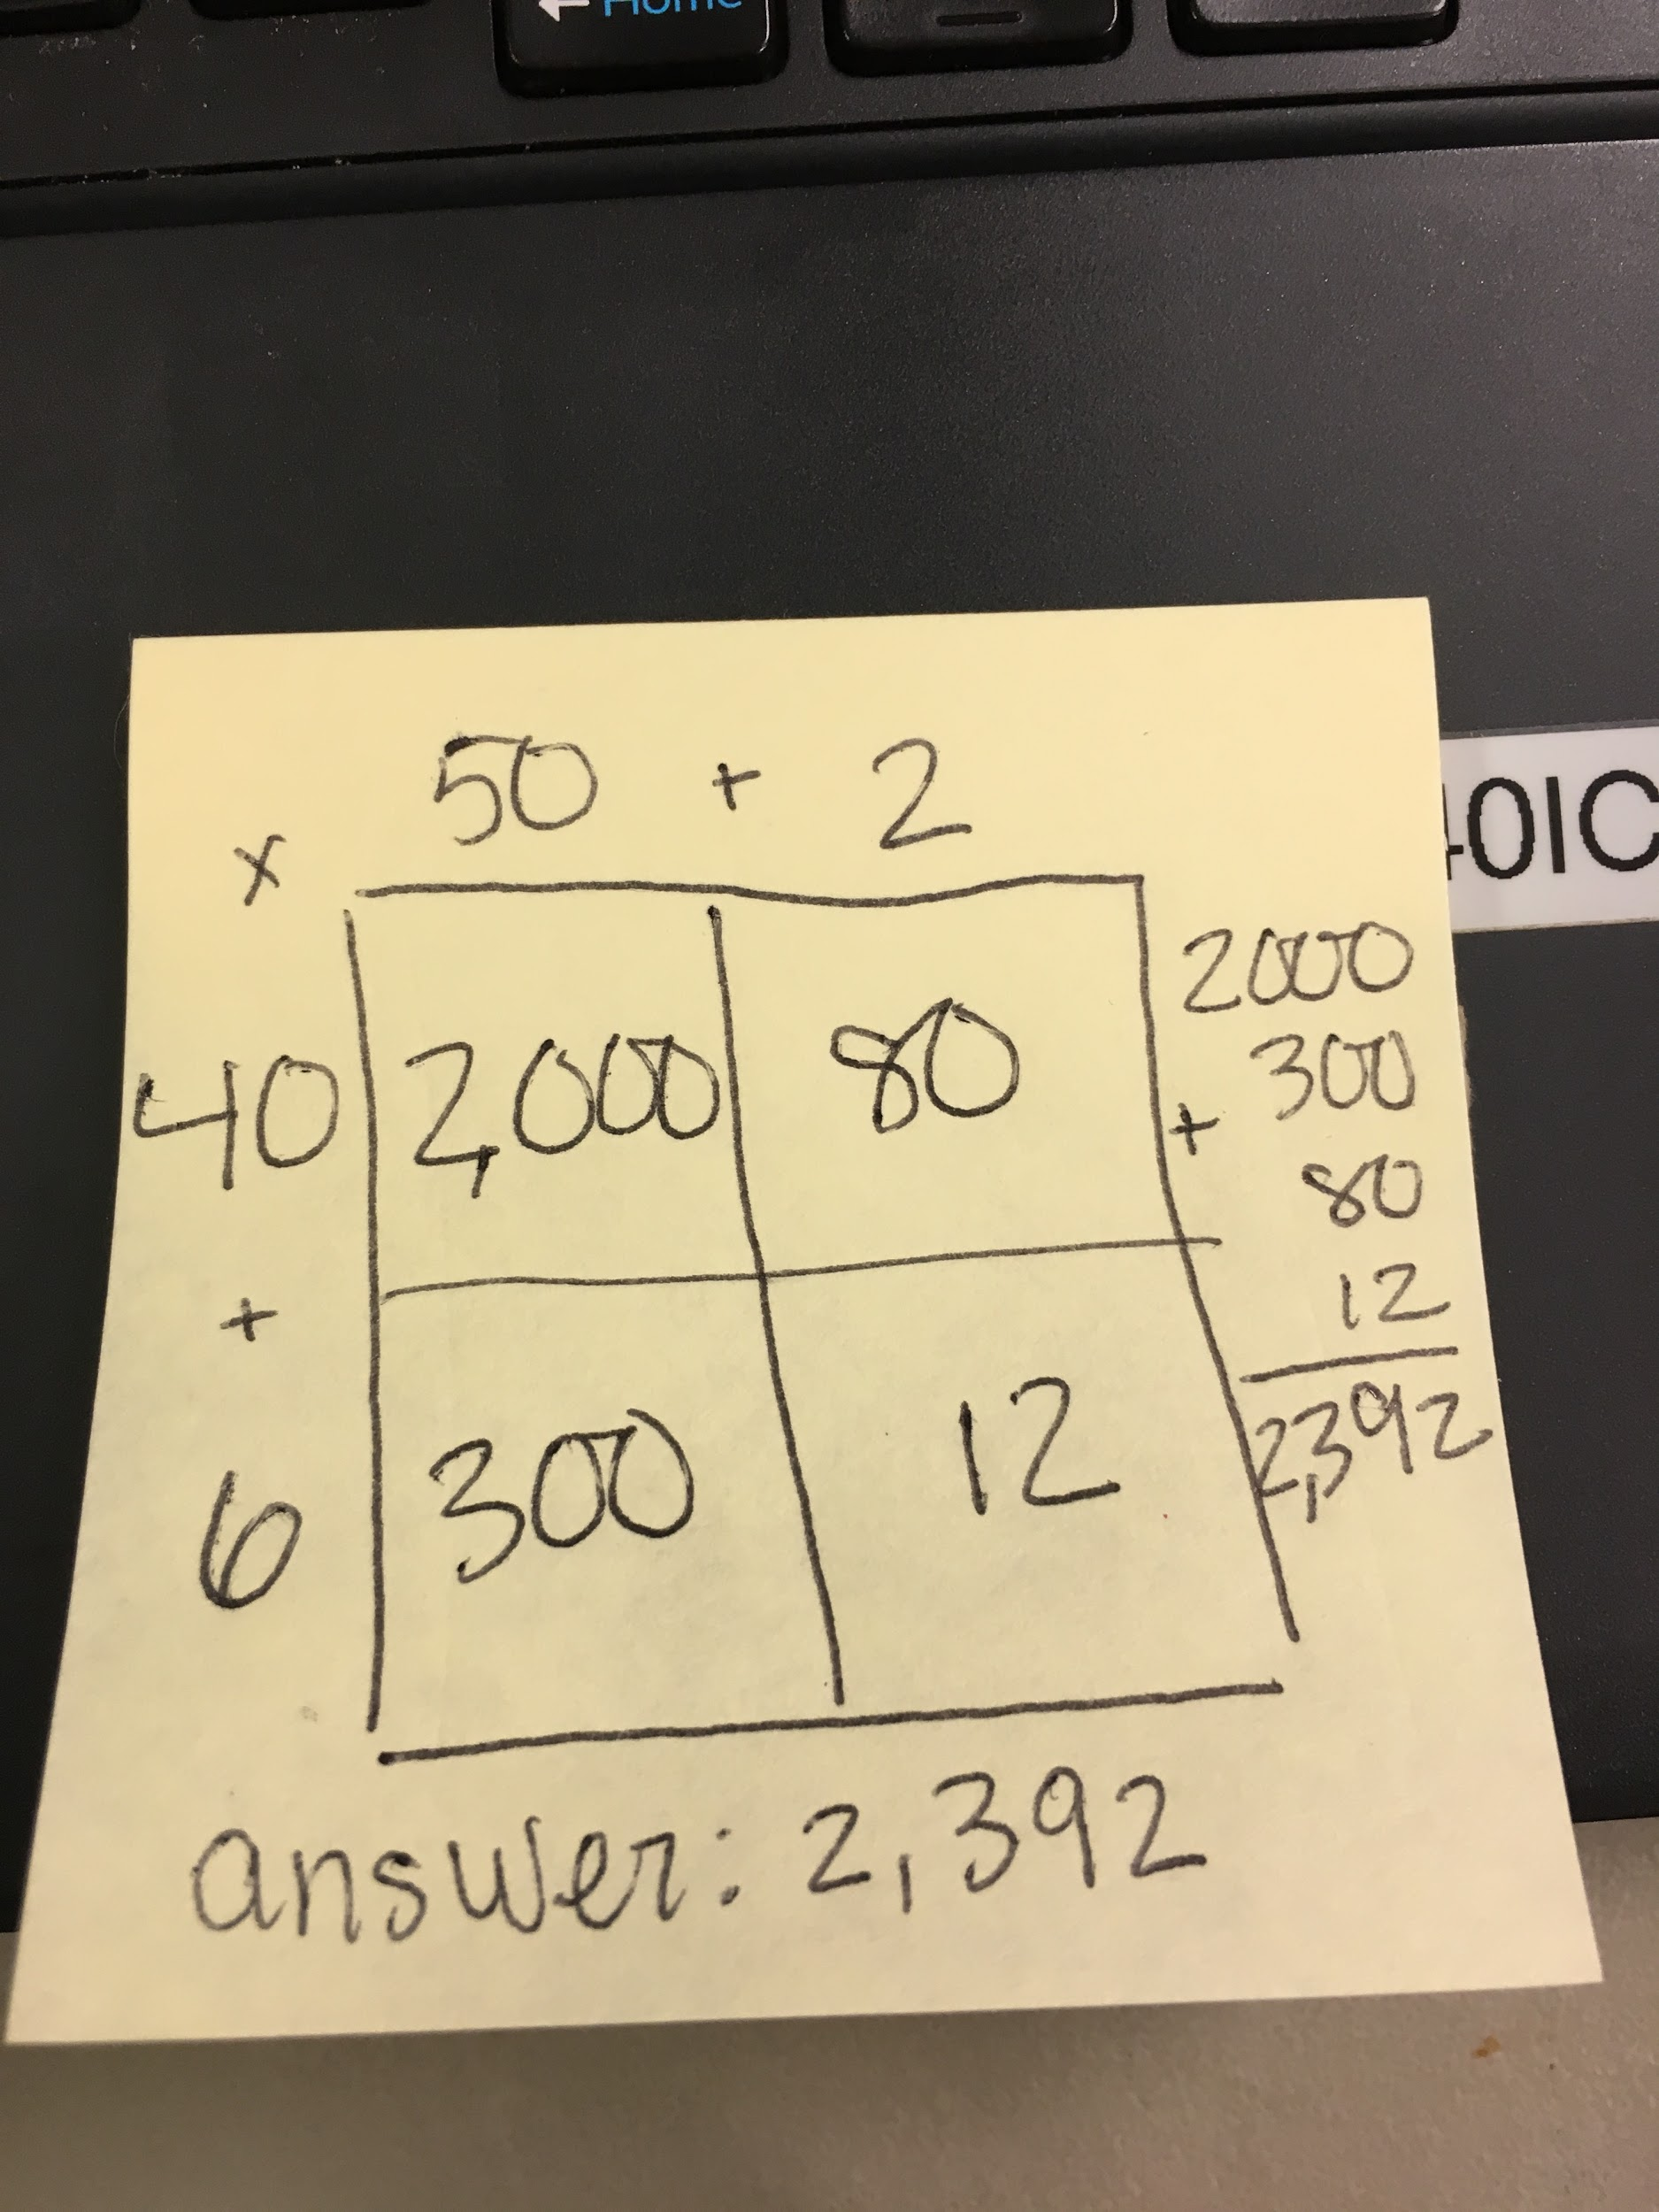

For students who decompose correctly but leave out some partial products when multiplying:
- Have students use estimation strategies such as rounding to determine if the solution they came up with makes sense.
- Provide students with an area model that shows all of the parts. Have students shade as they multiply each part so they can visually see if they are leaving out any parts.
- Use a set of boxes to symbolize the array model so that students can organize their numbers by place value and not leave out any parts.

For students multiplying multiples of ten incorrectly when using partial products:
(Example: Students multiply 40 x 30 and come up with a product of 120.)
- Provide students with base ten manipulatives to explore the reasonableness of their responses.
- Provide students with number strings so that they can practice and notice patterns and related facts: 4 x 3, 4 x 30, 40 x 3, 40 x 30.
- Students should assess the reasonableness of their answer. Does 40 x 30 = 120 make sense? What does 40 x 2 equal? If 40 x 2 equal 80, how does 40 x 30 equal 120? Students should understand that the reasonableness of the answer should come into play when multiplying (or even dividing) to find an answer.

For students who incorrectly add the parts when using partial products:
- Ask students to estimate to determine if their products are reasonable.
- Provide students with place value pieces to aid in addition the numbers.
- Provide students with graph paper to line up addends correctly.

For students who don’t understand the partial quotients strategy:
- Be sure students connect back to fact families and the partial products method for multiplication. Students may need to highlight corresponding parts of both models in matching colors to be able to see how they connect. They should also match the partial products and quotients with corresponding colors as the model.
- Begin with small numbers and use grids so students can visually see the parts of the models.
- Make sure the students see that the number being subtracted with the partial quotients is the number being distributed. Model or act out with small numbers.
Meets Expectation | Students that are consistently scoring “Meets Expectation” on multiplication and division tasks should have a good command of addition and subtraction and be able to fluently use multiplication and division strategies to solve multiplication and division equations. Fluency means students are accurate, flexible, and efficient with their strategies. According to NCTM, “Computational fluency refers to having efficient and accurate methods for computing. Students exhibit computational fluency when they demonstrate flexibility in the computational methods they choose, understand and can explain these methods, and produce accurate answers efficiently. Focusing on efficiency rather than speed means valuing students’ ability to use strategic thinking to carry out computation without being hindered by many unnecessary or confusing steps in the solution process. Accuracy involves considering the meaning of an operation, recording work carefully, and asking oneself whether the solution is reasonable.” Students may need to work on developing mental fluency, appropriate explanations, and effectively moving between strategies to be considered fluent.
Next Steps:
Students who have met the expectation for the multiplication or division task can further their thinking in a couple of different ways.
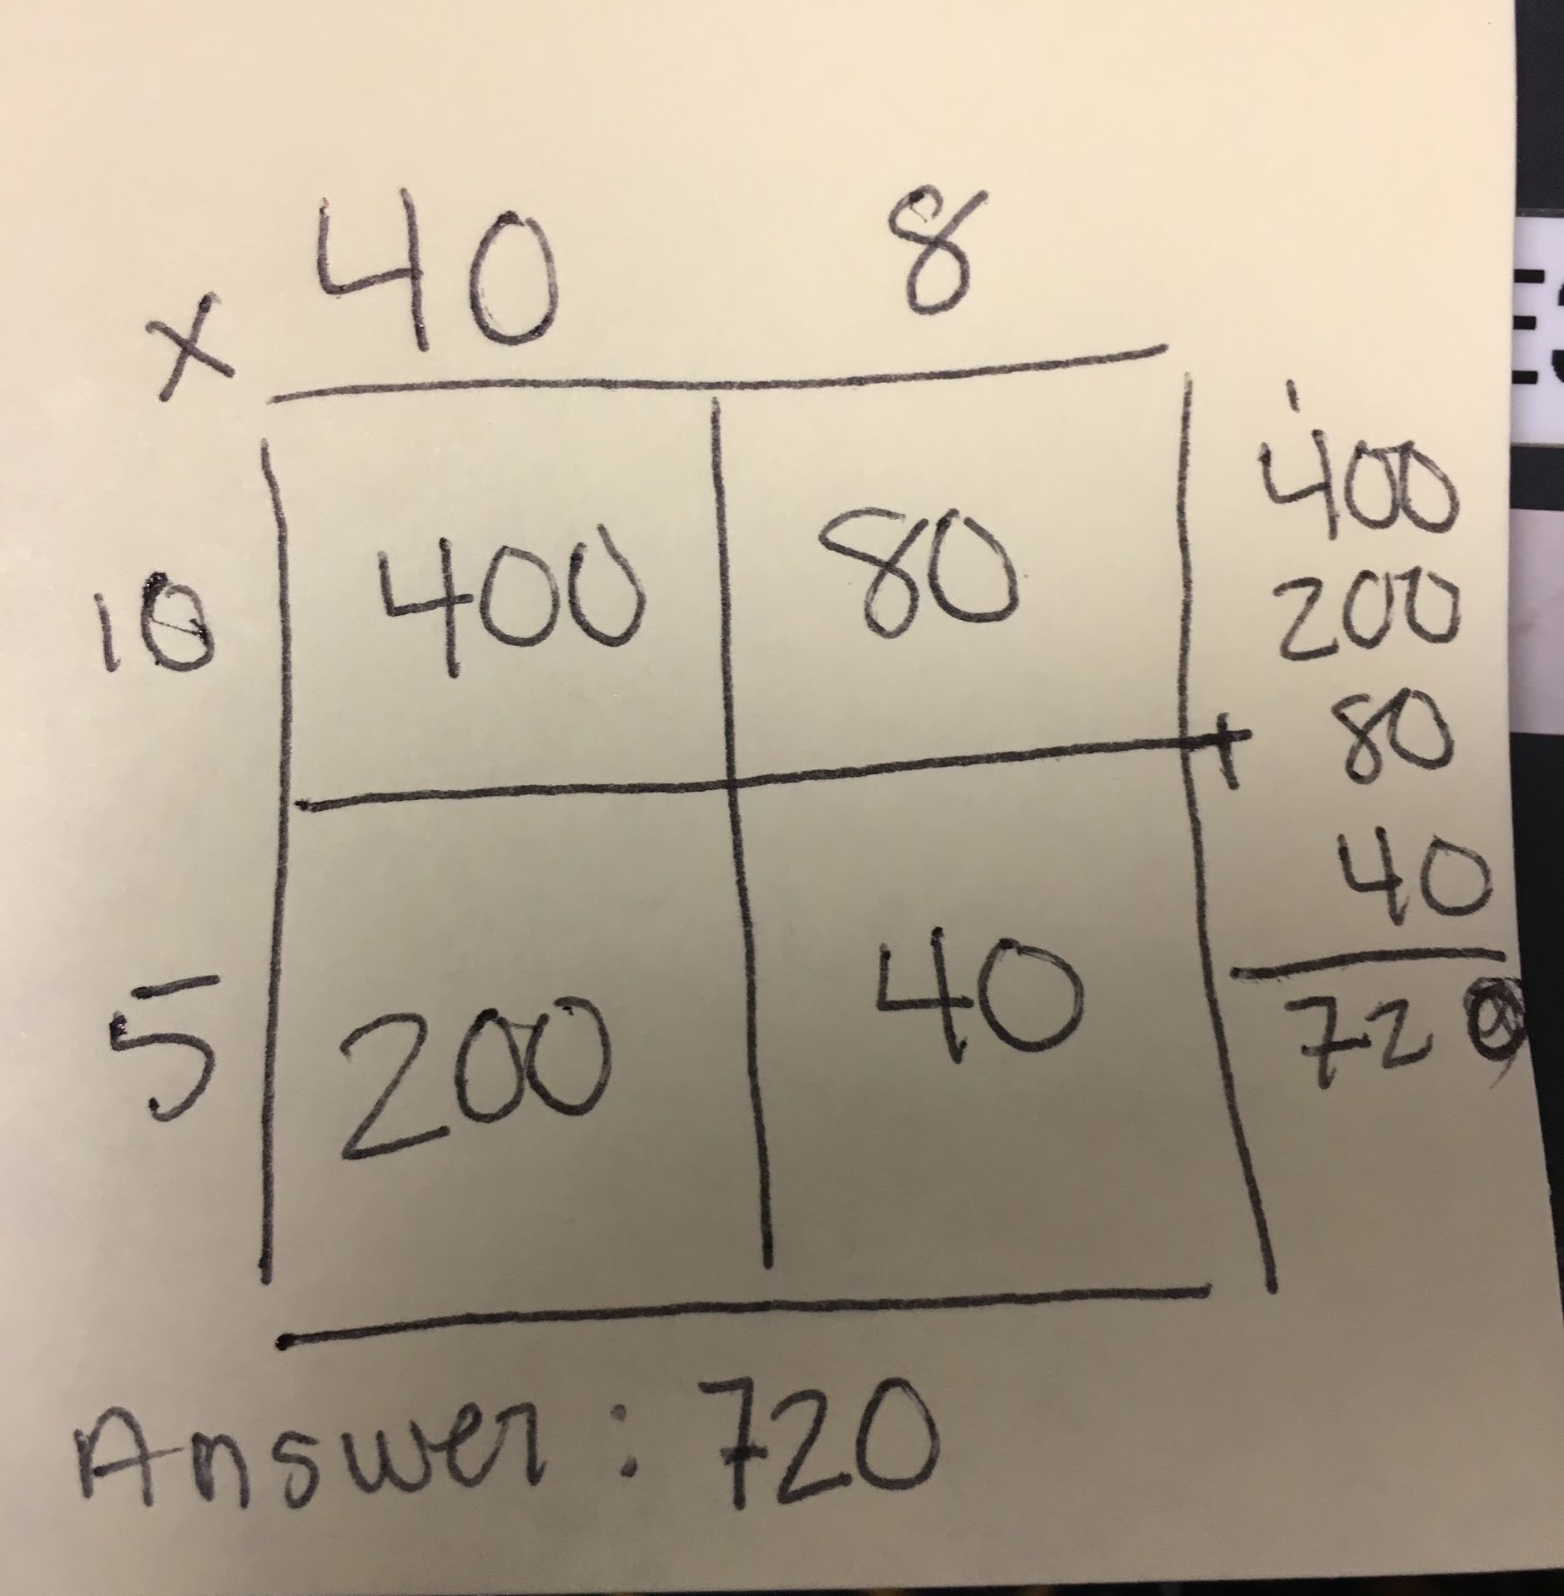
- Ask students to explain their work, citing evidence and support in written form for why worked out the problem and how they worked out the equation in the problem.
  - Example: Julissa and Kayla were buying candy for a party. They bought bags of candy that had 48 pieces of candy in each bag, and they bought fifteen bags. How many pieces of candy do Julissa and Kayla have for their party?
  - Possible student work: (see picture to the right)
  - Possible explanation: “I knew that they girls were buying fifteen bags of candy. I also knew that each bag of candy has forty-eight pieces of candy in it. The question asked for how many total pieces of candy the girls bought. I broke the forty-eight and the fifteen up by place value and multiplied them by the other numbers. First I multiplied 40 times 10 and got 400. Next, I multiplied 10 x 8 and got 80. After that I multiplied 5 x 40 and got 200, and last I multiplied 5 x 8 and got 40. I took all of the products and added them together and got 720 which is my answer.”
- Ask students to explain their multiplication and division process. Students should be able to explain why they decomposed their numbers. Their explanation should connect to their understanding of place value.
- Ask, “How do you know your solution is accurate and reasonable?” Students should be able to answer this by applying estimation strategies.
- Explain that multiplication and division are inverse operations. Challenge students to be able to check their work by using the inverse operation.
- Students should be able to solve their problem using a variety of strategies and understand how place value connects their various strategies.

