Skip Counting Goofs
This is lesson focuses on repeated addition and identifying errors in skip counting. The activities provide opportunities for teachers to discuss the role of dealing with errors while establishing a classroom community of mathematicians.

NC Mathematics Standards:
Operations and Algebraic Thinking
Represent and solve problems involving multiplication and division.
NC.3.OA.1 For products of whole numbers with two factors up to and including 10:
- Interpret the factors as representing the number of equal groups and the number of objects in each group.
- Illustrate and explain strategies including arrays, repeated addition, decomposing a factor, and applying the commutative and associative properties.

Standards for Mathematical Practice:
- Make sense of problems and persevere in solving them.
3. Construct viable arguments and critique the reasoning of others.
4. Model with mathematics.
6. Attend to precision.

Student Outcomes:
- I can make connections between repeated addition and multiplication.
- I can identify errors and correct them.

Math Language:
- Error
- Multiple
- Repeated Addition
- Skip Count

Materials:
- Paper, pencil
- Hundreds board
- Multi-link (pop) cubes
- What Do You See? Images
- Skip Counting Goofs Student activity sheet

Advance Preparation:
- Gather materials

Launch:
- How Many Boxes? and Introduce the Task (10 minutes)
Display the first image. Ask students to think of two different strategies to find the total number of boxes. Ask students to think of an equation to find the total number of boxes. Repeat these steps for the other images.

Introduce the Skip Counting Goofs activity sheet. Pass out the activity sheet. Say to the class, “One of the things that mathematicians do is identify mistakes and work on correcting them. On the activity sheet there are some errors in skip counting. You need to work with your classmates to identify the errors in skip counting and correct the errors.”

Explore:
- Working Together to Solve Problems (20-25 minutes)
Pair students up and make sure students have access to the Skip Counting Goofs activity sheet. Encourage students to use their cubes or pictures to build representations to examine each skip counting sequence.

Observation | Questions to Ask
Students attempt to complete the activity without pictures or cubes. | - “Can you build groups of cubes to find the error in the counting sequence?”  - “Can you draw an array to find the error in the counting sequence?”
Students are unable to identify errors. | - “When you look at the counting sequence what do you notice?”  - “What do you add to find the next number in the list?”
Students are unable to correct errors. | - “What number was incorrect in your list?”  - “For the numbers that were correct what did you add to find the next number in the list?”

Discuss:
- Class Discussion of Task (15 minutes)
Once students have completed at least 4 of the counting sequences bring them back together to discuss their strategies and the mathematics concepts in the task.

Sample Questions | Possible Responses or Talk Frames
How did you use pictures or cubes to find the error in this list <specify list>? | - “For the first list I made a group of 3, then 2 groups of 3 which was 6, but then when I made 3 groups of 3 I had 9 cubes but the list said 10.”  - “For the second list I drew a rectangle that had 1 row and 2 columns. Then I kept adding rows. After 1 row there were 4 boxes, then there were 6 boxes, then 8 boxes, then 10 boxes, then there should have been 12 boxes.”
How did you determine the correct numbers in the first sequence? (or any sequence the teacher chooses) | - “For the first list I kept adding groups of 3 cubes. I then kept adding 3 so I changed the list to 3, 6, 9, 12, 15, then 18.”  - “For the first list I drew a rectangle with 3 rows and 1 column. I kept adding columns and wrote down the number of boxes each time I added a column. The list should have been 3, 6, 9, 12, 15, and 18.”
What did this activity have to do with multiplication? | - “The correct list had us add the same number each time which is like representing multiplication with equal groups. Each time we moved to the next number we were adding an equal group.”  - “Multiplication is a way to determine how many times you have skip counted by the same number. If I skip count by 2 4 times I land on 8 which is the same as 2 times 4.”

Ask students how they felt finding and correcting errors.
Show the video from You Cubed about learning from mistakes. https://www.youcubed.org/resources/mistakes-powerful-video/
Ask students to share with their partner/table why mistakes are important.
Conclude the discussion by saying, Think about what we did today. Can you help me finish the sentence “Mathematicians are people who ______.”

Additional Activities:
These activities can either be done by everyone in the class or as part of centers/math workshop.

Hundreds Board Patterns
Students need a copy of a hundreds board and crayons or colored pencils. They should color all of the multiples of 2, 4, and 8 in different colors on the hundreds board. They can also use a different hundreds board to look at multiples of 3, 6, and 9.

Making Rectangles
Students get 16 cubes. Students need to arrange the 16 cubes into as many different rectangles as they can. They should record drawings and written explanations in their math journal or on paper.
Modifications: Students can repeat with 12 cubes, 20 cubes, or 24 cubes.

Close to 100
Students need number cards and either a recording sheet or their math journal.
Directions:
  - Students play with partners or in groups of 3. Each student gets 8 cards.
  - They use 4 of their cards to make 2 2-digit numbers that will add up to 100 or as close to it as possible.
  - Their score is their difference from 100. For example, if they had a sum of 106 then their score would be 6.
  - Students get new cards so they always start with 8.
  - Students continue to play. The lowest score wins.

Evaluation of Student Understanding:
Informal Evaluation:
- Observe students and ask questions as they Explore the task. Make note of specific strategies to have certain students share during the Discuss phase of the lesson.

Formal Evaluation:
- Students’ work on the activity sheet can be collected for a formal evaluation.
- If you need an exit ticket you can pose the following task: There are 3 cupcakes in each package. How many cupcakes are in 4 packages? Draw a picture and write an equation.

Meeting the Needs of the Range of Learners:
Interventions:
- For students who struggle identifying errors for some of the larger numbers focus only on skip counting lists that skip by 2s, 4s, and 5s.

Extensions:
- This lesson provides a conceptual foundation of skip counting and finding errors in a list of 6 multiples. Students may find errors in longer lists or extend their list for 10 multiples for more of a challenge.

Possible Misconceptions/Suggestions:
Possible Errors  and Misconceptions | Suggestions
Students attempt to complete the activity without pictures or cubes. | - “Can you build groups of cubes to find the error in the counting sequence?”  - “Can you draw an array to find the error in the counting sequence?”
Students are unable to identify errors. | - “When you look at the counting sequence what do you notice?”  - “What do you add to find the next number in the list?”
Students are unable to correct errors. | - “What number was incorrect in your list?”  - “For the numbers that were correct what did you add to find the next number in the list?”

Special Notes:
- The How Many Boxes? Activity can be revisited at various times during the year.
- The Additional Activities can be done at various times during the year.

How Many Boxes?

Image A

Image B

Image C

Image D

Skip Counting Goofs

Identify the Skip Counting Goofs for each of the lists below. Use cubes or pictures to help you. Then correct the Goof.

Sequence | Corrected Sequence
3, 6, 10, 13, 16, 19
2, 4, 6, 8, 11, 12

4, 8, 12, 14, 20, 24
5, 10, 15, 21, 26, 31
10, 20, 30, 41, 51, 61
6, 12, 18, 22, 28, 34

Hundreds Board

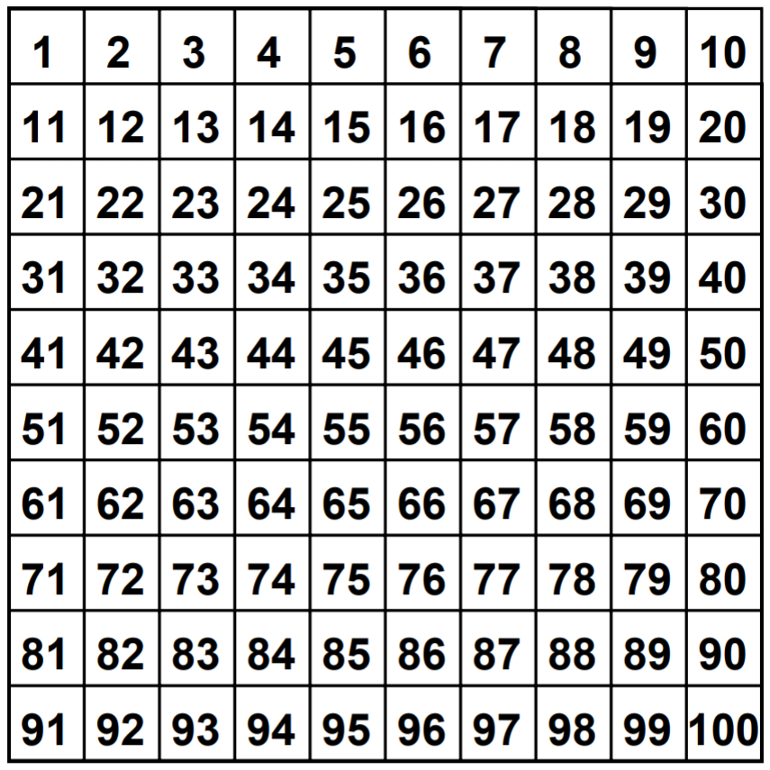

Number Cards Page 1 of 2

0 | 1 | 2 | 0 | 1 | 2
3 | 4 | 5 | 3 | 4 | 5
6 | 7 | 8 | 6 | 7 | 8
9 | 0 | 1 | 9 | 0 | 1
2 | 3 | 4 | 2 | 3 | 4

Page 2 of 2

5 | 6 | 7 | 5 | 6 | 7
8 | 9 | 0 | 8 | 9 | 0
1 | 2 | 3 | 1 | 2 | 3
4 | 5 | 6 | 4 | 5 | 6
7 | 8 | 9 | 7 | 8 | 9

Hundreds Board

