NC.4.NBT.5
Greatest Product
Domain | Number and Operations in Base Ten
Cluster | Use place value understanding and properties of operations to perform multi-digit arithmetic.
Standard(s) | NC.4.NBT.5 Multiply a whole number of up to three digits by a one-digit whole number, and multiply up to two two-digit numbers with place value understanding using area models, partial products, and the properties of operations. Use models to make connections and develop the algorithm.
Materials | activity sheet, pencil, additional paper to work out problems
Task | Greatest Product  Patrick and Danielle are playing a card game. The goal of the game is to arrange cards to make a multiplication equation and to see who can make the greatest product.  Patrick draws the following cards: 4, 7, 2, and 1. He makes the equation 174 x 2 = ___.  Danielle draws the following cards: 3, 5, 2, and 8. She makes the equation 352 x 8 = ____.  Part 1:  - What was Patrick’s product? (348)  - What was Danielle’s product? (2,816)  - Which player had the greatest product? (Danielle)  Part 2:  - Could Patrick have rearranged his cards to get a greater product? If so, find the greatest product Patrick could have made. (421 x 7 = 2,947)  - Could Danielle have rearranged her cards to get a greater product? If so, find the greatest product Danielle could have made. (532 x 8 = 4,256)

Rubric
Level I  Not Yet | Level II  Progressing | Level III  Meets Expectation
Student answers 0-1 parts of the problem correctly. | Student answers 2-4 parts of the problem correctly. | Student answers all 5 parts of the problem correctly.

Standards for Mathematical Practice
1. Makes sense and perseveres in solving problems.
2. Reasons abstractly and quantitatively.
3. Constructs viable arguments and critiques the reasoning of others.
4. Models with mathematics.
5. Uses appropriate tools strategically.
6. Attends to precision.
7. Looks for and makes use of structure.
8. Looks for and expresses regularity in repeated reasoning

Greatest Product
5

Patrick and Danielle are playing a card game. The goal of the game is to arrange cards to make a multiplication equation and to see who can make the greatest product.

Patrick draws these cards: 4, 7, 2, and 1. He makes the equation 174 x 2 = ___.
Danielle draws these cards: 3, 5, 2, and 8. She makes the equation 352 x 8 = ___.

Part 1:
- What was Patrick’s product?

- What was Danielle’s product?

- Which player had the greatest product?

Part 2:
- Could Patrick have rearranged his cards to get a greater product? If so, find the greatest product Patrick could have made.

- Could Danielle have rearranged her cards to get a greater product? If so, find the greatest product Danielle could have made.

Scoring Examples

Not Yet: The student answers 1 of the questions correctly for this task. The student was able to use repeated addition to solve 174 x 2, but was unable to use the algorithm to solve 352 x 8. In Part 2, the student rearranged the cards in a way that would have provided a larger product, but did not find the product.

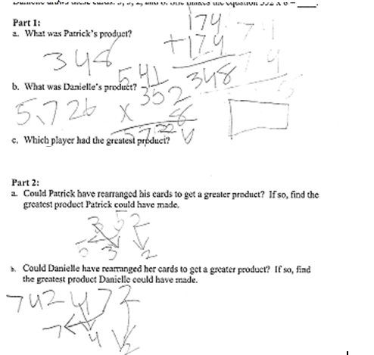

Progressing: The student answered all of Part 1 correctly, but was unable to use the guess and check strategy effectively to find the greatest products for Part 2.
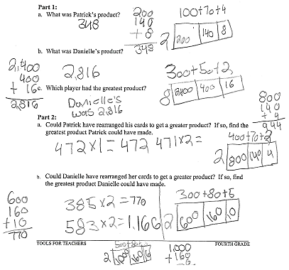
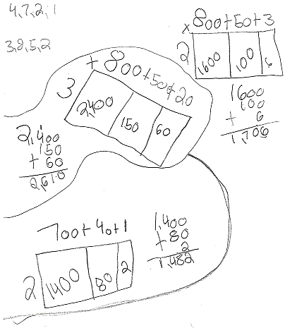
Meets Expectation: The student was able to solve all parts of the task correctly and used the guess and check strategy effectively in Part 2.
