NC.4.NBT.5
Multiplication Strategies
Domain | Numbers and Operations in Base Ten
Cluster | Generalize place value understanding for multi-digit whole numbers.
Standard(s) | NC.4.NBT.5 Multiply a whole number of up to three digits by a one-digit whole number, and multiply up to two two-digit numbers with place value understanding using area models, partial products, and the properties of operations. Use models to make connections and develop the algorithm.
Materials | pencil, activity sheet
Task | Multiplication Strategies  In the cafeteria, each row seats 22 students. There are 12 rows. How many students can be seated?  Part 1: Solve this problem using an area model.  Part 2: Solve this problem using partial products.  Part 3: Solve this problem using the standard algorithm.  Part 4: Describe the connections you see between the area model you made in Part 1 and the way you solved the problem using the standard algorithm in Part 3.  This standard calls for students to understand and use a variety of strategies for multiplying multi-digit numbers.  Possible strategies:  Traditional Algorithm:  22  x 12  44  +220  264  Area array model:  20 x 10 = 200 20 x 2 = 40  2 x 10 = 20 2 x 2 = 4  Partial Products:  20 x 10 = 200 22 x 2 = 44  20 x 2 = 40 22 x 10 = 220  2 x 10 = 20 220 + 44 = 264  2 x 2 = 4  200 + 40 + 20 + 2 = 264

Rubric
Level I  Not Yet | Level II  Progressing | Level III  Meets Expectation
Students are unable to use a strategy to solve the multiplication problem.  OR  Student may be able to use the algorithm to find an answer but cannot explain why it works. | Student answers 2-3 parts of the problem completely and correctly. | Student answers all 4 parts of the problem completely and correctly.

Standards for Mathematical Practice
1. Makes sense and perseveres in solving problems.
2. Reasons abstractly and quantitatively.
3. Constructs viable arguments and critiques the reasoning of others.
4. Models with mathematics.
5. Uses appropriate tools strategically.
6. Attends to precision.
7. Looks for and makes use of structure.
8. Looks for and expresses regularity in repeated reasoning.

Multiplication Strategies

In the cafeteria, each row seats 22 students. There are 12 rows. How many students can be seated?

Part 1: Solve this problem using an area model.

Part 2: Solve this problem using partial products.

Part 3: Solve this problem using the standard algorithm.

Part 4: Describe the connections you see between the area model you made in Part 1 and the way you solved the problem using the standard algorithm in Part 3.

Scoring Examples
Not Yet: This student was unable to solve the problem using correctly using any strategy.
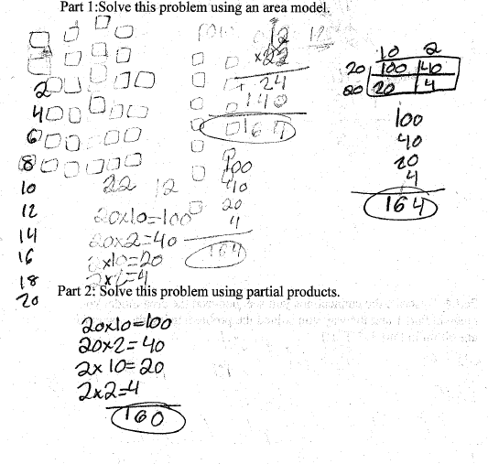
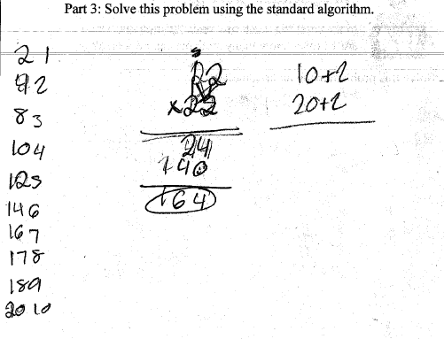
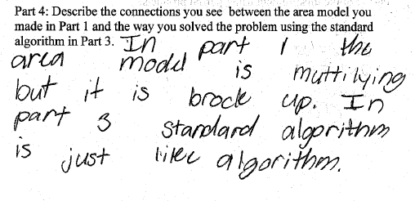
Progressing: The student solved the problem correctly using two different strategies and could make connections between strategies, but was unable to solve using the algorithm.
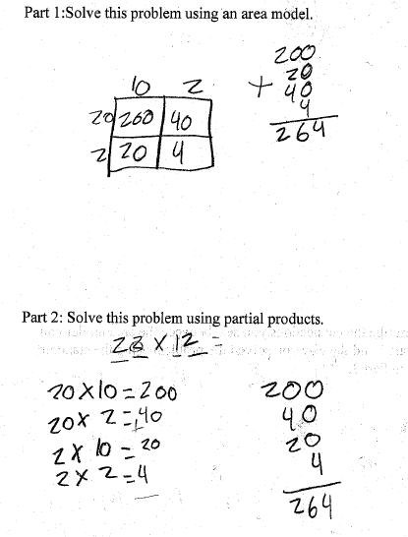
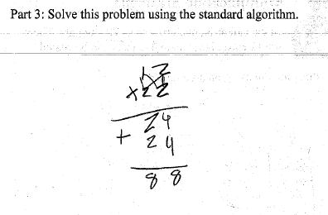
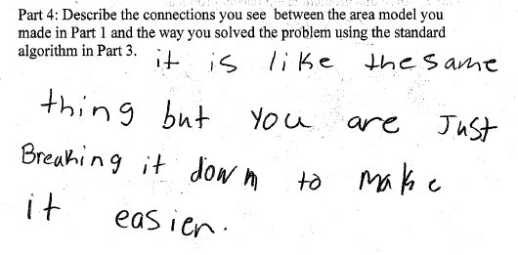

Meets Expectation: The student was able to correctly solve the problem three different ways and explain how the strategies were related.

