NC.4.MD.3
Enlarging the Yard
Domain | Measurement and Data
Cluster | Solve problems involving area and perimeter.
Standard(s) | NC.4.MD.3 Solve problems with area and perimeter.  - Find areas of rectilinear figures with known side lengths  - Solve problems involving a fixed area and varying perimeters and a fixed perimeter with varying areas  - Apply the area and perimeter formulas for rectangles in real world and mathematical problems
Materials | activity sheet, graph paper (optional), pencil
Task | Enlarging the Yard  Currently, you have a rectangular yard that has perimeter of 72 meters. The current area is between 300 and 350 meters.  Part 1:  What are the dimensions of your current fenced-in space? Explain your reasoning.  Solution: The 2 dimensions must add up to 36. The two dimensions must have a product between 300 and 350. Possible answers: 18x18, 19x17, 20x16, 21x15, 22x14.  Part 2:  In order to have more space to play, your parents decide that they want to extend both dimensions by 5 meters. What are the new dimensions of your yard? What is the new perimeter? What is the new area? Explain your reasoning.  Solution: The dimensions chosen by the student from Part 1 have been increased by 5. The new perimeter and the area are correct.  23x23 (perimeter = 92m, area=529 sq. m)  24x22 (perimeter = 92m, area=528 sq. m)  25x21 (perimeter=92m, area=525 sq. m)  26x20 (perimeter=92m, area=520 sq. m)  27x19 (perimeter=92m, area=513 sq. m)

Rubric
Level I  Not Yet | Level II  Progressing | Level III  Meets Expectation
Student is unable to use strategies to find correct answers to any aspect of the task or explain their reasoning. | Student is inconsistent in solving all parts of the task and/or explaining their reasoning clearly and accurately. | Student is able to correctly solve all parts of the task and explain his/her reasoning clearly and accurately.
Standards for Mathematical Practice
1. Makes sense and perseveres in solving problems.
2. Reasons abstractly and quantitatively.
3. Constructs viable arguments and critiques the reasoning of others.
4. Models with mathematics.
5. Uses appropriate tools strategically.
6. Attends to precision.
7. Looks for and makes use of structure.
8. Looks for and expresses regularity in repeated reasoning

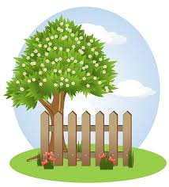
Enlarging the Yard

Currently, you have a rectangular yard that has perimeter of 72 meters. The current area is between 300 and 350 meters.

Part 1:
What are the dimensions of your current fenced-in space?

Explain your reasoning:

Part 2:
In order to have more space to play, your parents decide that they want to extend both dimensions by 5 meters. What are the new dimensions of your yard? What is the new perimeter? What is the new area?

Explain your reasoning:

Scoring Examples
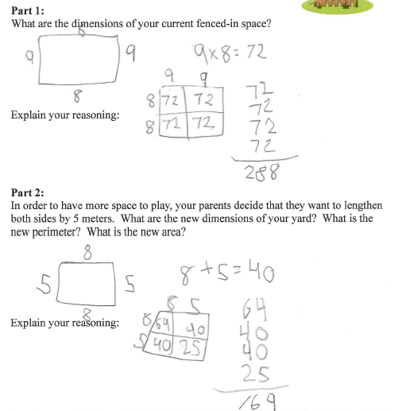
Not Yet: The student is unable to use strategies to find correct answers to any aspect of the task or explain his/her reasoning.

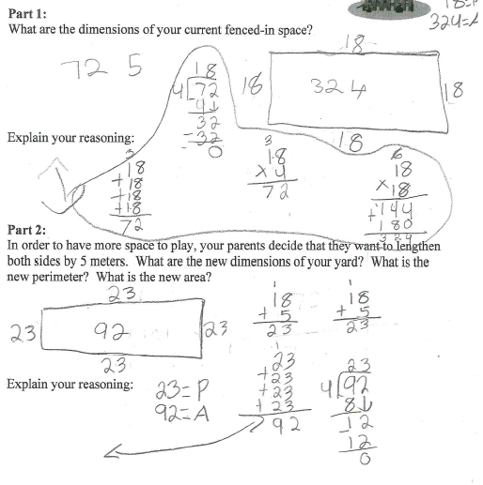
Progressing: In Part 2, the student mixed up area and perimeter and didn’t completely explain his/her reasoning.

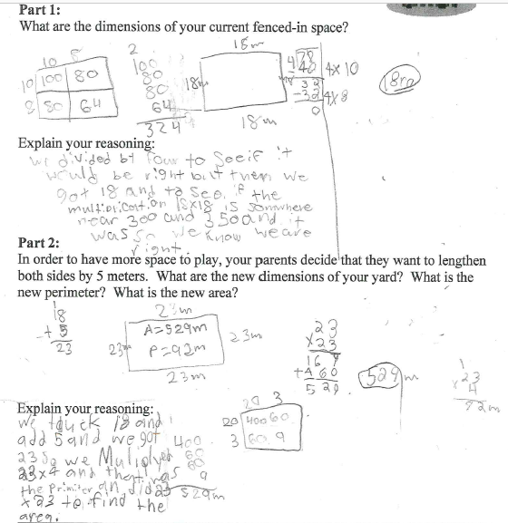
Meets Expectation: This work is correct and clear and easy to understand. Student thinking is well explained and easy to follow.

