NC.4.MD.3
Fencing Yards
Domain | Measurement and Data
Cluster | Solve problems with area and perimeter.
Standard(s) | NC.4.MD.3 Solve problems with area and perimeter.  - Find areas of rectilinear figures with known side lengths  - Solve problems involving a fixed area and varying perimeters and a fixed perimeter and varying areas.  - Apply the area and perimeter formulas for rectangles in real world and mathematical problems.
Materials | square tiles, activity sheet, pencil, graph paper (optional)
Fencing Yards
Part 1:
For a summer job, your older brother is working for a fencing company. Determine how much fencing is needed for each of these rectangular yards.
Yard 1: Area is 500 square meters. Length is 25 meters.
Yard 2: Area is 567 square meters. Length is 9 meters.
Yard 3: Area is 736 square meters. Length is 4 meters.

Solutions:
Yard 1:
Length = 25 meters, Width = 20 meters
Fencing Needed: 90 meters
Yard 3:
Length: 4 meters, Width = 184 meters
Fencing Needed: 376 meters

Yard 2:
Length = 9 meters, Width = 63 meters
Fencing Needed: 144 meters

Part 2:
Write a sentence and explain how you solved this task.

Rubric
Level I  Not Yet | Level II  Progressing | Level III  Meets Expectation
Student found no missing side lengths or perimeters for each of the three yards and is not able to clearly and accurately explain how they solved the task. | Student was inconsistent in finding missing side lengths and perimeters for each of the three yards and may or may not be able to clearly and accurately explain how they solved the task. | Student is able to find missing side lengths and perimeters for all three yards and is able to clearly and accurately explain how they solved the task.

Standards for Mathematical Practice
1. Makes sense and perseveres in solving problems.
2. Reasons abstractly and quantitatively.
3. Constructs viable arguments and critiques the reasoning of others.
4. Models with mathematics.
5. Uses appropriate tools strategically.
6. Attends to precision.
7. Looks for and makes use of structure.
8. Looks for and expresses regularity in repeated reasoning.

Fencing Yards
Part 1:
For a summer job, your older brother is working for a fencing company. Determine how much fencing is needed for each of these rectangular yards.

Yard 1: Area is 500 square meters. Length is 25 meters.
Yard 2: Area is 567 square meters. Length is 9 meters.
Yard 3: Area is 736 square meters. Length is 4 meters.

Part 2:
Write a sentence and explain how you solved this task.

Scoring Examples
Not Yet: The student understands how to find area, but solves incorrectly for each width.
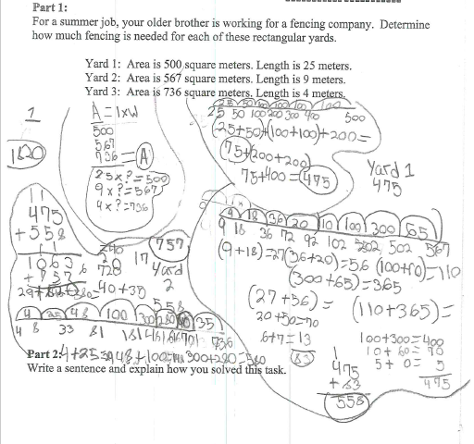

Progressing: The student correctly solves for two of the yards, but not for three yards. The student’s explanation is logical and correct.
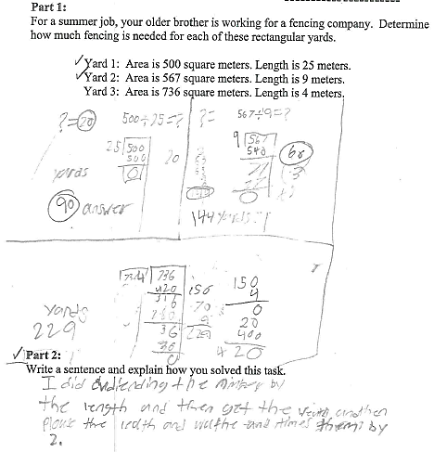

Meets Expectation: The student correctly solves for all widths and uses that answer to solve for the perimeter. The explanation is correct and logical.
