NC.4.MD.3
Making a Dog Pen
Domain | Measurement and Data
Cluster | Solve problems with area and perimeter.
Standard(s) | NC.4.MD.3 Solve problems with area and perimeter.  - Find areas of rectilinear figures with known side lengths.  - Solve problems involving a fixed area and varying perimeters and a fixed perimeter and varying areas.  - Apply the area and perimeter formulas for rectangles in real world and mathematical problems.
Materials | square tiles, activity sheet, paper, pencil, graph paper (optional)
Task | Making a Dog Pen  Part 1:  You want to make a rectangular dog pen using 20 yards of fencing. The side lengths must be in whole yards. Create as many different rectangular pens as you can.  Solutions:  9 x 1, 8 x 2, 7 x 3, 6 x 4, 5 x 5  Part 2:  Which dog pen gives your dog the most space to run around and play in? Write a sentence explaining how you know.  Solution:  The 5 x 5 pen gives the most space with an area of 25 square yards. The larger the area of the pen, the more space the dog has to run.  Part 3:  You want to build the rectangular dog pen with 20 yards of fencing against your house which is 20 yards wide. Which dimensions will give you the most space for your dog?  Solution:  A 10 x 5 pen gives the most area for the dog to run. 10 yards would run parallel to the house, while 5 yards connect the house to the other side.  Part 4:  One of your friends just got a puppy. She is going to buy fencing with her parents this weekend to build her own pen. Explain to her how to design the fence so that her puppy will have the biggest pen possible, as well as how you know it will be the biggest pen possible.  Possible Explanation:  In order to get the biggest pen, you must consider the amount of fencing (perimeter) and decide which possible dimensions will give you the largest area. The closer the dimensions are to a square, the larger area it will provide.

Rubric
Level I  Not Yet | Level II  Progressing | Level III  Meets Expectation
Student is able to complete 0-1 of the following:  - Create all possible pens with a perimeter of 20 yards and identify which dimension yields the largest area  - Clearly explains how they have identified the pen with the largest area  - Creates the largest pen possible within the parameters given in Part 3  - Clearly and accurately explains how the dimensions/perimeter of a rectangle relate to its area | Student is able to complete 2-3 of the following:  - Create all possible pens with a perimeter of 20 yards and identify which dimension yields the largest area  - Clearly explains how they have identified the pen with the largest area  - Creates the largest pen possible within the parameters given in Part 3  - Clearly and accurately explains how the dimensions/perimeter of a rectangle relate to its area | Student is able to complete all of the following:  - Create all possible pens with a perimeter of 20 yards and identify which dimension yields the largest area  - Clearly explains how they have identified the pen with the largest area  - Creates the largest pen possible within the parameters given in Part 3  - Clearly and accurately explains how the dimensions/perimeter of a rectangle relate to its area

Standards for Mathematical Practice
1. Makes sense and perseveres in solving problems.
2. Reasons abstractly and quantitatively.
3. Constructs viable arguments and critiques the reasoning of others.
4. Models with mathematics.
5. Uses appropriate tools strategically.
6. Attends to precision.
7. Looks for and makes use of structure.
8. Looks for and expresses regularity in repeated reasoning.

Making a Dog Pen

Part 1:
You want to make a rectangular dog pen using 20 yards of fencing. The side lengths must be in whole yards. Create as many different rectangular pens as you can.

Part 2:
Which dog pen gives your dog the most space to run around and play in? Write a sentence explaining how you know.

Part 3:
You want to build the rectangular dog pen with 20 yards of fencing against your house which is 20 yards wide. Which dimensions will give you the most space for your dog?

Part 4:
One of your friends just got a puppy. She is going to buy fencing with her parents this weekend to build her own pen. Explain to her how to design the fence so that her puppy will have the biggest pen possible, as well as how you know it will be the biggest pen possible.

Scoring Examples
Not Yet: The student creates possible pens with a perimeter of 20. The student was unable to use the dimensions to find the largest area and could not explain how the perimeter relates to area.
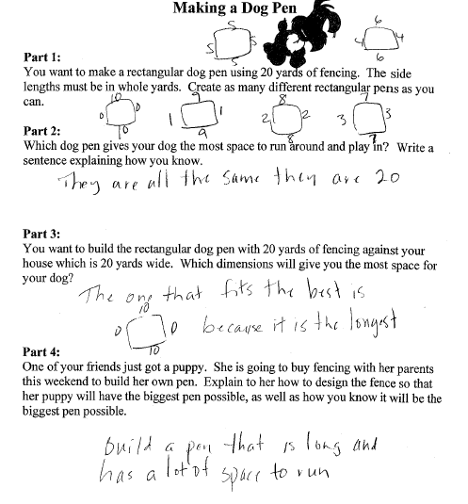

Progressing: The student found the possible perimeters and was able to identify which pen had the largest area. However, the student was unable to correctly complete Part 3 and does not demonstrate an understanding of the relationship between perimeter and area.
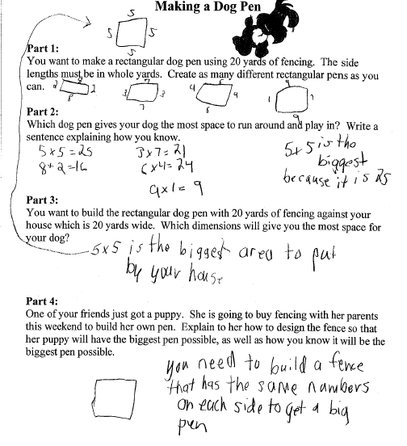

Meets Expectation: The student found all possible dimensions for pens and demonstrated an understanding of the relationship between area and perimeter.
