NC.4.NBT.5 & NC.4.MD.3
Playground Design
Domain | Number and Operations in Base Ten
Cluster | Use place value understanding and properties of operations to perform multi-digit arithmetic.
Standard(s) | NC.4.NBT.5 Multiply a whole number of up to three digits by a one-digit whole number, and multiply up to two two-digit numbers with place value understanding using area models, partial products, and the properties of operations. Use models to make connections and develop the algorithm.  NC.4.MD.3 Solve problems with area and perimeter.  • Find areas of rectilinear figures with known side lengths.  • Solve problems involving a fixed area and varying perimeters and a fixed perimeter and varying areas.  • Apply the area and perimeter formulas for rectangles in real world and mathematical problems.
Materials | activity sheet, pencil
Task | Playground Design  Fundays Elementary School is having a contest to design their new playground. Two of the finalists in the contest are shown below. Aleah wants to vote for the playground design with the largest soccer field. Which design should she vote for and why?  Design A 48 ft. Soccer Field 23 ft. Area: 1,104 square feet Design B 35 ft. Soccer Field 32 ft. Area: 1,120 square feet  *Aleah should vote for Design B because it has the greatest area to play soccer.

Rubric
Level I  Not Yet | Level II  Progressing | Level III  Meets Expectation
Student is unable to answer any parts of the task correctly. | Student correctly answers 1-2 parts of the task. | Student correctly answers each part of the task.

Standards for Mathematical Practice
1. Makes sense and perseveres in solving problems.
2. Reasons abstractly and quantitatively.
3. Constructs viable arguments and critiques the reasoning of others.
4. Models with mathematics.
5. Uses appropriate tools strategically.
6. Attends to precision.
7. Looks for and makes use of structure.
8. Looks for and expresses regularity in repeated reasoning.
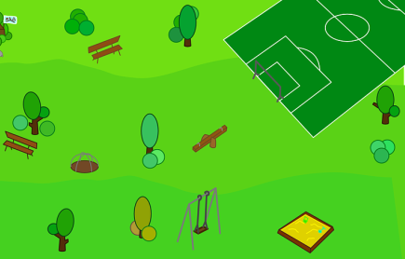
Playground Design

Fundays Elementary School is having a contest to design their new playground. Two of the finalists in the contest are shown below. Aleah wants to vote for the playground design with the largest soccer field. Which design should she vote for and why?

Design A  48 ft.  Soccer Field  23 ft. | Design B  35 ft.  Soccer Field  32 ft.

Scoring Examples

Not Yet: This student does not find correct answers to any part of the task. The student finds the area instead of the perimeter.
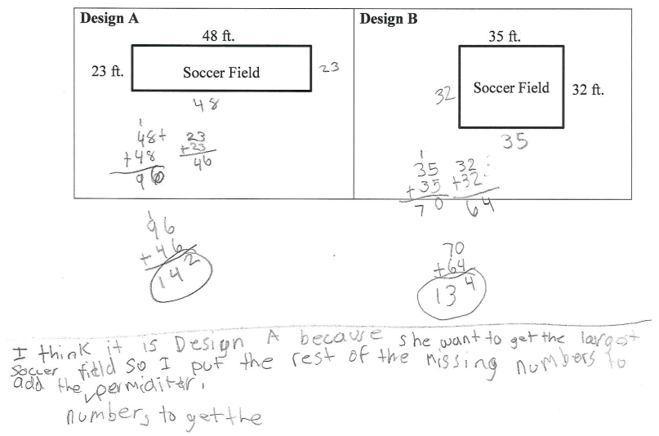

Progressing: The student was able to find the area for Design B using the standard algorithm, but was not able to find the correct area for Design A. The explanation is therefore incorrect.
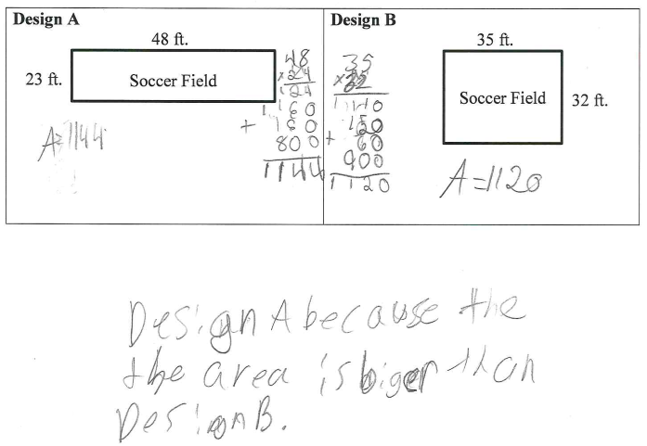

Meets Expectation: The student finds the correct area for both designs using an area model for multiplication and explains why Aleah would choose Design B.
