NC.4.OA.3
Making Gift Bags
Domain | Operations and Algebraic Thinking
Cluster | Use the four operations with whole numbers to solve problems.
Standard(s) | NC.4.OA.3 Solve two-step word problems involving the four operations with whole numbers.  - Use estimation strategies to assess reasonableness of answers.  - Interpret remainders in word problems.  - Represent problems using equations with a letter standing for the unknown quantity.
Materials | activity sheet, pencil, counters (if needed)
Task | Making Gift Bags  Mrs. Turner’s fourth grade class is making gift bags for their parent volunteers. They have collected bite-sized candy bars which they are distributing equally among each bag.  Here is a list of the candy:  - 27 Dark Chocolate bars  - 12 Milky Way bars  - 19 Three Musketeer bars  Part 1:  How much candy will be in each bag if they have 7 parent volunteers? How much leftover candy will they have? Explain your reasoning.  There are 58 candy bars divided among 7 people. Each person gets 8 bars in the bag and 2 bars are left over.  Part 2:  The class decides to make gift bags for the parent volunteers, and also make gift bags for their teacher, principal, and assistant principal. How much candy will be in each bag now? How much leftover candy will they have? Explain your reasoning.  There are 58 candy bars divided among 10 people. Each person gets 5 bars in the bag and 8 bars are left over.

Rubric
Level I  Not Yet | Level II  Progressing | Level III  Meets Expectation
Student is unable to use strategies to find correct answers to either part of the task and explanation is unclear or incomplete. | Student has some aspects of the task correct, but is inconsistent in either solving and/or explaining their reasoning. | All aspects of the task are correct. Explanations are clear and accurate.
Standards for Mathematical Practice
1. Makes sense and perseveres in solving problems.
2. Reasons abstractly and quantitatively.
3. Constructs viable arguments and critiques the reasoning of others.
4. Models with mathematics.
5. Uses appropriate tools strategically.
6. Attends to precision.
7. Looks for and makes use of structure.
8. Looks for and expresses regularity in repeated reasoning

Making Gift Bags

Mrs. Turner’s fourth grade class is making gift bags for their parent volunteers. They have collected bite-sized candy bars which they are distributing equally among each bag.

Here is a list of the candy:
- 27 Dark Chocolate bars
- 12 Milky Way bars
- 19 Three Musketeer Bars

Part 1:
How much candy will be in each bag if they have 7 parent volunteers? How much leftover candy will they have? Explain your reasoning.

Part 2:
The class changes their mind and decides to also make gift bags for their teacher, principal and assistant principal. How much candy will be in each bag now? How much leftover candy will they have? Explain your reasoning.

Scoring Examples
Not Yet: This student is unable to find correct answers to any part of the task. The student does not demonstrate a clear understanding of division within the context of this task.
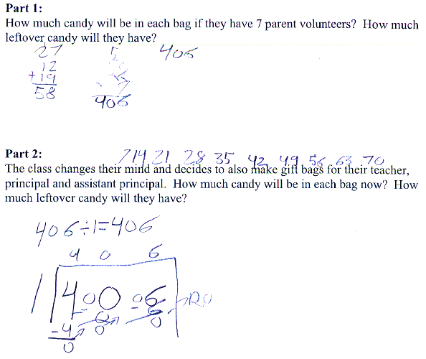

Progressing: The student was able to use strategies to find the answer for one part of the task, but was unable to consistently use that strategy to find the answers for all parts of the task.
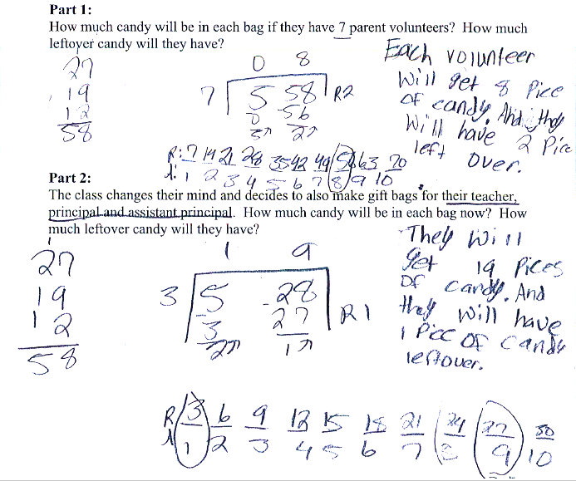

Meets Expectation: The student was able to use a division strategy to find correct answers for both parts of the task. The explanations for each part are clear and accurate.
