NC.4.OA.3
How Many Teams?
Domain | Operations and Algebraic Thinking
Cluster | Use the four operations with whole numbers to solve problems.
Standard(s) | NC.4.OA.3 Solve two-step word problems involving the four operations with whole numbers.  - Use estimation strategies to assess reasonableness of answers.  - Interpret remainders in word problems.  - Represent problems using equations with a letter standing for the unknown quantity.
Materials | activity sheet, pencil
Task | How Many Teams?  The table below shows the number of fourth grade students signed up for basketball in each region of North Carolina.  Region Number of Students  Western Region 982  Central Region 517  Eastern Region 377  Every player will get placed on a team in their region of the state.  Part 1:  Each region’s league wants to place 9 players on each team. Leftover players will be added to teams, so some teams will have ten players. How many teams will have 9 players in each region of the state? How many teams will have 10 players in each region of the state?  Explain your reasoning.  Western - 108 teams of 9, 1 team of 10  Central - 53 teams of 9, 4 teams of 10  Eastern - 33 teams of 9, 8 teams of 10  Part 2:  In order to maximize playing time, each region’s league decides to only place 7 players on each team. If there are extra players, some teams will have 8 players. How many teams will have 7 players in each region of the state? How many teams will have 8 players in each region of the state? Explain your reasoning.  Western - 138 teams of 7, 2 teams of 8  Central - 67 teams of 7, 6 teams of 8  Eastern - 47 teams of 7, 6 teams of 8

Rubric
Level I  Not Yet | Level II  Progressing | Level III  Meets Expectation
Student is not able to complete any of the following correctly:  - Uses a strategy to correctly solve the division problem  - Interpret remainders in the problem  - Explanations are clear and accurate | Student is able to do 1-2 of the following correctly:  - Uses a strategy to correctly solve the division problem  - Interpret remainders in the problem  - Explanations are clear and accurate | Student is able to do all of the following correctly:  - Uses a strategy to correctly solve the division problem  - Interpret remainders in the problem  - Explanations are clear and accurate
Standards for Mathematical Practice
1. Makes sense and perseveres in solving problems.
2. Reasons abstractly and quantitatively.
3. Constructs viable arguments and critiques the reasoning of others.
4. Models with mathematics.
5. Uses appropriate tools strategically.
6. Attends to precision.
7. Looks for and makes use of structure.
8. Looks for and expresses regularity in repeated reasoning

How Many Teams?
The table below shows the number of fourth grade students signed up for basketball in each region of North Carolina.
Region | Number of Students
Western Region | 982
Central Region | 517
Eastern Region | 377
Part 1:
Every player will get placed on a team in their region of the state. Each region’s league wants to place 9 players on each team. Leftover players will be added to teams, so some teams will have ten players. How many teams will have 9 players in each region of the state? How many teams will have 10 players in each region of the state?
Western Region  ___ teams will have 9 players.  ___ teams will have 10 players. | Central Region  ___ teams will have 9 players.  ___ teams will have 10 players. | Eastern Region  ___ teams will have 9 players.  ___ teams will have 10 players.

Explain your reasoning.
__________________________________________________________________________________________________________________________________________________________________________________________________________________________________________________________________________________________________________________________________________________________________________________________________________________
Part 2:
In order to maximize playing time, each region’s league decides to only place 7 players on each team. If there are extra players, some teams will have 8 players. How many teams will have 7 players in each region of the state? How many teams will have 8 players in each region of the state? Explain your reasoning.
Western Region  ___ teams will have 9 players.  ___ teams will have 10 players. | Central Region  ___ teams will have 9 players.  ___ teams will have 10 players. | Eastern Region  ___ teams will have 9 players.  ___ teams will have 10 players.

Explain your reasoning.
___________________________________________________________________________________________________________________________________________________________________________________________________________________________________________________________________________________________________________________________________________________________________________________________________________________________________________________________________________________________________________________________________________________________
Scoring Examples
Not Yet: The student is unable to correctly solve the division problems and interpret remainders.
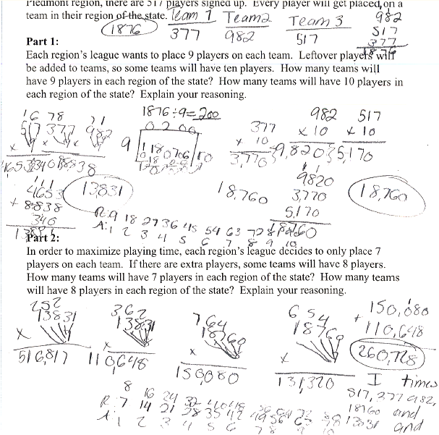

Progressing: Student is able to solve some division problems and interpret remainders.
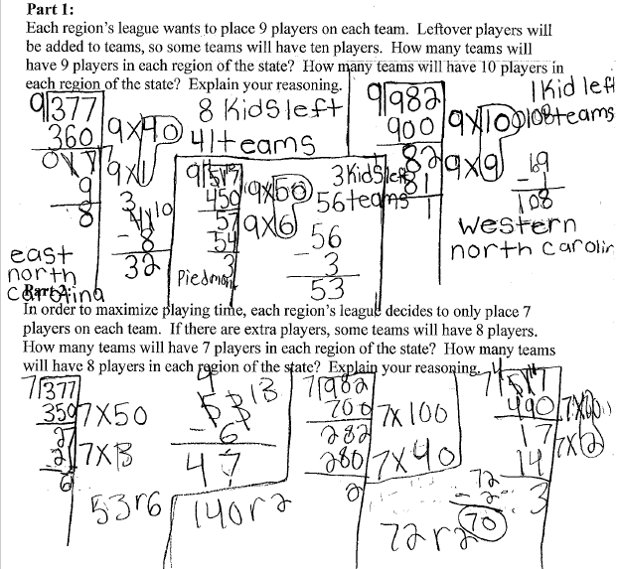

Meets Expectation: Student is able to correctly divide and interpret remainders for all aspects of the task.
