NC.4.OA.3
Remainders
Domain | Operations and Algebraic Thinking
Cluster | Use the four operations with whole numbers to solve problems.
Standard(s) | NC.4.OA.3 Solve two-step word problems involving the four operations with whole numbers.  - Use estimation strategies to assess reasonableness of answers.  - Interpret remainders in word problems.  - Represent problems using equations with a letter standing for the unknown quantity.
Materials | activity sheet, pencil
Task | This standard involves interpreting remainders. Remainders should be interpreted in story contexts so students can make sense of how to deal with them.  Ways to address remainders include:  - Remain as a left over  - Partitioned into fractions or decimals  - Discarded leaving only the whole number answer  - Increase the whole number answer up one  - Round to the nearest whole number for an approximate result  Give students the problem 53 ÷ 7 = ? and allow students time to generate situations in which each answer would be correct.  Problem A: 7  Problem B: 7 r 4  Problem C: 8  Problem D: 7 or 8  Problem E: 7 $\frac{4}{7}$  Possible solutions:  - Problem A: 7 Josh had 53 cookies. Seven cookies fit into his snack size bag. How many bags did he fill? 53 ÷ 7 = p; p = 7 r 4 Josh can fill 7 bags completely.  - Problem B: 7 r 4 Josh had 53 cookies. Seven cookies fit into each of his snack bags. How many snack bags could he fill and how many cookies would he have left? 53 ÷ 7 = p; p = 7 r 4 Josh can fill 7 bags and have 4 left over.  - Problem C: 8 Josh had 53 cookies. Seven cookies fit into each of his snack bags. What would be the fewest number of bags he would need in order to hold all of his cookies? 53 ÷ 7 = p; p = 7 r 4 Josh needs 8 bags to hold all of the cookies.  - Problem D: 7 or 8 Josh had 53 cookies. He divided them equally among his friends. Then, he gave the leftovers away, one each to some of his friends. How many cookies could his friends have received? 53 ÷ 7 = p; p = 7 r 4 Some of his friends received 7 cookies. Four friends received 8 cookies.  - Problem E: 7 $\frac{4}{7}$ Josh had 53 cookies and put seven cookies in each bag. What fraction represents the number of bags that he filled? 53 ÷ 7 = p; p = 7 $\frac{4}{7}$  Debrief:  After students have had an appropriate amount of time to generate situations in which each answer would be correct, have students share and discuss what they have created.  Ask students to generate additional examples of situations in which the remainder would be dealt with differently. Choose one scenario and try to apply it to each treatment of the remainder. Would it make sense to interpret the remainder as a decimal or fraction in all situations?  Through discussion and examples, make a list of generalizations or rules about how the remainder should be dealt with in certain situations.

Rubric
Level I  Not Yet | Level II  Progressing | Level III  Meets Expectation
The student has limited or no strategy for interpreting or solving word problems and is unable to explain how the remainder should be dealt with in a real life example. | The student has at least one strategy for interpreting or solving word problems and can explain at least two to three different ways the remainder might be dealt with in a real life example. | The student has at least one strategy for interpreting or solving word problems and can explain at least four or more ways the remainder might be dealt with in a real life example.

Standards for Mathematical Practice
1. Makes sense and perseveres in solving problems.
2. Reasons abstractly and quantitatively.
3. Constructs viable arguments and critiques the reasoning of others.
4. Models with mathematics.
5. Uses appropriate tools strategically.
6. Attends to precision.
7. Looks for and makes use of structure.
8. Looks for and expresses regularity in repeated reasoning

Remainders

Using the problem 53 ÷ 7 = ?, create situations in which each of the following answers would be correct.

Problem A: 7

Problem B: 7 r 4

Problem C: 8

Problem D: 7 or 8

Problem E: 7 $\frac{4}{7}$

Scoring Examples
Not Yet: Student creates word problems, but the problems are all the same. Student does not change or differentiate wording based on the different answers.
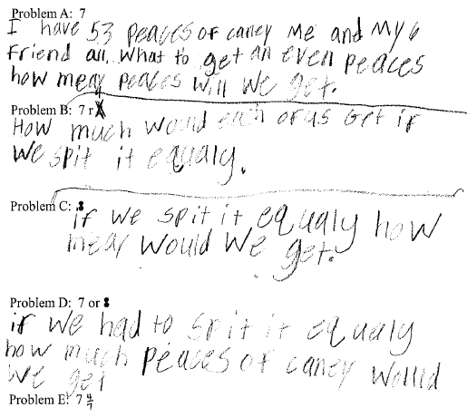

Progressing: Student is only able to create word problems for some of the answers given.
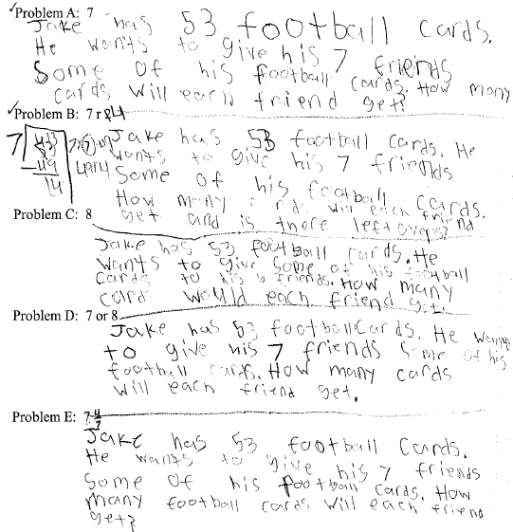

Meets Expectation: Student is able to create word problems for the various remainders shown.
