NC Mathematics Standards:
In this lesson, students will design a dog pen using grid paper and square tiles to develop concepts about fixed perimeter and varying areas.
Measurement and Data
NC.4.MD.3 Solve problems with area and perimeter.
- Find areas of rectilinear figures with known side lengths.
- Solve problems involving a fixed area and varying perimeters and a fixed perimeter and varying areas.
- Apply the area and perimeter formulas for rectangles in real world and mathematical problems.

Standards for Mathematical Practice:
  - Make sense of problems and persevere in solving them.
  - Construct viable arguments and critique the reasoning of others.

Student Outcomes:
- I can find the perimeter of a rectangle.
- I can find the missing sides of a rectangle given the perimeter.
- I can find patterns between length and width of rectangles and squares.

Materials:
- Grid paper (at least one sheet per student)
- Square tiles (at least 40 square tiles in each bag)
- Building a Pen for Your Dog problem sheet (1 copy for each student or display on board)

Advance Preparation:
- Gather materials including grid paper and square tiles.
- Copy the problem sheet (if desired).
- Consider how you will partner students.

Launch:
- Introduce Problem (5 – 10 minutes)
To interest students in the task, ask students to describe any pets they have. Ask students to describe where they keep their pets (bowls, aquariums, houses, pens, cages, etc.). Tell students that today’s task will involve designing a dog pen. Display a picture of a dog pen.

Present the follow problem to students:
My friend has a dog and she wants to build a pen for the dog to stay in while she is at work for the day. She has 24 feet of fencing to use for the pen. She wants the pen to be shaped like a rectangle. What are the possible dimensions of the pen?

Provide students with a copy of the problem or display on the board. Read the problem aloud, but avoid over-explaining or unpacking the task. Allow students to begin solving the problem in their own way to ensure that there are multiple approaches to the solution. Let students know that they can use grid paper and/or square tiles to solve the task.

Explore:
- Solving the Problem (10 – 20 minutes)
Give partner groups time to work through the problem. As students work, observe students to see how they are solving the problem.

Questions to pose:
- How are you determining the length and width for the pen?
- Is there a different way you can model your thinking?
- Do you notice a pattern between the length and width of the rectangle? If so, what is it?

Carefully select solutions you would like to share with the class. Look for solutions that modeled various dog pens using square tiles, grid paper, or drawings, found multiple solutions to the problem, and determined the pattern between the length and width of the dog pens.

Discuss:
- Discussion of Solutions (20 – 30 minutes)
Ask student groups to present their solutions. Be selective about the order you determine for each group to share their solution. It is recommended to begin with a model (using square tiles or grid paper) of one possible dog pen before moving to more abstract methods such as equations, formulas, or tables to determine the dimensions of other dog pens. Provide time for the students to justify their answers.

As different dimensions are shared, record them on grid paper or poster paper on the board. Create a T-chart to represent length and width of each dog pen.
Discuss the relationship between the length and width on the T-chart.
Questions to pose:
- What happens to the length when the width changes?
- What happens to the width as the length changes?
- Which pen do you think will be the largest for the dog? How do you know?
- How do we know when we have determined all of the possible dog pens?

The discussion should reveal the following relationships:
- Doubling the sum of the length and width equals the perimeter or half of the given perimeter must equal the sum of the length and width.
  - In the chart, the length and width always add up to 12, because that is half of the perimeter.
  - Connect to geometry (parallel sides are equivalent in rectangles and squares).

Possible Misconceptions/Suggestions:
Possible Misconceptions | Suggestions
- Students confuse perimeter and area.  - Students incorrectly calculate perimeter and area by leaving out or using the wrong dimensions. | - Continue to give students real-life examples of perimeter (fencing, baseboard of a room) and area (paint on a wall, space inside a room). Have students find real-life examples as well. Relate to various problems used in the classroom.  - Encourage students to model and/or draw figures using square tiles, grid paper, or blank paper.  - Provide students with visuals (graphics, anchor charts) to help them differentiate the two concepts.  - Have students make a drawing or model of the figure and label each dimension.  - Reinforce the idea that students’ equations and calculations need to match their drawings and representations.

Special Notes:
- This task can be done multiple times with different numbers. Students who struggle may benefit from using a perimeter of 8 or 12 or 16. Advanced students can work with larger numbers (36 or 48) and then generate a rule for determining the smallest or largest area given any perimeter.
- If the total perimeter is divisible by 4, then the shapes that can be made also include a square, which is the shape that will have the largest area.

Solutions:
For a perimeter of 24 feet possible dimensions and areas:
Length | Width | Perimeter | Area
1 | 11 | 24 | 11
2 | 10 | 24 | 20
3 | 9 | 24 | 27
4 | 8 | 24 | 32
5 | 7 | 24 | 35
6 | 6 | 24 | 36

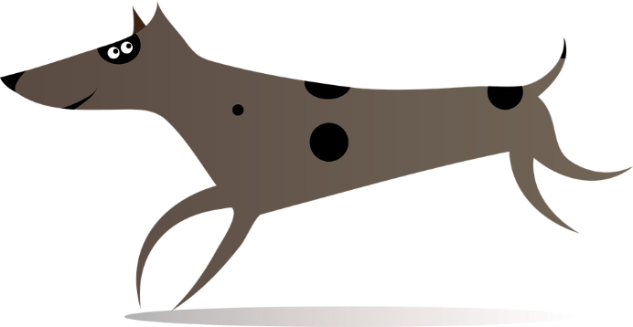
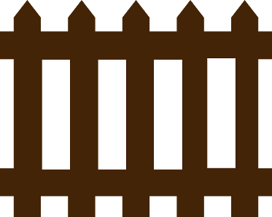
Building a Pen for Your Dog

My friend has a dog and she wants to build a pen for the dog to stay in while she is at work for the day.

She has 24 feet of fencing to use for the pen.
She wants the pen to be shaped like a rectangle.
What are the possible dimensions of the pen?

