Larry’s Dream Home
In this lesson, students find the area of rectilinear figures with known side lengths and justify which home would be the best home for Larry.

NC Mathematics Standards:
Measurement and Data
NC.4.MD.3 Solve problems with area and perimeter.
- Find areas of rectilinear figures with known side lengths.
- Solve problems involving a fixed area and varying perimeters with a fixed perimeter and
varying areas.
- Apply the area and perimeter formulas for rectangles in real world and mathematical problems.

Standards for Mathematical Practice:
1. Make sense of problems and persevere in solving them.
2. Reason abstractly and quantitatively.
3. Construct viable arguments and critique the reasoning of others.
4. Model with mathematics.

Student Outcomes:
- I can solve problems that involve analyzing perimeter and area.
- I can find the area of rectilinear figures.

Math Language:
- perimeter
- area
- dimensions
- rectilinear figures

Materials:
- student handout (1 per student)

Launch:
- Introduce Problem (5 minutes)
Present the following problem to students:
Larry Lots O’Money has dedicated his life to making money and is now ready to build his dream home. Unfamiliar with the process, he decided to seek help in determining which property is ideal for his new home. His friend, Matthew Moneymaker, showed him several properties.
Matthew Moneymaker found three properties that he feels would be ideal for Larry’s dream home. Each of the properties cost $50,000, yet they differ in size. Ideally, he wants the largest property for the cheapest cost. Which one is the best purchase for Larry?
You are Mr. O’Money’s financial advisor. Advise Mr. O’Money which property he should purchase. Justify your choice using your calculations.

- Have students predict which property they feel will be the best for Larry’s dream home and have them justify their choice. Ask students to solve the problem and represent their work so anyone that is looking at the paper can understand how they are solving the problem.

Explore:
- Solving the Problem (15 – 20 minutes)
Allow students time to work individually and then with partners in order to solve the task. As students work, observe students to see how they are solving the task. Encourage students to share their strategies with one another and describe how they are answering each question.
- Look for students who incorrectly use perimeter rather than area to determine the ideal property.
- Do students forget to calculate all of the sides of the rectangle to determine the area?
- Look for the various strategies that students use to solve the problem.
- How do students break up the rectangles in order to find the area of the rectilinear
figures?
- How do students justify which property is the most ideal?

Carefully select students to present to the class. Look for different strategies and ways that students determined the area of the rectilinear figures.

Discuss:
- Discussion of Solutions (15 – 25 minutes)
Bring the group back together and have selected students share their strategies for solving the task. Summarize the lesson by comparing the various strategies for finding the area of rectilinear rectangles. Be sure the students understand and can explain each method. Two critical strategies are:
  - Decompose the shape into two or more rectangles and find the area of each rectangle. Then find the sum of the area for all the rectangles to find the total area of the shape. This method helps students see that area is additive. It may help students if you make the connection back to creating arrays in the shape.
  - Find the area of the shape by “filling in the missing piece” of the rectilinear rectangle so it is one large rectangle. Find the area of the large rectangle. Find the area of the missing chunk of the rectangle. Subtract that smaller chunk’s area from the area of the entire large rectangle to find the area of the rectilinear shape.

Evaluation of Student Understanding:
Informal Evaluation:
- Observe and monitor students as they solve the problem. How are they making sense of the problem? What strategies do students have for finding the area of each figure?
Formal Evaluation/Exit Ticket:
- At the end of the lesson, give students a simple rectilinear rectangle with sides labeled to see if they can find the area using the methods discussed in class. (See additional resources on tools4ncteachers website for specific exit tickets for this standard.)

Possible Misconceptions/Suggestions:
Possible Misconceptions | Suggestions
- Students mix up numbers for the smaller rectangles they create when they divide the rectilinear rectangle.  - Students have trouble decomposing the rectilinear rectangles. | - Use grid paper and colored pencils to help students keep track of their numbers.  - Students need to find area of shapes with smaller side lengths using models and paper shapes to cut out the rectangles. Consider starting with two pre-cut rectangles with a given area written on each rectangle, then ask students to compose a rectilinear shape using the rectangles and find the area of the newly constructed shape. Continue using the pre-cut rectangles to compose rectilinear shapes; then ask students to decompose shapes you create with the pre-cut pieces before moving to rectilinear shapes the students cut apart to decompose into rectangles.

Solutions:
- Tarheel Ranch: 6500 square feet
- Wolfpack Manor: 7500 square feet
- Blue Devil Acres: 5600 square feet

Larry’s Dream Home Options

Option 1: Tarheel Ranch

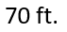
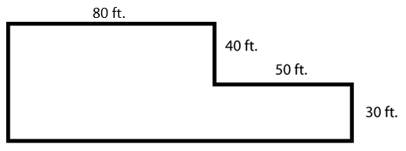
130 ft.

Option 2: Wolfpack Manor
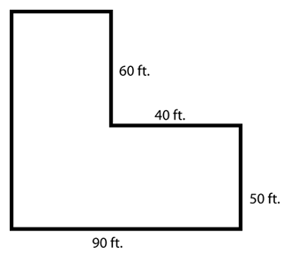
Option 3: Blue Devil Acres
