Solving Story Problems on the Open Number Line
In this lesson students use the open number and various strategies to solve story problems.

NC Mathematics Standard(s):
Represent and solve problems.
NC.2.OA.1 Represent and solve addition and subtraction word problems, within 100, with unknowns in all positions, by using representations and equations with a symbol for the unknown number to represent the problem, when solving:
  - One-Step problems:
    - Add to/Take from-Start Unknown
    - Compare-Bigger Unknown
    - Compare-Smaller Unknown
  - Two-Step problems involving single digits:
    - Add to/Take from- Change Unknown
    - Add to/Take From- Result Unknown

Additional/Supporting Standards:
Understand Place Value
NC.2.NBT.3 Read and write numbers, within 1,000, using base-ten numerals, number names, and expanded form.

Use place value understanding and properties of operations.
NC.2.NBT.8 Mentally add 10 or 100 to a given number 100–900, and mentally subtract 10 or 100 from a given number 100–900.

Standards for Mathematical Practice:
- Make sense of problems and persevere in solving them.
- Reason abstractly and quantitatively
- Construct viable arguments and critique the reasoning of others
- Model with mathematics
- Use appropriate tools strategically

Student Outcomes:
- I can use a number line to represent addition and subtraction word problems.
- I can solve addition and subtraction word problems using strategies related to place value.
- I can communicate how I solved problems to my teacher and classmates.

Math Language:
What words or phrases do I expect students to talk about during this lesson?
Addition, Count, Count On, Group, Hundreds, Ones, Subtraction, Tens

Materials:
- Ten Strips, Activity Sheet, Base ten blocks

Advance Preparation:
- Gather materials

Launch:
Patterns in Two-Digit Numbers (8-10 minutes)
Use ten strips, ten frames or base ten blocks to have students count by tens.

For example:
Start by displaying 4 ones. Ask students to count with you (4). Add a ten, students should say 14.
Continue to add tens and have students count on (24, 34, 44, 54).

Do this for 3-4 different start numbers. A student can record the numbers on the board. Ask students, “what do you notice about the numbers that we counted?”
Emphasize that when we add 10, the digit in the ones place stays constant, but the digit in the tens changes by 1.

Repeat with a few different start numbers.

Possible Extension by Subtracting Backwards
Start with a large two-digit number such as 91.
Remove tens and have students count backwards by tens (81, 71, 61, etc.).

Explore
Exploring the Open Number Line (20-25 minutes)

Explain to students, “We are going to use counting by tens to help us solve story problems.”
Display an open number line on the board. Start at 4 and make hops of 10. Relate this to the counting they did with the ten strips (or ten frames.) The teacher can model this for several different start numbers. One way to model this is to have a students display strips as the teacher marks counting on the number line.

Note: An open number line is just an empty line used to record children’s addition (and later subtraction) strategies. Only the numbers children use are recorded and the addition is recorded as leaps or jumps. For example, if a child’s strategy for adding 18 + 29 is to keep 29 whole and decompose the 18 into smaller pieces, the jumps on the open number line would be to start at 29, jump 10 to 39 and then jump 8 more to 47. Another strategy is moving to a landmark or friendly number of 30. Since the jump from 29 to 30 was a jump of 1, the student needs to still jump 17 more from 30, which gets them to 47. Those jumps on the number line can be written as: 29+1+10+7= 47.
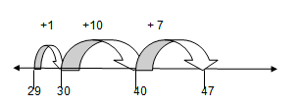
Display a story problem and read it aloud. You can change this problem to include names of students in the class. Feel free to change the numbers if the students in class need smaller/larger numbers. Easier problems have high numbers in the ones place (7, 8 or 9) so that it is easier to jump to a multiple of 10.

Part 2: Another Story Problem
Tom and his mom are driving to the zoo. It is 75 miles away. They have already driven 36 miles. How many more miles do they have to drive? (This is an Add to, Change Unknown problem— refer to the attached table from the Common Core for examples of various problem structures.)

Have students pair-share (talk with a partner) about what the problem is asking and how they would solve it. After about 1 minute ask students to share their thoughts with the class.

Ask, “What is the problem asking?” and “How would you solve it?”

Ask, “How far away is the zoo?” Students should say 75 miles. On a number line mark 0 and mark 75. Ask, “How far have they gone already?” Students should say 36. On the number line mark 36.
Ask, “What do we need to find?” Students should talk about finding how far 36 is from 75.

If students struggle guide them with the following questions, “Should our answer be more than or less than 75? Why?”
You could also have a student act the problem out by walking in front of the classroom.

Have students share how to solve the problem. Examples of strategies:
Start with 36 and count up until you get to 75. If a number line is posted in the class the teacher could have a student start at 36 and have the class count up by ones to 75. Keep track of the count with tally marks. If there is not a number line have the class count up to 75 and keep track with tally marks. In this lesson you want students to realize that this is not a very efficient method for solving the problem.

Draw an empty number line (horizontal line). Explain that is a new tool for solving problems. Include an arrow on either end to show that the number line continues indefinitely in both directions. Place a point on the number line labeled 36. Remind them about how they are counting by tens and how this is a way to count to 75 without saying all the ones. Record the jumps of ten saying, “36, 46, 56, 66, 76— oops that too far. I’ll go back to 66. How should I hop to 76?” Some students may suggest going by ones. Say, “OK 67, 68, 69, 70, 71, 72, 73, 74, 75.”
Record each number beyond 66 as individual hops.
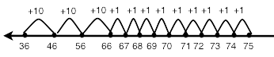

After recording on the number line ask, “How will this (referring to the number line) help us know how far they have to drive to the zoo?” Have students come up to the number line and show the hops and how to determine the answer.

Another approach could be:
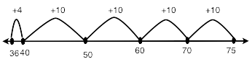

After recording the number line ask, “How will this help us know how far they have to drive to the zoo?” Have students come up to this number line and show how to use it to determine the answer.

Questions to ask?
How much farther did Tom and his mom have to drive to get to the zoo? How do you know? Show us on the number line.

There are multiple ways to jump on the number line from 36 to 75. Other suggestions may be: 36 to 46 to 56 to 66 to 76 and then subtract 1 (36 + 10 +10 +10 +10 -1)
36 to 40 to 50 to 60 to 70 to 75 (+4 +10 + 10 +10 +5)
36 to 66 to 70 to 75 (+30 +4 + 5)

Ask, “How are these strategies similar or different?” Possible responses on how they are alike: They all jump by tens.
They start at 36 and end at 75.

Possible responses on how they are different:
One starts at 36 and jumps to a “friendly” number 40 and then jumps by tens. One makes bigger jumps (40).

After a student has shared what the problem is asking, the teacher asks students to think of an equation that they could write for the problem that they just solved.
36 + _____= 75.

Ask, “What does the blank mean in this equation?” Answers might include: “It’s the part you figure out. It’s the answer. You have to solve 36 plus what equals 75.”

Part 3: One More Story Problem

Maria and John are going to the beach. It is 68 miles away. They have already driven 31 miles. How many more miles do they have to drive?

Ask, “What equation would represent this story.” 31 + ____ = 68.

Some students may know that you can subtract to solve this problem 68-31 = ___.

Draw an open number line on the board.
Ask, “How can we use the number line to solve the problem? Pair-share for a minute.” After pairs have discussed how to solve it. Have them work the problem, using a number line, on a white board or notebook paper.

As they are solving the problem, observe students. Look for students who:
  - know to start at 31.
  - know how to jump by tens and label the number line.
  - know how to jump by tens but do not label the number line.
  - “hop” up the number line by ones.
  - are not making the connection of how to use the number line to solve the problem.
  - see this as a subtraction problem. Can they start at 68 and hop backwards to 31?

As you observe, choose the strategies that you want shared.
Discuss
Discussion of Strategies Used to Solve Story Problems (8-10 minutes)
After students have had a few minutes to solve the problem ask students to share their strategies: Show the strategies on the board that are given by the students. Let students draw the number lines or have them use the document camera to show their work.

After 2-3 different ways of using the number line are given ask: How are these two ways alike?
How are they different?
How are we using what we know about counting by tens to work on the number line?

Note: The class discussion is critical to helping students build an understanding of how place value can be used to solve addition and subtraction problems. The open number line is a tool for students to use their knowledge of adding multiples of 10 and 100 to solve a problem. Sharing strategies and having students compare them helps students become more fluent in using place value understanding and properties of operations to add and subtract.

Additional Activities (20-30 minutes)
More Story Problems
After sharing strategies have students complete the activity sheet Solving Problems Using a Number Line.

The teacher can have students work independently on the worksheet or work with their Think-Share partner to solve the tasks.
As the students are working look to see:
- Do students know where to start on the number line?
- Do students accurately jump by tens and label the number line correctly?
- Do students know how to decompose a one-digit number to make jumps of 1 that land on a landmark (number that ends in a zero)?
- Can students tell you how to use the number line to find the answer?
- Do students see tasks as subtraction tasks?

Create and Solve Your Own Story Problems
Students need primary number cards. Students select two primary number cards and make a two-digit number (3 and 6 could be 36 or 63). Students then put that number into a story problem and choose whether they will add or subtract the numbers.

I had __ pieces of candy and my friend (gave me/ gave away) 20 more. How many do I have now? (62 + 20 or 62 - 20).

Students solve several problems that involve adding and subtracting multiples of ten to help students connect this game and the ten strips or base ten blocks to adding and subtracting multiples of ten in a story problem. Have students make a representation of the problem in their math journal or on a whiteboard.

Depending on the time of year, students may be ready to add and subtract hundreds or tens from a three-digit number. Students would draw 3 number cards instead of 2 for this activity and put the number within the context of a word problem. Use Table 1 (attached to this lesson) for examples of problem types.

Building Three-Digit Numbers
Give students primary number cards and base ten blocks. Students pick two number cards and make a two-digit number: a 5, a 4, and a 3 could be 543, 534 or other possible numbers. Students then build those three-digit numbers with base ten blocks, record the number and a picture of the blocks. They continue to do this during the center.

Hundreds Board Bingo
Students use primary number cards and a hundreds board. Students pick two number cards, make a two-digit number, and then cover the number up on the hundreds board with a game piece. The goal is to cover up 5 consecutive numbers- vertical, horizontal, or diagonal.

Evaluation of Student Understanding
Informal: Checked through questioning during the lesson. Also formative assessment is done while students are working on the worksheet. As students are working questions to ask are;
- Why did you start here?—pointing to the number line.
- Where will you stop on the number line?
- What is the problem asking?
- How can you use the number line to find the answer to the question?

Formal: The student worksheet will be used to evaluate their initial understanding of jumping on the number line to solve the problems.

The activity sheet provides you with data on students’ understanding about using the open number line. It is normal for students to struggle with the strategy the first few times they use it. Additional lessons and tasks should be given to help students further develop understanding of this method.

We suggest using data from worksheets and observations to plan future lessons.
Do students need to work with smaller numbers to get use to using the number line?
Is it clear that some students understand this strategy and others are struggling? If so, the lesson tomorrow could be a brief overview of this method and then divide the class into groups.

Meeting the Needs of the Range of Learners
Intervention: Students who do not understand how to use the number line may use a 100 board to solve the problem. Have them start at the beginning number and move to the ending number. Observe if they move by ones or by tens? This can be related to the game, “Plus-Minus Stay the Same.”

If the numbers seem too large change the numbers in the problem so they only have to move one ten and a few ones. If they then move on the number line by ones show them a jump of ten for the ten ones.

Students could use ten sticks and ones (lesson 1) to solve the problem. The teacher could help them see the relationship between the ten sticks/ones and the open number line.

Extension: Some students will be able to make jumps larger than ten—larger multiples of ten. Ask, “How would you record your moves?
Other students will understand that they can move in tens beyond the targeted number and then subtract. For example, when determining how far 56 is from 92 a student may make 4 jumps of 10 or a move of 40 and then subtract 4. Ask, “How would you record your moves on the number line?”

Possible Misconceptions/Suggestions:
Possible Misconceptions | Suggestions
Students may struggle adding or subtracting by multiples of 10. | Work with smaller numbers (50 or less) and provide them with base ten blocks or ten frame cards to support their work.
Students may struggle determining whether to add or subtract. | Students need concrete objects such as base ten blocks or ten strips. Use smaller numbers and have students discuss with classmates and you about the action of the problem to determine whether they should add or subtract.

Name

Solving a Problem Using a Number Line

Solve each problem. Use a number line to help you solve the problem.
- Kyle and his mom are driving to the mountains. The mountains are 82 miles away. They have already driven 38 miles. How many more miles do they have to drive?

- Teresa wants to buy a video game that costs 56 dollars. She has saved 29 dollars. How much more money does she need to save?

- Elijah had 47 baseball cards. He got some more baseball cards for his birthday. Now Elijah has 88 baseball cards. How many baseball cards did Elijah get for his birthday?

Ten Strips

Hundreds Board
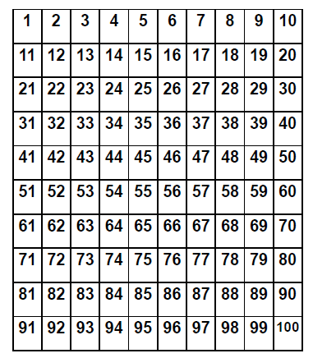

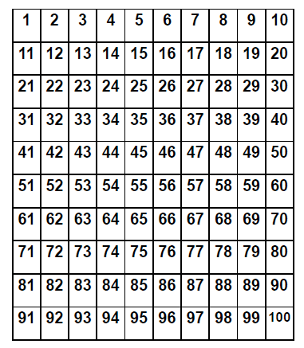

Name ______________________________

Solve each problem and show how you solved it. Use numbers, pictures or words to explain your strategy.

- I saw (15, 67, 145) butterflies in the garden. (10, 20, 100) joined them. How many butterflies are now in the garden?

- My class took a walk to collect leaves. The children collected (18, 41, 117) leaves. The teacher collected (10, 30, 100) more. How many leaves were collected?

- Our class is collecting money for our field trip. On Monday we collected (25, 66, 131) dollars. On Tuesday we collected (10, 20, 50) dollars. How much money have we collected?

- Wow, yesterday I went to the State Fair! I saw (16, 72, 278) cows. Then I saw (10, 20, 40) chickens. How many animals did I see?

Name ______________

Solve each problem and show how you solved it. Use numbers, pictures or words to explain your strategy.

- (15, 45, 121) bunnies were sitting in the grass. Some more bunnies hopped there. Then there were (25, 65, 141) bunnies. How many bunnies hopped over to join the bunnies in the grass?

- My mother and I were collecting seashells. We collected (13, 66, 179) seashells on Monday. On Tuesday we collected some more. Then we had (23, 86, 199) seashells. How many seashells did we collect on Tuesday?

- My basketball team scored (13, 41, 61) points in the first half. During the second half we scored more points. At the end of the game we had (33, 71, 101) points. How many points did we score in the second half?

Name ______________

Solve each problem and show how you solved it. Use numbers, pictures or words to explain your strategy.

- Our class is raising butterflies. On Monday (12, 34, 129) butterflies emerged from their chrysalises. Then on Tuesday some more hatched. We now have (32, 54, 149) butterflies flying in the butterfly house. How many butterflies hatched on Tuesday?

- We were observing our tadpoles. We had (18, 65, 234) tadpoles. Then Tom brought (20, 30, 50) more to our class. How many tadpoles do we have now?

- We collected (20, 78, 231) seashells in the morning. During the afternoon we found some more seashells. Now we have (50, 98, 291) seashells. How many did we find in the afternoon?

- There were (21, 45, 92) children on the playground. Then (20, 40, 30) more children ran to the playground. How many children are now on the playground?

Glossary, Table 1. Common addition and subtraction situations.1
 | Result Unknown | Change Unknown | Start Unknown
 | Two bunnies sat on the grass. | Two bunnies were sitting on | Some bunnies were sitting on
 | Three more bunnies hopped | the grass. Some more | the grass. Three more
 | there. How many bunnies are | bunnies hopped there. Then | bunnies hopped there. Then
Add to | on the grass now? | there were five bunnies. | there were five bunnies. How
 | 2 + 3 = ? | How many bunnies hopped | many bunnies were on the
 |  | over to the first two? | grass before?
 |  | 2 + ? = 5 | ? + 3 = 5
 | Five apples were on the table. | Five apples were on the | Some apples were on the
 | I ate two apples. How many | table. I ate some apples. | table. I ate two apples. Then
Take from | apples are on the table now? 5 – 2 = ? | Then there were three apples. How many apples did | there were three apples. How many apples were on
 |  | I eat? | the table before?
 |  | 5 – ? = 3 | ? – 2 = 3
 | Total Unknown | Addend Unknown | Both Addends Unknown2
 | Three red apples and two | Five apples are on the table. | Grandma has five flowers.
 | green apples are on the table. | Three are red and the rest | How many can she put in her
Put Together/ Take Apart3 | How many apples are on the table?  3 + 2 = ? | are green. How many apples are green?  3 + ? = 5, 5 – 3 = ? | red vase and how many in her blue vase?  5 = 0 + 5, 5 = 5 + 0
 |  |  | 5 = 1 + 4, 5 = 4 + 1
 |  |  | 5 = 2 + 3, 5 = 3 + 2
 | Difference Unknown | Bigger Unknown | Smaller Unknown
 | (“How many more?” version): | (Version with “more”): | (Version with “more”):
 | Lucy has two apples. Julie has | Julie has three more apples | Julie has three more apples
 | five apples. How many more | than Lucy. Lucy has two | than Lucy. Julie has five
 | apples does Julie have than | apples. How many apples | apples. How many apples
 | Lucy? | does Julie have? | does Lucy have?
Compare4 | (“How many fewer?” version): | (Version with “fewer”): | (Version with “fewer”):
 | Lucy has two apples. Julie has | Lucy has 3 fewer apples than | Lucy has 3 fewer apples than
 | five apples. How many fewer | Julie. Lucy has two apples. | Julie. Julie has five apples.
 | apples does Lucy have than | How many apples does Julie | How many apples does Lucy
 | Julie? | have? | have?
 | 2 + ? = 5, 5 – 2 = ? | 2 + 3 = ?, 3 + 2 = ? | 5 – 3 = ?, ? + 3 = 5

2These take apart situations can be used to show all the decompositions of a given number. The associated
equations, which have the total on the left of the equal sign, help children understand that the = sign does not always mean makes or results in but always does mean is the same number as.
3Either addend can be unknown, so there are three variations of these problem situations. Both Addends Unknown
is a productive extension of this basic situation, especially for small numbers less than or equal to 10.
4For the Bigger Unknown or Smaller Unknown situations, one version directs the correct operation (the version
using more for the bigger unknown and using less for the smaller unknown). The other versions are more difficult.

1Adapted from Box 2-­‐4 of Mathematics Learning in Early Childhood, National Research Council (2009, pp. 32, 33).

Plus-Minus Stay the Same

Materials
100 chart to share between 2 players
Deck of numeral cards 1-9, four of each numeral Distinct markers for each player

Players: 2

Directions
- Decide which player will go first. The first player chooses 2 numeral cards from the deck. Determine which card is the tens digit and which card is the ones digit. For example, if 2 and 4 are drawn the player can use these cards as 24 or 42.

- Player one must decide whether to add 10 to this number, subtract 10 from this number or keep the number the same. After the decision is made, player 1 covers the number on his/her chart. For example, if the player decides to use 42 the player can cover 42, 32, or 52.

- Player two chooses two numeral cards from the deck, determines the number, and decides whether to add 10 to the number, subtract 10 from the number or stay with the number. Player 2 covers the number on the 100 chart.

- Players continue to play.

- The winner is the first player to cover 3 numbers in a row. Rows can be vertical, horizontal or diagonal. Players can try to cover 4 or 5 numbers in a row.

The Game of Tens and Ones

Materials
100 chart or 0-99 chart one per pair of students 2 game markers
Spinner (or die) labeled +10, +10, -10, -10, +1, -1

Directions
- Each player places a marker on the zero (or off the board if using a 100 chart) the 0-99 chart. Players take turns spinning.
- Player One spins and moves a marker according to the roll.
- Player 2 checks the move and agrees.
- Player 2 follows the same steps as Player 1.
- The winner is the first person to move his or her marker to 99 (or 100 if using the 100 chart).
- Players can record number sentences to match the moves.
§▪ Example: Player 1 spins +10 and moves to the 10 place.
§▪ She records 0 + 10=10. On the next move she spins +1 and records 10+ 1 = 11.

Version 2
Players do not have to land exactly on 99 (or 100) to win the game. Play the game until time is up. The winner is the person who has landed on the larger number.

Version 3
Players play on a 200 or 300 chart. Start at 100 or 200.

Adapted from : www.mathsolutions.com Marilyn Burns Education Associates.

Spinner for The Game of Tens and Ones
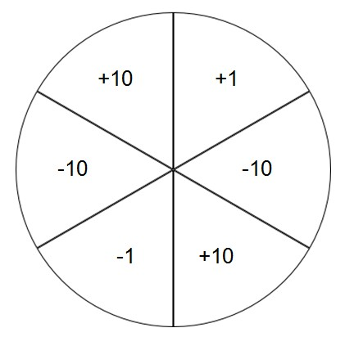

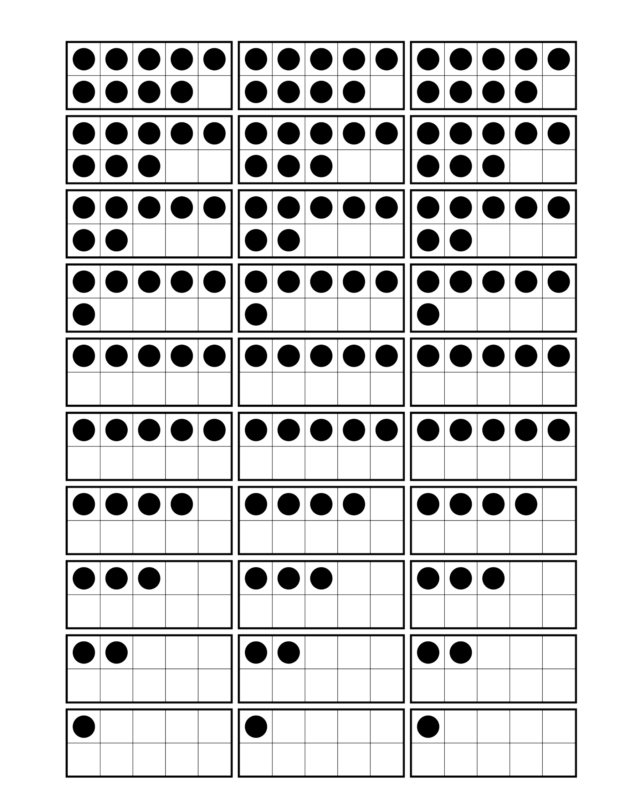

Primary Number Cards

0 | 1 | 2 | 0 | 1 | 2
3 | 4 | 5 | 3 | 4 | 5
6 | 7 | 8 | 6 | 7 | 8
9 | 0 | 1 | 9 | 0 | 1
2 | 3 | 4 | 2 | 3 | 4

5 | 6 | 7 | 5 | 6 | 7
8 | 9 | 0 | 8 | 9 | 0
1 | 2 | 3 | 1 | 2 | 3
4 | 5 | 6 | 4 | 5 | 6
7 | 8 | 9 | 7 | 8 | 9

