Two-Digit Multiplication: Beginning Lesson
In this lesson, students decompose, or break apart, two-digit numbers (12 and 14) with various models to more easily multiply the two numbers. The distributive and associative properties will be introduced during this lesson.

NC Mathematics Standards:
Numbers and Operations in Base Ten
NC.4.NBT.5 Multiply a whole number of up to three digits by a one-digit whole number and multiply up to two two-digit numbers with place value understanding using area models, partial products, and the properties of operations. Use models to make connections and to develop the algorithm.
Standards for Mathematical Practice:
1. Make sense of problems and persevere in solving them.
3. Construct viable arguments and critique the reasoning of others.
4. Model with mathematics.
6. Attend to precision.

Student Outcomes:
- I can develop strategies for multiplying that involve breaking apart numbers and using the distributive property.
- I can represent a multiplication problem with pictures, diagrams, or models.

Language:
- decompose
- array
- multiply
- distributive property

Materials:
- presentation slides
- paper/pencil
- snap cubes or color tiles
- grid paper
- large grid poster paper

Launch
- Introduce Problem (10 minutes)
Ask students if they are familiar with the Guinness Book of World Records. Using the slide presentation, show students several examples of world records included in the Guinness Book of World Records. (Ex. tallest people, animals, and snowwoman.) Point out that eating records are also set, based on the amount of food eaten or the fastest time to eat or drink an item. Show several pictures and records. (Guinness Records: http://challengers.guinnessworldrecords.com/challenges)
Show students a video of a person eating a pizza in 41.31 seconds. You Tube - World’s Fastest Time to Eat a 12” Pizza: https://www.youtube.com/watch?v=8fsCMJqocho

Introduce the problem to students.
Furious Pete set a new world record by eating a large pizza in one minute. If a large pizza contains 12 slices, how many slices would Furious Pete eat in 14 minutes, if he continues eating pizza at the same rate?

Explore:
- Solving the Problem (15 – 20 minutes)
Give students time to work individually and with a partner to solve the problem. Encourage students to share their strategies with one another and describe how they are solving the problem. As students work, observe to see how they are solving the problem.
Observe:
- How are students interpreting and understanding the problem?
- How are students modeling and representing their thinking?
- How do students make sense of the numbers and context of the problems?
- What strategies do students use to solve the problem? (visual models including pictures or arrays, breaking apart 12 or 14, manipulatives using tiles, repeated addition, skip counting)
Questions for students:
- Can you represent the problem a different way (using arrays, tiles, or cubes)?
- Can you break apart 14 x 12 into easier problems to solve?

Carefully select students to present to the class. Look for students who modeled the problem in different ways that demonstrate reasoning and understanding. Also, look for students who broke apart the numbers in different ways (using the distributive property).

Discuss:
- Discussion of Solutions (15 – 25 minutes)
Bring the group back together and have the selected students share their strategies for solving the first problem.
Possible points to address:
- Discuss how students are making sense of the problem and understanding the operation of multiplication.
- Discuss various modeling strategies (particularly those strategies that focus on breaking apart 12 and 14).
- Compare different ways to break up 12 x 14 and model using arrays. Connect to the distributive property.

Summarize today’s lesson by focusing on the distributive property and the strategies that students used to solve the problems. Have students share what they have learned about multiplication.

Evaluation of Student Understanding:
Informal Evaluation:
- Observe and monitor students as they solve the problem. How are they making sense of the problem?
Formal Evaluation/Exit Ticket:
- At the end of the lesson, ask students to solve the following problem:
Marshmallow Matt set a world record by eating 18 marshmallows in one minute. How many marshmallows would Matt eat in 15 minutes?

Possible Strategies for Multiplying Two 2-digit Numbers:
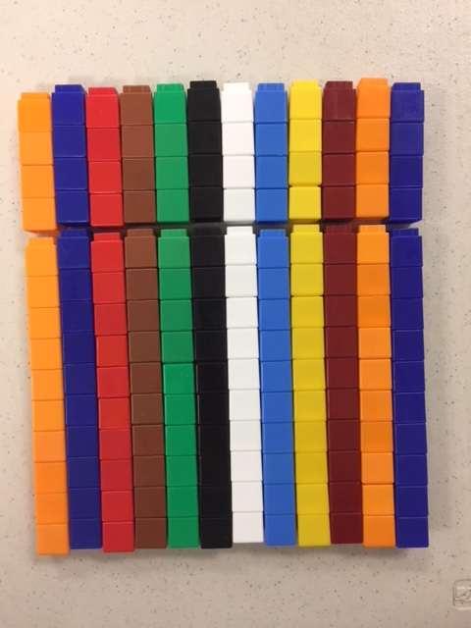  Model shows 12 groups of 14 cubes. The 14 cubes are separated slightly to easily show 1 ten and 4 ones for a total of 14, but each tower could also be put into one tower of 14. | 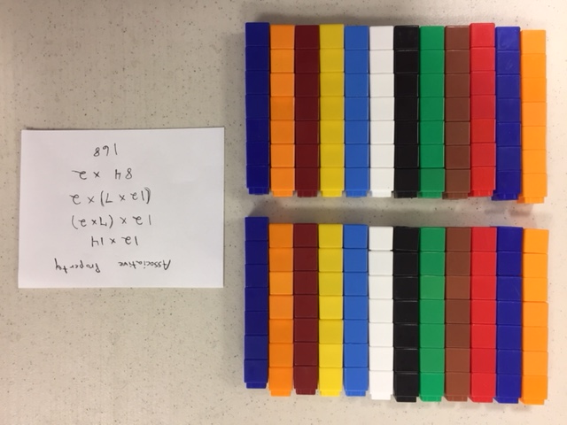  Associative property showing 2 groups each with 12 groups of 7 cubes. The 14 cubes were decomposed into 2 groups of 7 showing the associative property: 12 x (7 x 2).
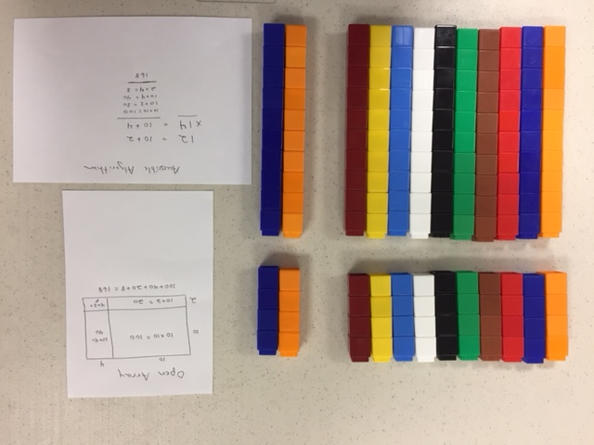  Model of the open array and partial products for an accessible algorithm. The top left shows 4x10; the top right shows 4x2; the bottom left shows 10x10; and the bottom right shows 10x2. | 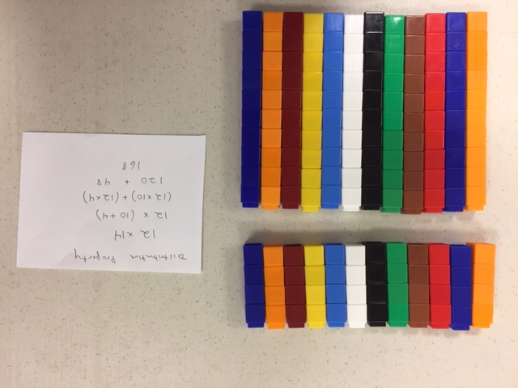  Distributive property showing 12 groups of 10 and 12 groups of 4. The 14 cubes were decomposed into 10 cubes and 4 cubes showing the distributive property: 12 x (10 + 4).

