NC Mathematics Standards:
In this lesson, students will estimate and solve multi-step word problems to develop multiplication concepts.
Operations and Algebraic Thinking
NC.4.OA.3 Solve two-step word problems involving the four operations with whole numbers.
- Use estimation strategies to assess reasonableness of answers
- Interpret remainders in word problems.
- Represent problems using equations with a letter standing for the unknown quantity.

Additional/Supporting Standards:
NC.4.NBT.4, NC.4.NBT.5, NC.4.NBT.6 Use place value understanding and properties of operations to perform multi-digit arithmetic.

Standards for Mathematical Practice:
1. Make sense of problems and persevere in solving them.
2. Reasons abstractly and quantitatively.
4. Models with mathematics.
5. Uses appropriate tools strategically.
6. Attends to precision.

Student Outcomes:
- I can make reasonable estimates with two-step story problems.
- I can solve two-step problems using a variety of strategies.
- I can justify my reasoning for estimating and solving problems.

Materials:
      - Task cards (1 set per group of 3-4 students)
      - Student journals, blank or graph paper, or individual white boards and markers

Advance Preparation:
      - Decide how to make groups of 3-4 students for the small group part of the lesson.
      - Display story problems on the board or copy on individual sheets for students.
      - Cut apart and bag a set of task cards for each student group.

Launch:
- Introduce the problem (5 minutes)
Present the problem to students. Display on the board or give each student a copy of the problem. Ask students to mentally estimate the total number of popcorn bags and then solve the problem to find the total.
Problem:
The class filled bags of popcorn for the school’s Fall Carnival. Mary filled 3 bags of popcorn. Thomas filled 9 times as many bags as Mary. Amy filled 5 times the amount of bags as Thomas. What is total number of popcorn bags that have been filled?

Explore:
- Solving the Problem (10 – 15 minutes)
Allow students time to work independently to mentally estimate the total number of popcorn bags and solve the problem to find the exact answer using a strategy that makes sense to them. Allow students time to share their strategies and solutions with a partner. Select students to share different methods of mental computation and strategies for solving this problem.

Possible Estimation Strategies:
Example 1:
- 3 x 10 = 30 (Thomas has about 30 bags)
- 30 x 5 = 150 (Amy has about 150 bags)
- 150 + 30 + 0 = 180 (I did not add Mary’s bags since it was just 3)

Example 2:
- 3 x 9 = 27 (I know 3x9 is 27 so Thomas has 27 bags. 27 is close to 30)
- 30 x 5 = 150 (Amy has about 150)
- 150 + (30 + 3) = 183 (I added Mary’s 3 bags to Thomas’ total so they have about 183 bags.)

Discuss:
- Discussion of Solutions (15 – 20 minutes)
During a whole class discussion, ask several students with different strategies to share their thinking using a document camera or white board.
- Compare strategies. How are they alike? How are they different?
- Make connections with the estimates. How did estimating first help with solving the problem?

Additional Practice:
- Present a second problem for students to estimate mentally:
Ryan, Sally, and Jordan are going to trade baseball cards. Ryan has 43 cards. Sally has twice as many at Ryan. Jordan has 50 more cards than Ryan and Sally have together. How many cards are available to trade?
- Repeat steps 1-3.

Small Group Work:
- Divide the class into groups of 3-4 students to play “Show Down” in each group.
- One student in each group is the leader. This student has a set of problem cards.
- The student leader shows and reads a problem card to the group.
  - Individually, students write an estimate to the problem on either a small white board or journal page (keeping the estimate to themselves).
- When all students are ready, the student leader says “Show Down” and all students in the group show their estimates.
  - The student leader has each group member explain how they arrived at their estimate.
- Once all in the group have shared, the student leader has the group solve the problem by finding the exact answer.
- When all are finished, the student leader says “Show Down”. Students show their strategy for solving the problem.
- The group discusses the correct answer and strategies.
- Change the student leader in each group for each new problem so that every student in the group has a chance to be the leader. Repeat steps 6-7 for each new problem.

Questions to Pose:
As students work individually or with small groups:
- Can you describe your method? Can you explain why it works?
- How did you get your answer?
During whole group discussion:
- How does your strategy relate to…?
- Why did you decide to use this method?
- Do you think this strategy will work with other numbers?

Discussion Teacher Note: Ask students to talk about estimation strategies that helped them to get close to the solution. Be sure to press students on whether they used the same strategy with all problems or if their strategy changed with different numbers. Refer to the Estimation Strategies Document in Cluster 3, if needed.

Possible Misconceptions/Suggestions:
Possible Misconceptions | Suggestions
- Students have difficulty estimating a two-step problem.  - Students have difficulty solving two-step problems. | - Students practice estimating with one step problems.  - If students can solve one-step problems, help them break the two-step problems into the two separate steps.  - If students struggle with one-step problems, practice solving one-step problems guiding them to use problem solving strategies such as visualizing, making sense of the problem, drawing, etc.

Solutions:
Problem | Possible Estimates | Solution
Whole class problem 1 | 160-190 | 165 bags of popcorn
Whole class problem 2 | 290-320 | 308 baseball cards
Task 1 | 300-360 | 346 books
Task 2 | 4000-4300 | 4200 people
Task 3 | 50-60 | 56 blocks
Task 4 | 20-30 | 25 cans

Multi-Step Multiplication
Problem 1:

The class filled bags of popcorn for the school’s Fall Carnival.

Mary filled 3 bags of popcorn. Thomas filled 9 times as many bags as Mary. Amy filled 5 times the amount of bags as Thomas.

What is total number of popcorn bags that have been filled?

Multi-Step Multiplication
Problem 2:
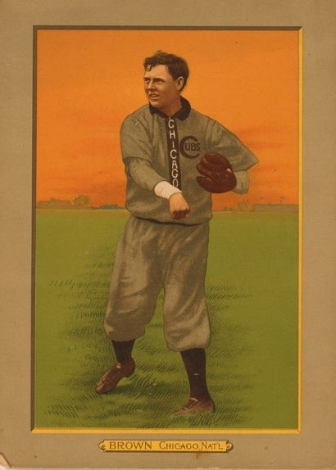
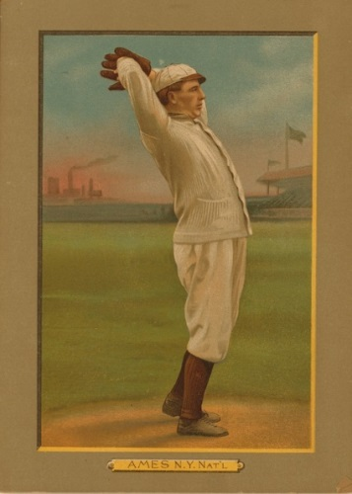
Ryan, Sally, and Jordan are going to trade baseball cards. Ryan has 43 cards. Sally has twice as many at Ryan. Jordan has 50 more cards than Ryan and Sally have together.

How many cards are available to trade?

Show Down Task Cards

We are trying to buy more books for our school library. Currently, the library has 286 books.  If the librarian buys 12 books each month for the next five months, how many books will the library have in all? | On Friday, 1,050 people visited the zoo. Three times as many people visited on Saturday than on Friday.  How many people visited the zoo on Friday and Saturday?
Mya walks her dog every day. First, she walks 7 blocks to the park. Then she walks 9 blocks to the elementary school. Finally, she walks 12 blocks to get back home. Mya walks her dog 2 times each day.  How many blocks does Mya's dog walk each day? | Julian bought 9 packages of cat food and 5 packages of dog food. Each package of cat food contained 5 cans, and each package of dog food contained 4 cans.  How many more cans of cat food than dog food did Julian buy?

