Play Area Plan
In this lesson, students will design a play area by dividing it into four sections. Students will decompose the total play area into parts by decomposing the length and width measures. Students will connect their drawing to the partial products strategy and area model for multiplication.

NC Mathematics Standards:
Number and Operations in Base Ten
NC.4.NBT.5 Multiply a whole number of up to three digits by a one-digit whole number, and multiply up to two two-digit numbers with place value understanding using area models, partial products, and the properties of operations. Use models to make connections and to develop the algorithm.
Measurement and Data
NC.4.MD.3 Solve problems with area and perimeter.
- Find areas of rectilinear figures with known side lengths.
- Solve problems involving a fixed area and varying perimeters with a fixed perimeter and varying areas.
- Apply the area and perimeter formulas for rectangles in real world and mathematical problems.

Standards for Mathematical Practice:
1. Make sense of problems and persevere in solving them.
2. Reason abstractly and quantitatively.
3. Construct viable arguments and critique the reasoning of others.
4. Model with mathematics.
6. Attend to precision.
8. Look for and express regularity in repeated reasoning.

Student Outcomes:
- I can find decompose a rectangle into parts. I can combine the areas of each part to find the total area.
- I can relate the decomposition of the rectangle to decomposing factors to multiply.
- I can decompose factors to multiply numbers.

Math Language:
- factor
- product
- area
- decompose
- perimeter

Materials:
- chart paper
- student handout (1 per student)
- graph paper
- meter sticks
- calculators

Launch:
- Introduce Problem (10-15 minutes)
Tell students that today they will be designing a play area for the school’s new playground. You may want to have students read some information about playground planning from one of the links below or you share the information you think is important.
https://www.dodea.edu/edSpecs/upload/4-6c-E-Outdoor_Play_Areas-ES-MS.pdf
https://playgroundideas.org/10-principles-of-playground-design/

Distribute the student handout and read the task aloud to the students. Draw a model of the play area with the fence dividing the space so that students understand the fence needs to remain as they work to divide their subsections. Make sure that students are able to articulate what the task is asking them to do (divide the original space into four rectangular sections and then find the area of each individual section). They may want to highlight what they need to remember while they are working. During task introduction, remind students to consider which of the required sections of the playground might need to be larger. Remind them that their section measurements should also be reasonable. For example, it would not make sense to have a K-2 playground area that had a width of only was only 3 meters. (You may need to show students meter sticks so that they can visualize the size.)

Note: Students will have background on how to find the area of a figure from Cluster 1, but may need calculators to multiply some of the larger numbers of their subsections. The goal of this lesson is to focus on the decomposition of the rectangle into parts and understanding the area model rather than the calculations of the numbers.

Explore:
- Solving the Problem (30-40 minutes)
Have students work in partners or small groups to solve the task. Groups may choose to use grid paper or draw their play area designs on chart paper.
Observe:
- Are students’ subsection measurements reasonable?
- Are the subsections divided into rectangles?
- Are students attending to the all of the criteria of the task?
- How are students determining the area of the subsections? What strategies/tools are students using?
- Are students using the calculator and the application of the area formula to determine the area of the subsections?

While students are working, make notes of how students are decomposing the rectangles and how the two factors are broken into parts.

Discuss:
Part I: Gallery Walk (15 – 20 minutes)
Hang or display each group’s design after students have decomposed the rectangles and found the areas of the subsections. Have students take a gallery walk to observe other groups’ work. As they rotate, have them discuss how the other designs are similar or different to their own. You may want to have students divide their paper into sections so that they can jot notes about each group’s work.

Part II: Discussion (15-20 minutes)
Have students gather and share what they noticed about the playground designs during the gallery walk.
Possible Points to address and questions to ask:
- How many different ways were the “play areas” divided? At this point, as you discuss you may want to record in equation form the different ways that the length was decomposed in a chart:
Length (99 m) | Width (66 m)
45 m + 54 m | 33 m + 33 m
- How did the total area(s) found compare? (They should all be the same and it may be that you want to highlight use of calculator for precision at this point in the lesson.)
- Discuss how different groups found the total areas. Each subsection’s length and width were multiplied and then all of the sub-areas were added together to find the total area.
- Show complete equation on the board:
(45 x 33) + (45 x 33) + (54 x 33) + (54 x 33)
- Make sure to show where each “part” comes from by connecting to the model.
- Which play area design was most reasonable and might be selected by the PTO? Why do you think so?
- If we wanted to use this model to multiply most efficiently, without worrying about the sizes of the play area sections, how could we decompose 99. (90 + 9)

Evaluation of Student Understanding:
Informal Evaluation:
- Give students another couple of equations: 42 x 55 and 18 x 25. Have students think about how they might decompose each factor to make these easier to solve. Have them to draw an area model to match.
Formal Evaluation/Exit Ticket:
  - Exit Ticket: Mirian’s house is 82 meters long and 63 meters wide. Find the total area of Mirian’s house. (Students may use calculators at this point if needed, since the focus of the lesson is on the decomposition and use of the area model.)

Meeting the Needs of the Range of Learners:
Interventions:
- Students can use grid paper or give students single-digit numbers to use in solving the problem.
Extensions:
- Have students find the amount of fencing that would be needed if the PTO wanted to put a fence around each section.

Possible Misconceptions/Suggestions:
Possible Misconceptions | Suggestions
- Students do not draw the subsections correctly.  - Students have trouble writing the equations with the four parts to match their model.  - Students have trouble labeling the area model’s parts with the correct numbers. | - Provide an example and a non-example of how to correctly divide the play area.  - Give students more work with single digit by two digit numbers using the area model.

Possible Solutions:
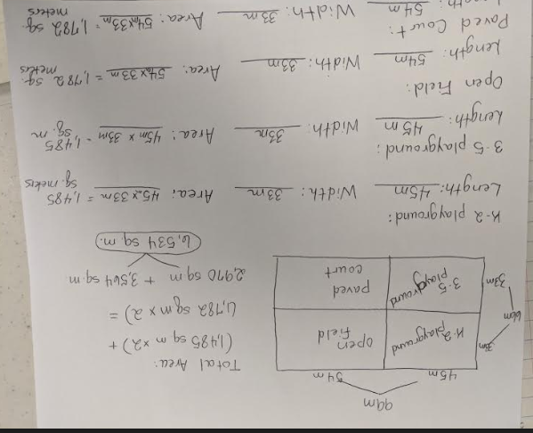
- This problem has multiple solutions depending on how students divide their work. Here is one example.

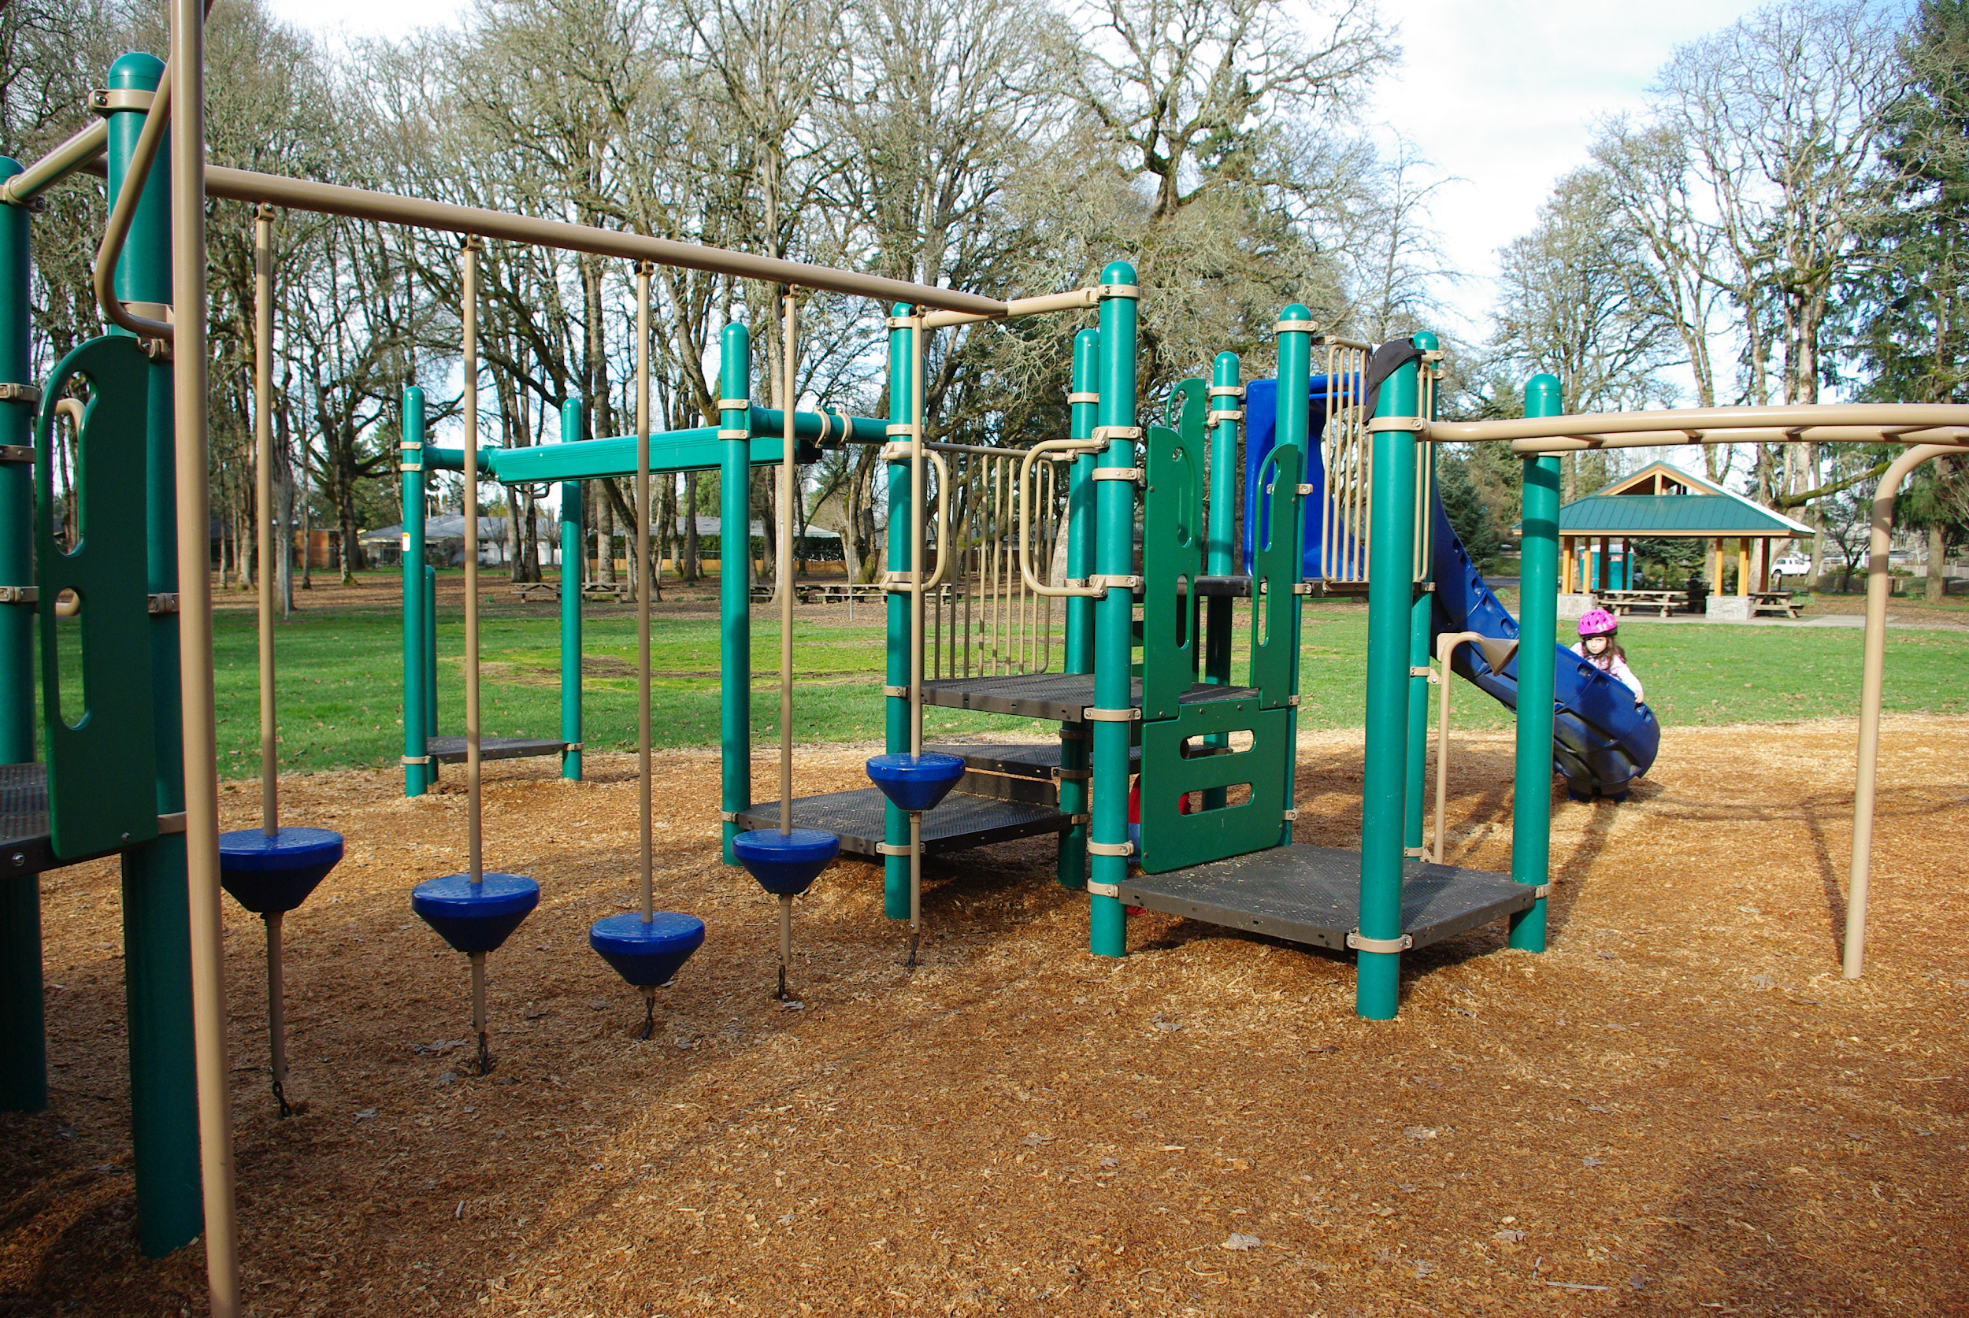
Play Area Plan

The PTO (Parent Teacher Organization) at your school has raised enough money for a new playground. They need your help in deciding how the play area should be divided. The best design will be used in planning the playground. Here is the information you will need when planning your design.

- The space used for the play area is a rectangle with a length of 99 meters and a width of 66 meters.

- Your design needs four different rectangular sections:
- a K-2 playground area
- a 3-5 playground area
- an open field area
- a paved court area

- A fence already divides the total space in half (see below).
- The K-2 and 3-5 playground areas need to have the same length.
- The open field and paved court area need to have the same length.

The PTO is asking that you label each section. The dimensions (length and width) of each section as well as the area of each section should also be given so that PTO can decide which design is most reasonable. Use your chart paper to plan your design. Write a paragraph to explain why this is the best playground design for your school.

66 m
33 m
33 m

Extension:
If PTO decides to put a fence around each section of your playground design, how many meters of fencing will they need?

