Sharing Candy
In this lesson, students model and discuss the reasoning behind the partial quotients method of division.

NC Mathematics Standards:
Number and Operations in Base Ten
NC.4.NBT.6 Find whole number quotients and remainders with up to three-digit dividends and one-digit divisors with place value understanding using rectangular arrays, area models, repeated subtraction, partial quotients, properties of operations, and/or the relationship between multiplication and division.

Standards for Mathematical Practice:
- Make sense of problems and persevere in solving them.
- Use appropriate tools strategically.
- Attend to precision.

Student Outcomes:
- I can model division using manipulatives.
- I can make connections between my model and the partial quotients method for division.

Math Language:
- share
- group
- equal groups
- division
- partial quotients

Materials:
- 245 snap cubes
- Sharing Candy student sheet
- Sharing Candy modeling mats
- Sharing Candy practice sheet
- Sharing Candy exit ticket

Advance Preparation:
- Copy the Sharing Candy student sheet, Sharing Candy practice sheet, and Sharing Candy exit ticket as needed for each student.
- Gather enough snap cubes for partner groups to have around 200 cubes each.

Launch:
      - Introduction (5 minutes)
Read the learning targets to students. Tell students that today the class will be modeling division together with cubes and using the partial quotients method.

Explore (Part I):
      - Modeling Division (30-35 minutes)
Gather students together in a circle. Sit in the circle with students, with 245 cubes placed in the center of the circle. Give each student a Sharing Candy student sheet. Read the problem to students. Ask: What is happening in this problem? How many people are sharing? What does it mean to share equally?

Show students the 245 snap cubes. Assign students to represent the five friends and give each of them one of the Sharing Candy modeling mats. Ask: How could we get started sharing the cubes with the five friends? Allow students to help you decide how many pieces of candy each friend will get first. For example, a student may suggest that each boy should get 10 pieces of candy to begin with. In this case, you would have students help to count out 10 cubes for each boy, snap them together, and place them on the mats. Ask: How many pieces of candy did we give out? Can you name a multiplication fact to show what we did? How many pieces of candy do we have left? Model the partial quotients division method for the amount of candy used so far, and allow students to record both a drawing of the manipulative model and the partial quotients method on their Sharing Candy student sheet as you model on the board. In order to help students make connections between the partial quotients method and the model, ask: Which of the numbers in the partial quotients method represents the boys? Where can we see how many pieces of candy each boy has at this point? How do we know how many total pieces of candy we’ve given out so far? Where can we see the amount of candy we still have left? Repeat this process with another student recommending how many pieces of candy each friend should get next, until all of the candy has been used.

Make connections between the modeling with cubes and the partial quotients method. Ask: How many pieces of candy did each boy get? How can you tell? Where do you see that in the model? In the partial quotient’s method? Was there any candy left over? How do you know?

Have students turn and talk to a partner to answer this question: Would there have been a more efficient way to share 245 pieces of candy among the five friends? As students talk, choose 2-3 of their suggestions to complete with the class. Repeat the modeling and the partial quotients method with students’ suggestions for more efficient ways to share the candy. Ask: Which of these was most efficient? What made it efficient? How do you think the group who suggested the most efficient strategy came up with their first number?

Explore (Part II):
      - Partner Work (15-20 minutes)
Assign partners and give each partner group one of the problems on the Sharing Candy practice sheet. Students must use the snap cubes to model the problem, draw their model on their paper, and also use the partial quotients method to solve the problem. As students work, ask: What is the answer? What does this answer tell us? How many pieces of candy does each boy get? How do you know? How do you know you shared equally? While students work, choose one of the problems to discuss with the class, and select 2-3 pieces of student work to display for the discussion.

Discuss: (20-25 minutes)
      - Discussion of Student Work (20-25 minutes)
Gather students together and display the student work. Lead the class in a discussion of the work. Ask: Why did this group decide to give each boy ___ pieces of candy first? After that, how many candies were left to distribute? How many total pieces of candy did each boy get? How do you know? How are these strategies related? Which was more efficient? How do you know? Summarize the lesson by asking students to explain to one another how the manipulative model for division relates to the partial quotient’s method. Restate and clear up any misconceptions students may have on the partial quotients method at the end of the lesson.

Evaluation of Student Understanding:
Informal Evaluation:
- Look for students who are able to draw a model to represent the division, complete the partial quotients method for the problem, and write about how they are related.
Formal Evaluation/Exit Ticket:
- Have students complete the Sharing Candy exit ticket sheet independently.

Meeting the Needs of the Range of Learners:
Interventions:
- Strategically choose which students help you count and group the cubes during the modeling portion of the lesson so that concrete learners are able to use the manipulatives to model the problem under the teacher’s guidance.
- Differentiate the Sharing Candy practice problems to match the multiplication facts students know.
Extensions:
- Challenge students to come up with a rule that any student could follow with any division problem to solve the problem in the fewest steps possible.

Possible Misconceptions/Suggestions:
Possible Misconceptions | Suggestions
- Students cannot name what the unknown is in the problem. This kind of student may confuse the number of groups with the number in each group.  - Students cannot identify what the partial quotients mean. | - Encourage students to make a model with manipulatives or drawings based on the unknown in the problem.  - Have students tell the story of what they did to solve the problem. Make connections between the partial quotients and the model with manipulatives.

Possible Solutions:
- Sharing Candy with Friends: 49
- Sharing Candy Practice: Students draw a model and use the partial quotients method to show the amount of candy each boy would get. 25, 44, 23
- Sharing Candy Exit Ticket: Students draw a model and use the partial quotients method to show that each boy would get 32 pieces of candy.

Sharing Candy with Friends

Alex bought a large bag of candy for a party with his friends. He counted 245 pieces of candy in the bag. He wants to share the candy with four of his friends so that all five boys get the same amount of candy. How many pieces of candy will each boy get?

Sharing Candy Modeling Mats

Friend 1: Alex
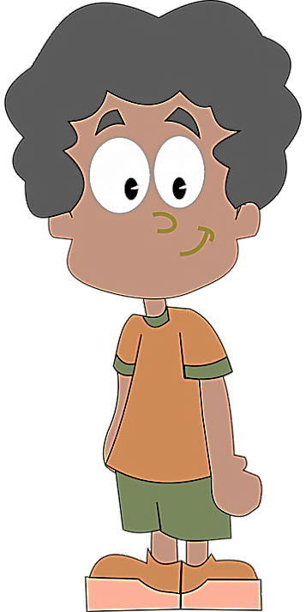

Friend 2: Brandon

Friend 3: Cesar

Friend 4: Derrick

Friend 5: Everett

Sharing Candy Practice

Alex bought a large bag of candy for a party with his friends. He counted 125 pieces of candy in the bag. He wants to share the candy with 4 of his friends so that all five boys get the same amount of candy. How many pieces of candy will each boy get?

Alex bought a large bag of candy for a party with his friends. He counted 176 pieces of candy in the bag. He wants to share the candy with 3 of his friends so that all four boys get the same amount of candy. How many pieces of candy will each boy get?

Alex bought a large bag of candy for a party with his friends. He counted 184 pieces of candy in the bag. He wants to share the candy with 7 of his friends so that all eight boys get the same amount of candy. How many pieces of candy will each boy get?

Sharing Candy Exit Ticket

Alex bought a large bag of candy for a party with his friends. He counted 128 pieces of candy in the bag. He wants to share the candy with three of his friends so that all four boys get the same amount of candy. How many pieces of candy will each boy get?
Draw a picture and use the partial quotients method to show how many pieces of candy each boy will get.

Sharing Candy II
In this lesson, students model and discuss the reasoning behind the partial quotients method of division.

NC Mathematics Standards:
Number and Operations in Base Ten
NC.4.NBT.6 Find whole number quotients and remainders with up to three-digit dividends and one-digit divisors with place value understanding using rectangular arrays, area models, repeated subtraction, partial quotients, properties of operations, and/or the relationship between multiplication and division.

Standards for Mathematical Practice:
- Make sense of problems and persevere in solving them
- Use appropriate tools strategically
- Attend to precision

Student Outcomes:
- I can model division using manipulatives.
- I can make connections between my model and the partial quotients method for division.

Math Language:
- share
- group
- equal groups
- division
- partial quotients

Materials:
- place value blocks for modeling: 3 hundreds, 2 tens, 8 ones
- place value blocks for students to use in pairs
- Sharing Candy student sheet
- Sharing Candy modeling mats
- Sharing Candy practice sheet
- Sharing Candy exit ticket

Advance Preparation:
- Copy the Sharing Candy student sheet, Sharing Candy practice sheet, and Sharing Candy exit ticket as needed for each student.
- Make place value blocks available for students to use when modeling their division situation.

Launch:
      - Introduction (5 minutes)
Read the learning targets to students. Tell students that today the class will be modeling division together with place value blocks and using the partial quotients method. Gather students together in a circle. Sit in the circle with students with the bucket of base ten blocks placed in the center of the circle. Display the Candy Packaging sheet. Give each student a Sharing Candy with Friends II student sheet. Read the problem to students. Ask: What is happening in this problem? How many people are sharing? What does it mean to share equally?

Explore (Part I):
      - Modeling Division (30-35 minutes)
Show students the base ten blocks and tell them it represents the candy. Ask students to help you count out the 3 cases, 2 boxes, and 8 single pieces of candy and find the total amount of candy. Assign students to represent the five friends and give each of them one of the Sharing Candy modeling mats. Ask: How could we get started sharing the candy with the five friends? Allow students to help you decide how many pieces of candy each friend will get first. For example, a student may suggest that each boy should get 1 of the single pieces of candy to begin with. In this case, you would have students help to count out 1 cube for each boy and place them on the mats. Ask: How many pieces of candy did we give out? Can you name a multiplication fact to show what we did? How many pieces of candy do we have left? Model the partial quotients division method for the amount of candy used so far, and allow students to record both a drawing of the manipulative model and the partial quotients method on their Sharing Candy with Friends II student sheet as you model on the board. In order to help students make connections between the partial quotients method and the model, ask: Which of the numbers in the partial quotients method represents the boys? Where can we see how many pieces of candy each boy has at this point? How do we know how many total pieces of candy we’ve given out so far? Where can we see the amount of candy we still have left?

Repeat this process with another student recommending how many pieces of candy each friend should get next until all of the candy has been used. Students might suggest to next share the 2 boxes of candy equally so that each boy gets 4 pieces. In this case, have the students help you trade out the 2 tens for 20 ones so that they can be distributed to the 5 Modeling Mats.

Make connections between the modeling with place value blocks and the partial quotients method. Ask: How many pieces of candy did each boy get? How can you tell? Where do you see that in the model? In the partial quotients method? Was there any candy left over? How do you know?

Have students turn and talk to a partner to answer this question: Would there have been a more efficient way to share 328 pieces of candy among the five friends? As students talk, choose 2-3 of their suggestions to complete with the class. Repeat the modeling and the partial quotients method with students’ suggestions for more efficient ways to share the candy. Ask: Which of these was most efficient? What made it efficient? How do you think the group who suggested the most efficient strategy came up with their first number?

Explore (Part II):
      - Partner Work (15-20 minutes)
Assign partners and give each partner group one of the problems on the Sharing Candy practice sheet. Students must use place value blocks to model the problem, draw their model on their paper, and also use the partial quotients method to solve the problem. As students work, ask: What is the answer? What does this answer tell us? How many pieces of candy does each boy get? How do you know? How do you know you shared equally?

While students work, choose one of the problems to discuss with the class, and select 2-3 pieces of student work to display for the discussion.

Discuss:
      - Discussion (20-25 minutes)
Gather students together again and display the student work. Lead the class in a discussion of the work. Ask: Why did this group decide to give each boy ___ pieces of candy first? After that, how many candies were left to distribute? How many total pieces of candy did each boy get? How do you know? How are these strategies related? Which was more efficient? How do you know?

Evaluation of Student Understanding
Informal Evaluation:
- Look for students who are able to draw a model to represent the division, complete the partial quotients method for the problem, and write about how they are related.
Formal Evaluation/Exit Ticket:
- Have students complete the Sharing Candy exit ticket sheet independently.

Meeting the Needs of the Range of Learners:
Interventions:
- Strategically choose which students help you count and group the blocks during the modeling portion of the lesson, so that concrete learners are able to use the manipulatives to model the problem under the teacher’s guidance.
- Differentiate the Sharing Candy practice problems to match the multiplication facts students know.
Extensions:
- Challenge students to come up with a rule that any student could follow with any division problem to solve the problem in the fewest steps possible.

Possible Misconceptions/Suggestions:
Possible Misconceptions | Suggestions
- Students cannot name what the unknown is in the problem. This kind of student may confuse the number of groups with the number in each group.  - Students cannot identify what the partial quotients mean. | - Encourage students to make a model with manipulatives or drawings based on the unknown in the problem.  - Have students tell the story of what they did to solve the problem. Make connections between the partial quotients and the model with manipulatives.

Possible Solutions:
- Sharing Candy with Friends: 49
- Sharing Candy Practice: Students draw a model and use the partial quotients method to show the amount of candy each boy would get. 25, 44, 23
- Sharing Candy Exit Ticket: Students draw a model and use the partial quotients method to show that each boy would get 32 pieces of candy.

Candy Packaging

Case

Box

Single

Sharing Candy with Friends II
Alex bought some candy for a party with his friends. The candy is sold in cases of 100, boxes of 10, and singles. Alex bought 3 cases, 2 boxes, and 8 single pieces of candy. He wants to share the candy with four of his friends so that all five boys get the same amount of candy. How many pieces of candy will each boy get? How many pieces of candy will be left over?

Sharing Candy Modeling Mats

Friend 1: Alex
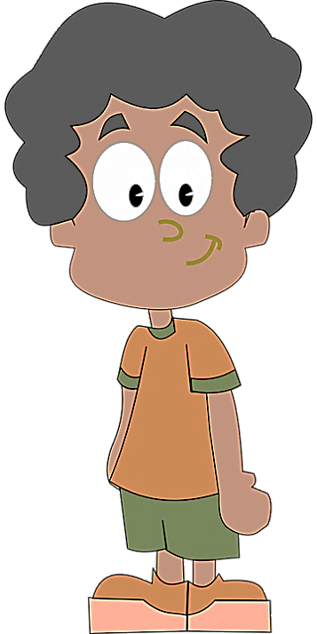

Friend 2: Brandon

Friend 3: Cesar

Friend 4: Derrick

Friend 5: Everett

Sharing Candy Practice II

Alex bought 1 case, 8 boxes, and 5 single pieces of candy to share with his friends. He wants to share the candy with 4 of his friends so that all five boys get the same amount of candy. How many pieces of candy will each boy get?

Alex bought 1 case, 3 boxes, and 6 single pieces of candy to share with his friends. He wants to share the candy with 3 of his friends so that all four boys get the same amount of candy. How many pieces of candy will each boy get?

Alex bought 1 case, 9 boxes, and 4 single pieces of candy to share with his friends. He wants to share the candy with 7 of his friends so that all eight boys get the same amount of candy. How many pieces of candy will each boy get? How many pieces of candy will be left over?

Sharing Candy Exit Ticket II

Alex bought 2 cases, 2 boxes, and 6 single pieces of candy to share with his friends. He wants to share the candy with three of his friends so that all four boys get the same amount of candy. How many pieces of candy will each boy get? How many pieces of candy will be left over?
Draw a picture and use the partial quotients method to show how many pieces of candy each boy will get.

