NC.4.NBT.6
Dividing by Multiples of Ten
Domain | Numbers and Operations in Base Ten
Cluster | Use place value understanding and properties of operations to perform multi-digit arithmetic.
Standard(s) | NC.4.NBT.6 Find whole-number quotients and remainders with up to three-digit dividends and one-digit divisors with place value understanding using rectangular arrays, area models, repeated subtraction, partial quotients, properties of operations, and/or the relationship between multiplication and division.
Materials | pencil, activity sheet
Task | One component of understanding the relationship between multiplication and division is understanding how multiples of 10, 100, or 1000 affect products and quotients. In these explorations, students work with multiples of 10 as divisors to understand how they relate to the quotient.  Dividing by Multiples of Ten  Part 1: Use pictures and numbers to explain how 27 divided by 3 is related to 270 divided by 3 and 2,700 divided by 3.  Part 2: Prove that 23 divided by 4 is the same as 230 divided by 40. Explain your thinking.

Rubric
Level I  Not Yet | Level II  Progressing | Level III  Meets Expectation
Student is unable to divide multi-digit numbers or explain how multiples of 10, 100, or 1000 affect products and quotients. | The student is inconsistent in showing and explaining how the problems are related. The student may find correct answers, but may not be able to explain how the relationship between ones, tens, hundreds, and thousands affects the products and quotients. | The student can accurately and completely show and explain how the problems are related using knowledge of the relationships between ones, tens, hundreds, and thousands.
Standards for Mathematical Practice
1. Makes sense and perseveres in solving problems.
2. Reasons abstractly and quantitatively.
3. Constructs viable arguments and critiques the reasoning of others.
4. Models with mathematics.
5. Uses appropriate tools strategically.
6. Attends to precision.
7. Looks for and makes use of structure.
8. Looks for and expresses regularity in repeated reasoning.

Dividing by Multiples of Ten

Part 1: Use pictures and numbers to explain how 27 divided by 3 is related to 270 divided by 3 and 2,700 divided by 3. Show your work in at least two different ways.

Part 2: Prove that 23 divided by 4 is the same as 230 divided by 40. Explain your thinking.

Scoring Examples

Not Yet: The student recognized that the numbers were related, but did not divide to show how the quotients would relate.
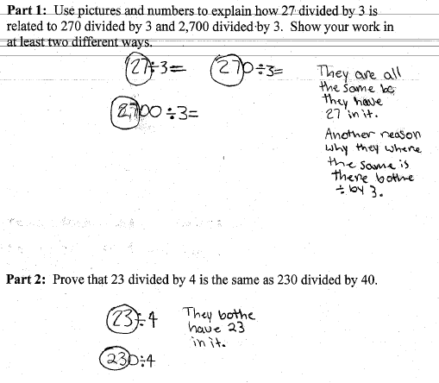

Progressing: The student is able to show some relationships in Part 1, but does not find correct answers for Part 2 and does not explain the relationship between the sets of numbers.
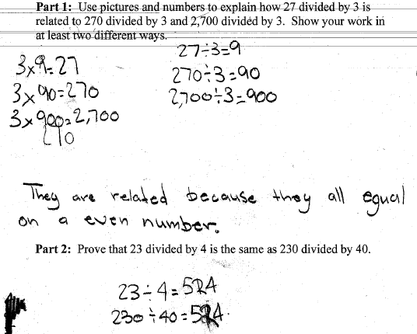

Meets Expectation: The student finds correct answers to all parts of the task and explains how the numbers are related based on knowledge of how ones, tens, hundreds, and thousands are related.

