NC.4.NBT.6
Dividing Resources
Domain | Number and Operations in Base Ten
Cluster | Use place value understanding and properties of operations to perform multi-digit arithmetic.
Standard(s) | NC.4.NBT.6 Find whole-number quotients and remainders with up to three-digit dividends and one-digit divisors with place value understanding using rectangular arrays, area models, repeated subtraction, partial quotients, properties of operations, and/or the relationship between multiplication and division.
Materials | pencil, task handout
Task | Dividing Resources  The school’s Parent Teacher Organization raised $936 through a fund raiser.  Part 1:  They divided the money evenly between the six grades at your school (Kindergarten through Fifth Grade). How much money did each grade receive?  Part 2:  When the fourth grade teachers received their money, they decided to spend one-third of it on field trip fees. They spent the rest on school supplies.  How much money was spent on field trip fees?  How much was spent on school supplies?  Part 3:  Explain how you found your answers to Part 2.

Rubric
Level I  Not Yet | Level II  Progressing | Level III  Meets Expectation
Student has correct answers for 0-1 aspects of the task. | Student has correct answers for 2-3 aspects of the task. | All answers are correct.  Part 1: 936 divided by 6 = $156  Part 2: One-third of $156 is $156 divided by 3 = $52. $52 was spent on field trip fees. The remaining $104 was spent on school supplies.  Part 3: The explanation is clear and accurate.
Standards for Mathematical Practice
1. Makes sense and perseveres in solving problems.
2. Reasons abstractly and quantitatively.
3. Constructs viable arguments and critiques the reasoning of others.
4. Models with mathematics.
5. Uses appropriate tools strategically.
6. Attends to precision.
7. Looks for and makes use of structure.
8. Looks for and expresses regularity in repeated reasoning

Dividing Resources

The school’s Parent Teacher Organization raised $936 through a fund raiser.

Part 1:
They divided the money evenly between the six grades at Happy Elementary School (Kindergarten through Fifth Grade). How much money did each grade receive?

Part 2:
With the amount of money that the fourth grade teachers received, they decided to spend one-third of it on field trip fees. They spent the rest on school supplies.
How much money was spent on field trip fees?

How much was spent on school supplies?

Part 3:
Explain how you found your answers to Part 2.

Scoring Examples

Not Yet: The student attempted a division strategy, but was unable to use the quotients to find correct answers to any part of the task.
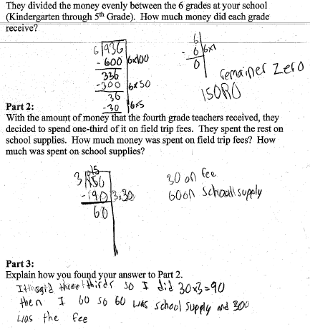

Progressing: The student correctly used a division strategy to find correct answers to some parts of the task. The student did not answer both questions in Part 2 and did not provide a clear explanation in Part 3.
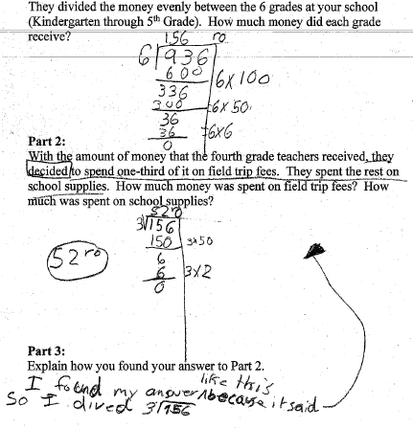

Meets Expectation: The student found correct answers for all parts of the task.
