NC.4.NBT.6
Mini Muffins
Domain | Number and Operations in Base Ten
Cluster | Use place value understanding and properties of operations to perform multi-digit arithmetic.
Standard(s) | NC.4.NBT.6 Find whole-number quotients and remainders with up to three-digit dividends and one-digit divisors with place value understanding using rectangular arrays, area models, repeated subtraction, partial quotients, properties of operations, and/or the relationship between multiplication and division.
Materials | pencil, task handout
Task | Mini Muffins  The Yummy Muffin Company packages their mini muffins to send to grocery stores. They package them in crates of 100, boxes of 10, and single mini muffins. Currently, the Yummy Muffin Company has 9 crates, 7 boxes, and 3 singles ready to ship. They will ship the same amount to 4 grocery stores. How many muffins will each grocery store receive? How many muffins will be left over? (243 muffins with 1 remaining)  Draw a model and use the partial quotients method to solve the problem.

Rubric
Level I  Not Yet | Level II  Progressing | Level III  Meets Expectation
Student is unable to answer the problem using an appropriate model and cannot use the partial quotient method to correctly solve the problem. | Student can either show the answer to the problem using an appropriate model or use the partial quotient method to correctly solve the problem, but is unable to do both. | Student can show the answer to the problem using an appropriate model and can use the partial quotient method to correctly solve the problem.
Standards for Mathematical Practice
1. Makes sense and perseveres in solving problems.
2. Reasons abstractly and quantitatively.
3. Constructs viable arguments and critiques the reasoning of others.
4. Models with mathematics.
5. Uses appropriate tools strategically.
6. Attends to precision.
7. Looks for and makes use of structure.
8. Looks for and expresses regularity in repeated reasoning

Mini Muffins

The Yummy Muffin Company packages their mini muffins to send to grocery stores. They package them in crates of 100, boxes of 10, and single mini muffins. Currently, the Yummy Muffin Company has 9 crates, 7 boxes, and 3 singles ready to ship. If they ship the same amount to 4 grocery stores, how many muffins will each grocery store receive? How many muffins will be left over?

Draw a model and use the partial quotients method to solve the problem.

Scoring Examples

Not Yet: The student cannot use the partial quotients model to solve the problem and does not use an appropriate model to represent the problem.
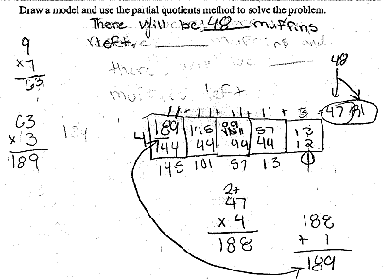

Progressing: The student found the correct answer using the partial quotients method.
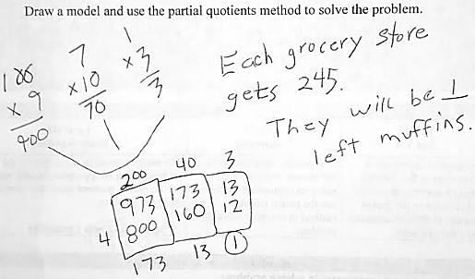

Meets Expectation: The student is able to use the partial quotients strategy as well as a model.
