NC.4.NBT.6
Packaging Cupcakes
Domain | Number and Operations in Base Ten
Cluster | Use place value understanding and properties of operations to perform multi-digit arithmetic.
Standard(s) | NC.4.NBT.6 Find whole-number quotients and remainders with up to three-digit dividends and one-digit divisors with place value understanding using rectangular arrays, area models, repeated subtraction, partial quotients, properties of operations, and/or the relationship between multiplication and division.
Materials | pencil, activity sheet
Task | Packaging Cupcakes  The cupcake factory sells cupcakes in three different types of packages. The first type is a 3-pack. The second type is a 6-pack. The third type is a 9-pack.  Part 1:  The cupcake factory has 810 cupcakes to package. The company’s leaders want to divide the cupcakes so that an equal number of cupcakes will be put into the 3 different types of packages. How many cupcakes will go into each type of package?  Part 2:  Now that the cupcakes have been evenly divided among the 3 different types of packages, answer the following questions:  How many 3-packs can be made?  How many 6-packs can be made?  How many 9-packs can be made?  Part 3:  Explain how you got your answer to Part 2.

Rubric
Level I  Not Yet | Level II  Progressing | Level III  Meets Expectation
The student finds correct solutions to 0-1 aspects of the task. | The student finds correct answers for 2-4 aspects of the task. | All answers are correct.  Part 1: 810 divided by 3 = 270 cupcakes per type of package.  Part 2: 3 packs: 270 divided by 3 = 90 packs  6 packs: 270 divided by 6 = 45 packs  9 packs: 270 divided by 9 = 30 packs  Part 3: The explanation is clear and accurate.

Standards for Mathematical Practice
1. Makes sense and perseveres in solving problems.
2. Reasons abstractly and quantitatively.
3. Constructs viable arguments and critiques the reasoning of others.
4. Models with mathematics.
5. Uses appropriate tools strategically.
6. Attends to precision.
7. Looks for and makes use of structure.
8. Looks for and expresses regularity in repeated reasoning
Packaging Cupcakes

The cupcake factory sells cupcakes in three different types of packages. The first type is a 3-pack. The second type is a 6-pack. The third type is a 9-pack.

Part 1:
The cupcake factory has 810 cupcakes to package. The company’s leaders want to divide the cupcakes so that an equal number of cupcakes will be put into the 3 different types of packages. How many cupcakes will go into each type of package?

Part 2:
Now that the cupcakes have been evenly divided among the 3 different types of packages, answer the following questions:
How many 3-packs can be made? ___________

How many 6-packs can be made? ___________

How many 9-packs can be made? ___________

Part 3:
Explain how you got your answer to Part 2.

Scoring Examples

Not Yet: The student found the correct answer for Part 1, but did not find correct answers for Part 2 and did not provide a correct explanation in Part 3.

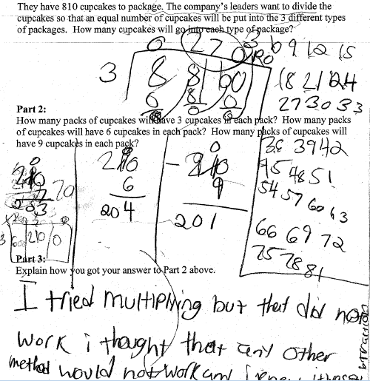

Progressing: The student found the correct answer for Part 1. In Part 2, the student confused the meaning of the quotient 90 and used it as the number of cupcakes instead of the number of packages. This resulted in an incorrect explanation as well.

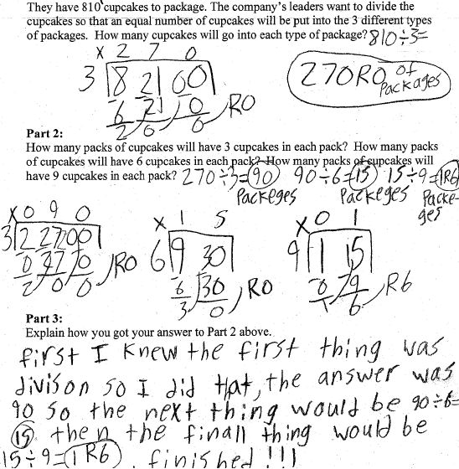

Meets Expectation: The student was able to find correct answers to each part of the task and was able to explain the strategies used for Part 3.

