NC.4.NBT.6
Reading Club
Domain | Number and Operations in Base Ten
Cluster | Use place value understanding and properties of operations to perform multi-digit arithmetic.
Standard(s) | NC.4.NBT.6 Find whole-number quotients and remainders with up to three-digit dividends and one-digit divisors with place value understanding using rectangular arrays, area models, repeated subtraction, partial quotients, properties of operations, and/or the relationship between multiplication and division.
Materials | pencil, task handout
Task | Reading Club  The Reading Club collected $839 from a fundraiser. They want to buy books for the school’s library with the money they collected. They have decided to purchase comic books, chapter books, and informational books. If they divide the money equally between the three types of books, how much money will they spend on each? How much money will be left over?  Use an area model to show your work.

Rubric
Level I  Not Yet | Level II  Progressing | Level III  Meets Expectation
Student is unable to solve the problem correctly and is unable to use an area model for division. | Student attempts to use an area model, but does not solve the problem correctly.  OR  Student correctly solves the problem, but is unable to use the area model to do so. | Student can show the correct answer to the problem using the area model.  Answer: $279 will be spent on each type of book, and there will be a remainder of $2.
Standards for Mathematical Practice
1. Makes sense and perseveres in solving problems.
2. Reasons abstractly and quantitatively.
3. Constructs viable arguments and critiques the reasoning of others.
4. Models with mathematics.
5. Uses appropriate tools strategically.
6. Attends to precision.
7. Looks for and makes use of structure.
8. Looks for and expresses regularity in repeated reasoning

Reading Club

The Reading Club collected $839 from a fundraiser. They want to buy books for the school’s library with the money they collected. They have decided to purchase comic books, chapter books, and informational books. If they divide the money equally between the three types of books, how much money will they spend on each? How much money will be left over?

Use an area model to show your work.

Scoring Examples

Not Yet: The student does not correctly solve the problem and does not use the area model.
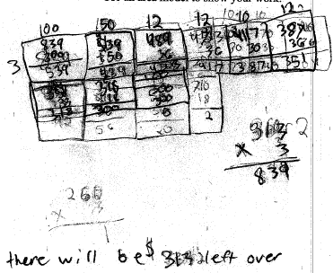

Progressing: The student finds the correct answers, but does not use the area model to find the answers. The student needs to use the area model in order to progress further.
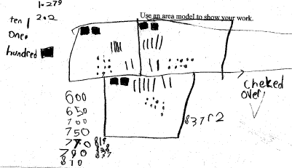

Meets Expectation: The student uses the area model to solve the problem and solve the problem correctly.
