NC.4.NBT.6
Road Trip
Domain | Number and Operations in Base Ten
Cluster | Use place value understanding and properties of operations to perform multi-digit arithmetic.
Standard(s) | NC.4.NBT.6 Find whole-number quotients and remainders with up to three-digit dividends and one-digit divisors with place value understanding using rectangular arrays, area models, repeated subtraction, partial quotients, properties of operations, and/or the relationship between multiplication and division.
Materials | pencil, task handout
Task | Road Trip  The Smith family traveled from North Carolina to Texas. The chart below shows the number of miles they traveled each day.  Day Number of Miles  Monday 215  Tuesday 227  Wednesday 296  Thursday 234  If the Smith family plans to use three days to travel home, how many miles will they drive daily if they drive the same amount each day? Use the partial quotients method to show your work.

Rubric
Level I  Not Yet | Level II  Progressing | Level III  Meets Expectation
Student is unable to show the answer to the problem using the partial quotients method and does not correctly solve the problem. | Student attempts to use the partial quotients method, but does not solve the problem correctly.  OR  Student correctly solves the problem, but is unable to use the partial quotients method to do so. | Student can show the correct answer to the problem using the partial quotients method.  215 + 227 + 296 + 234 = 972 miles  972 divided by 3 = 324 miles  Answer: 324 miles
Standards for Mathematical Practice
1. Makes sense and perseveres in solving problems.
2. Reasons abstractly and quantitatively.
3. Constructs viable arguments and critiques the reasoning of others.
4. Models with mathematics.
5. Uses appropriate tools strategically.
6. Attends to precision.
7. Looks for and makes use of structure.
8. Looks for and expresses regularity in repeated reasoning

Road Trip

The Smith family traveled from North Carolina to Texas. The chart below shows the number of miles they traveled each day.

Day | Number of Miles
Monday | 215
Tuesday | 227
Wednesday | 296
Thursday | 234

If the Smith family plans to use three days to travel home, how many miles will they drive daily if they drive the same amount each day?

Use the partial quotients method to show your work.

Scoring Examples

Not Yet: The student does not use the partial quotients method and does not find the correct answer for the problem.
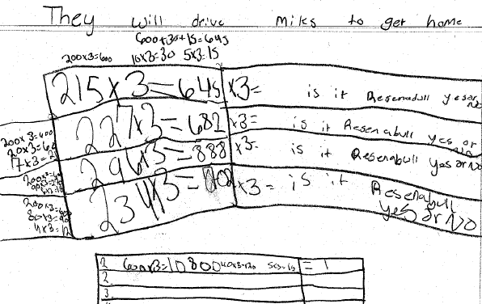

Progressing: The student attempts to use the partial quotients method, but does not solve the problem correctly.
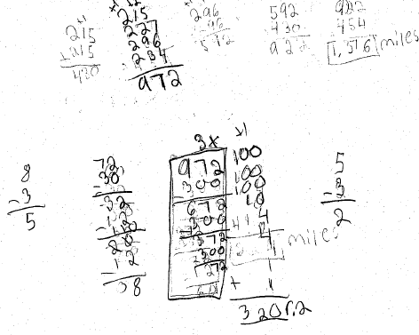
Meets Expectation: The student uses the partial quotients method to solve the problem correctly.
