NC.4.OA.3
Fizzy Soda Company
Domain | Operations and Algebraic Thinking
Cluster | Use the four operations with whole numbers to solve problems.
Standard(s) | NC.4.OA.3 Solve two-step word problems involving the four operations with whole numbers.  • Use estimation strategies to assess reasonableness of answers.  • Interpret remainders in word problems.  • Represent problems using equations with a letter standing for the unknown quantity.
Materials | pencil, activity sheet
Task | Fizzy Soda Company  Each minute, the Fizzy Soda Company makes 16 cans of soda.  They package the cans in packs of six.  - About how many cans of soda are made each hour? (Accept reasonable estimates between 600-1200 cans.)  - Write an equation to show how many packs of soda are packaged each hour. Use a letter to stand for the unknown. (16 x 60 ÷ 6 = p)  - How many packs of soda are packaged each hour? (160 packs of soda)  *If this task is too simple for your students, change up the time frame in which the sodas are made. (ex. About how many cans of soda are made in 66 minutes?)

Rubric
Level I  Not Yet | Level II  Progressing | Level III  Meets Expectation
Student is unable to answer any part of the problem correctly. | Student answers 1-2 parts of the problem completely and correctly. | Student answers each part of the question correctly.

Standards for Mathematical Practice
1. Makes sense and perseveres in solving problems.
2. Reasons abstractly and quantitatively.
3. Constructs viable arguments and critiques the reasoning of others.
4. Models with mathematics.
5. Uses appropriate tools strategically.
6. Attends to precision.
7. Looks for and makes use of structure.
8. Looks for and expresses regularity in repeated reasoning.

Fizzy Soda Company

Each minute, the Fizzy Soda Company makes 16 cans of soda. They package the cans in packs of six.

- About how many cans of soda are made each hour?

- Write an equation to show how many packs of soda are packaged
each hour. Use a letter to stand for the unknown.

- How many packs of soda are packaged each hour?

Scoring Examples

Not Yet: The student attempts a multiplication strategy, but is unable to find the correct answer for any part of the task.
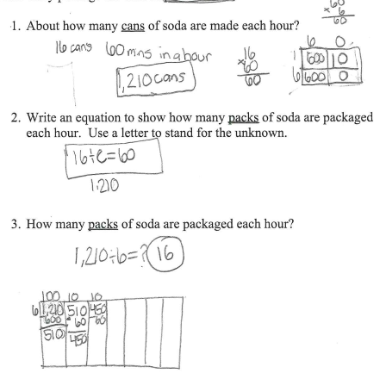

Progressing: The student answers one question correctly. He/She demonstrates a partial understanding of how to write an equation with an unknown and how to solve two-step word problems.
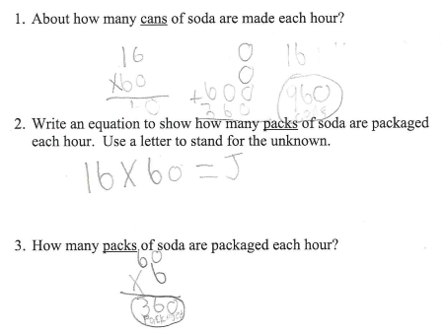

Meets Expectation: The student answers all three questions correctly. The student can make a reasonable estimate, write an equation with an unknown, and solve a two-step word problem.
