NC.4.OA.3
Planning a Pizza Party
Domain | Operations and Algebraic Thinking
Cluster | Use the four operations with whole numbers to solve problems.
Standard(s) | NC.4.OA.3 Solve two-step word problems involving the four operations with whole numbers.  • Use estimation strategies to assess reasonableness of answers.  • Interpret remainders in word problems.  • Represent problems using equations with a letter standing for the unknown quantity.
Materials | pencil, activity sheet
Task | Planning a Pizza Party  The following classes are having a pizza party for their good behavior.  Teacher Number of Students Participating  Mr. Thomas 23  Mrs. Little 25  Mrs. Jones 16  Mrs. Gordon 24  Part 1:  - About how many students are participating in the pizza party?  - How close was your estimate in question 1 to the actual answer?  - Explain why your estimate was different from your actual answer.  Part 2:  - One pizza will feed 4 students. How many pizzas are needed for all of the students?  - If each pizza costs $12.75, about how much money will be spent on pizza?  - About $324 is spent on the cost of pizza and drinks. Based on your estimate in question 4, about how much money will be spent on drinks? Explain how you found your answer.

Rubric
Level I  Not Yet | Level II  Progressing | Level III  Meets Expectation
Student answers 2 or fewer questions correctly. | Student answers 3-5 questions correctly. | Student provides correct answers on all questions.  Answers:  1) 20 + 30 + 20 + 20 = 90  2) Actual: 88 students  3) Possible answers could include: “When we rounded to the tens place and added the rounded numbers we got 90 for the answer.” 4) 88 divided by 4 is 22 pizzas.  5) We could round both numbers: 20 x $13 = 260. We could round only the cost of the pizza 22 x 13 = 286. Either is acceptable.  6) 324 minus the answer to number 5. Answers could be 64 or 38.

Standards for Mathematical Practice
1. Makes sense and perseveres in solving problems.
2. Reasons abstractly and quantitatively.
3. Constructs viable arguments and critiques the reasoning of others.
4. Models with mathematics.
5. Uses appropriate tools strategically.
6. Attends to precision.
7. Looks for and makes use of structure.
8. Looks for and expresses regularity in repeated reasoning.

Planning a Pizza Party

The following classes are having an end-of-the-quarter pizza party for their good behavior.
Teacher | Number of Students Participating
Mr. Thomas | 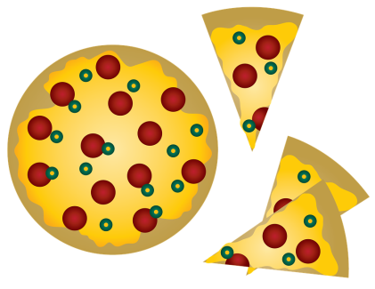  23
Mrs. Little | 25
Mrs. Jones | 16
Mrs. Gordon | 24

Part 1:
- About how many students are participating in the pizza party?

- How close was your estimate in question 1 to the actual answer?

- Explain why your estimate was different from your actual answer.

Part 2:
- One pizza will feed 4 students. How many pizzas are needed for all of the students?

- If each pizza costs $12.75, about how much money will be spent on pizza?

- About $324 is spent on the cost of pizza and drinks. Based on your estimate in question 4, about how much money will be spent on drinks? Explain how you found your answer.

Scoring Examples

Not Yet: The student was unable to find correct answers for any part of the task.

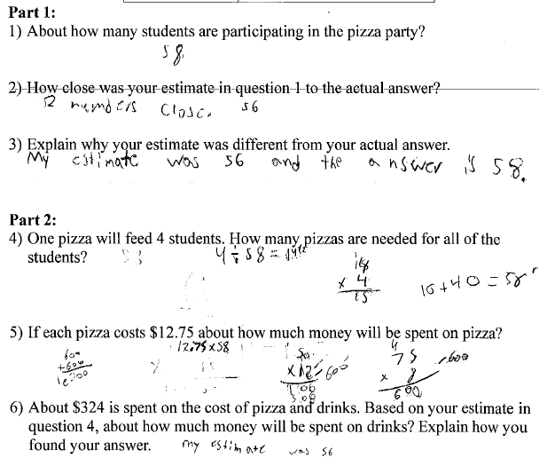

Progressing: The student was able to find correct answers for 4 of the questions in this task.

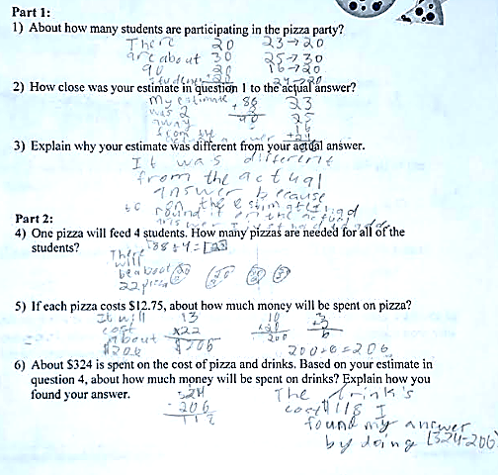

Meets Expectation: The student found correct answers for all parts of the task.

