NC.2.OA.1
Art Contest
Domain | Operations and Algebraic Thinking  Number and Operations in Base Ten
Cluster | Represent and solve problems involving addition & subtraction.  Use place value understanding and properties of operations to add and subtract.
Standard(s) | NC.2.OA.1 Represent and solve addition an subtraction word problems, within 100, with unknowns in all positions, by using representations and equations with a symbol for the unknown number to represent the problem, when solving:  - One-Step problems:  - Add to/Take from –Start Unknown  - Compare-Bigger Unknown  - Compare Smaller-Unknown  - Two-Step problems involving single digits:  - Add to/Take from- Change Unknown  - Add to/Take from- Result Unknown  NC.2.NBT.5 Demonstrate fluency with addition and subtraction, within 100, by:  - Flexibly using strategies based on place value, properties of operations, and/or the relationship between addition and subtraction.  - Comparing addition and subtraction strategies and explaining why they work.  - Selecting an appropriate strategy in order to efficiently compute sums and differences.
Materials | SF, Pencil, Paper, counters and base ten materials available
Task | Provide materials to the student. Read the problem to the student: Jacob drew 5 pictures to enter in the school art contest. Erick drew 7 pictures. Jacob spilled water on 2 of his pictures and ruined them. How many pictures will Jacob and Erick enter in the contest? Solve the problem and use words, numbers or pictures to explain your reasoning.

Continuum of Understanding
Not Yet Proficient | - Needs prerequisite concepts
Progressing | - Incorrectly solves the problem.  - Relies on counting as primary strategy for solving problem.  - Explanation is lacking in detail or non-existent. | Strategy(ies) Used:  - Counting All  - Counting On  - Makes Tens  - Basic Facts  - Creates easier or known sums  - Doubles  - Doubles +/- 1, 2  - Other:
Meets Expectation | - Correctly solves the problem: 10 pictures  - Successfully uses strategies such as making tens, creates easier or known sums, and basic facts  - Explanation is clear.

Standards for Mathematical Practice
1. Makes sense and perseveres in solving problems.
2. Reasons abstractly and quantitatively.
3. Constructs viable arguments and critiques the reasoning of others.
4. Models with mathematics.
5. Uses appropriate tools strategically.
6. Attends to precision.
7. Looks for and makes use of structure.
8. Looks for and expresses regularity in repeated reasoning.

Jacob drew 5 pictures to enter in the school art contest. Erick drew 7 pictures. Jacob spilled water on 2 of his pictures and ruined them. How many pictures will Jacob and Erick enter in the contest?
Solve the problem.
Use words, numbers or pictures to explain your reasoning.

__________________ pictures

Scoring Examples:
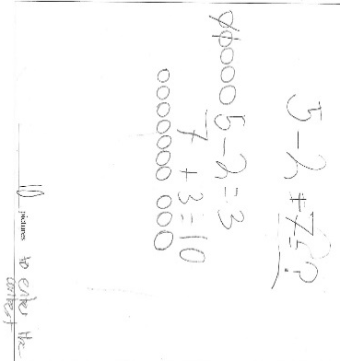
Progressing:
In the first sample, the student wrote an equation and solved it correctly. It the progressing level because the student relied on counting as the primary strategy.

The second example of student work is
considered progressing if this work was done at the end of
the school year. The strategy is clear and the answer is correct. The strategy for solving 7 + 3 is “counting on” which does not meet the end of the year expectation. At the beginning of the year, you can consider this strategy
“meets expectation” because counting on is a beginning
2nd grade strategy.

In this example, the student had a correct equation but subtracted 2-5 and got 3. He then added the 3 + 5 to get 8. The answer is incorrect.

Meets Expectation:

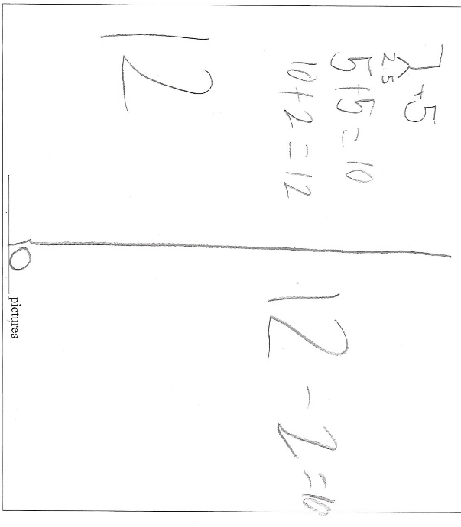
This student had a clear strategy for adding
7 + 5 (break the 7 into 2 and 5, and then add 5+5, making a ten. Next he added 2 to the 10. The student then subtracted the 2 from 12 and got the correct answer, 10.

