NC.2.OA.1
Puzzle Pieces
Domain | Operations and Algebraic Thinking  Number and Operations in Base Ten
Cluster | Represent and solve problems involving addition & subtraction.  Use place value understanding and properties of operations to add and subtract.
Standard(s) | NC.2.OA.1 Represent and solve addition an subtraction word problems, within 100, with unknowns in all positions, by using representations and equations with a symbol for the unknown number to represent the problem, when solving:  - One-Step problems:  - Add to/Take from –Start Unknown  - Compare-Bigger Unknown  - Compare Smaller-Unknown  - Two-Step problems involving single digits:  - Add to/Take from- Change Unknown  - Add to/Take from- Result Unknown  NC.2.NBT.5 Demonstrate fluency with addition and subtraction, within 100, by:  - Flexibly using strategies based on place value, properties of operations, and/or the relationship between addition and subtraction.  - Comparing addition and subtraction strategies and explaining why they work.  Selecting an appropriate strategy in order to efficiently compute sums and differences.
Materials | SF, Pencil, Paper, counters and base ten materials available
Task | Provide materials to the student. Read the problem to the student: The rocket puzzle has 51 pieces. The boat puzzle has 100 pieces. How many fewer puzzle pieces does the rocket puzzle have than the boat puzzle? Write an equation that represents this problem. Use a symbol for the unknown number.  Once an equation is written, say: Solve the problem and use words, numbers or pictures to explain your reasoning.

Continuum of Understanding
Not Yet Proficient | - Needs prerequisite skills
Progressing | - Incorrectly solves the problem.  - Relies on counting as primary strategy for solving problem.  - Equation is inaccurate.  - Explanation is lacking in detail or non-existent. | Strategy(ies) Used:  - Counting All  - Counting On  - Makes Tens  - Basic Facts  - Creates easier or known sums  - Doubles  - Doubles +/- 1, 2  - Other:
Meets Expectation | - Correctly solves the problem: 49 pieces  - Successfully uses strategies such as making tens, creates easier or known sums, and basic facts.  - Equation is accurate (e.g., 100 – 51 = *; 100 = 51 + *)  - Explanation is clear.

Standards for Mathematical Practice
1. Makes sense and perseveres in solving problems.
2. Reasons abstractly and quantitatively.
3. Constructs viable arguments and critiques the reasoning of others.
4. Models with mathematics.
5. Uses appropriate tools strategically.
6. Attends to precision.
7. Looks for and makes use of structure.
8. Looks for and expresses regularity in repeated reasoning.

The rocket puzzle has 51 pieces. The speed boat puzzle has 100 pieces. How many fewer puzzle pieces does the rocket puzzle have than the speed boat puzzle?
Write an equation that represents this problem. Use a symbol for the unknown number.
Solve the problem.
Use words, numbers or pictures to explain your reasoning.

__________________puzzle pieces

Student Work Samples

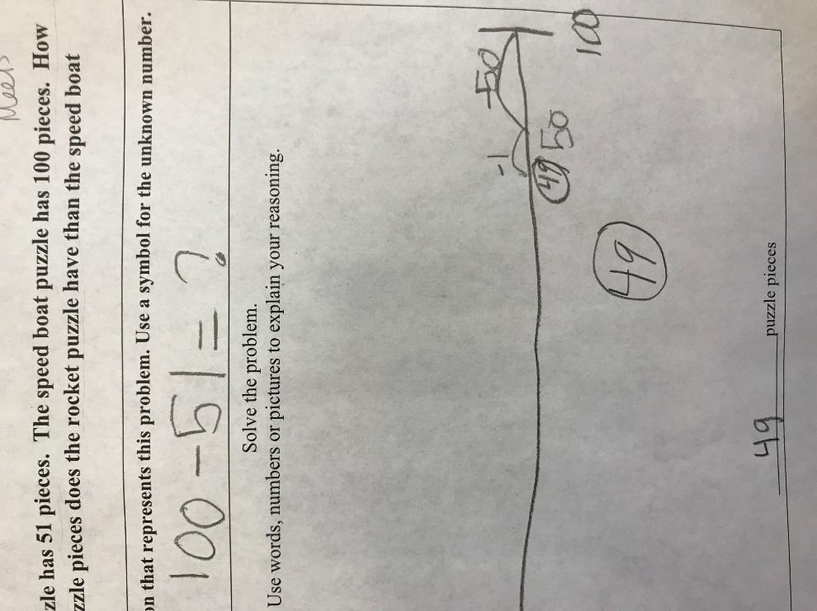 | Meets Expectation:  The student’s equation and strategy are correct. The number line strategy jumps back 50 and then 1. The answer of 49 is correct.
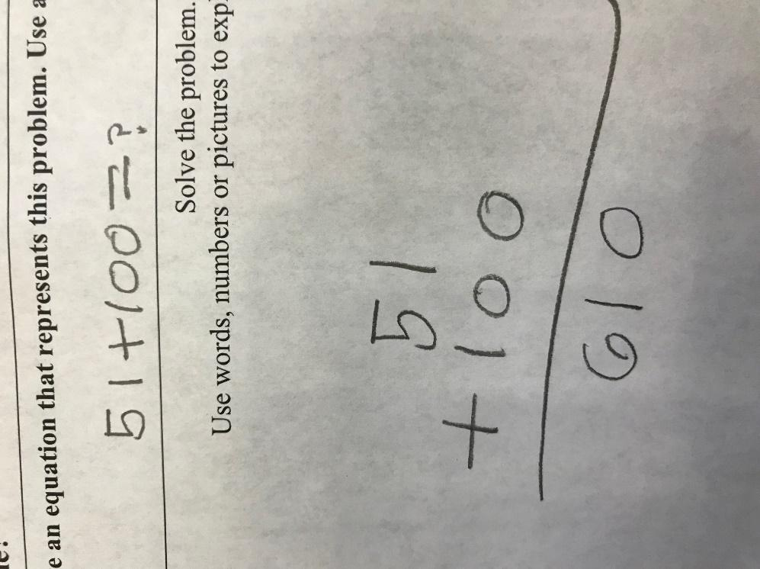 | Not Yet Proficient:  The student has an equation and strategy that are both incorrect.

