Name _______________________________ Quarter 2 CFA (Clusters 4 & 5)

- Sandra delivers flowers for her mom’s florist shop. Last week, she delivered 76 flower arrangements. Each arrangement had 12 flowers. How many flowers did she deliver last week in all?
  - 76
  - 88
  - 900
  - 912

- Amber has a container full of coins to take to the bank. She separated out the coins into separate piles and found that she has $165 in 5 dollar bills. How many 5 dollar bills does she have?
  - 30
  - 31
  - 33
  - 170

- Fancy Pastry has a large order of cupcakes to bake, decorate, and package. There are 367 cupcakes on order and they want to put them in packages of 4. How many total packages will they need to package all of the cupcakes?
  - 90
  - 91
  - 92
  - 93

- African Lions at the North Carolina Zoo ate 560 pounds of meat last week. If the lions ate the same amount of meat each day, how many pounds of meat did the zookeepers give them to eat per day?
  - 80 pounds
  - 112 pounds
  - 2,800 pounds
  - 3,920 pounds

- The lengths and widths of four rectangles are shown below. Which rectangle has a perimeter of 40 feet?
  - length = 20, width = 20
  - length = 39, width = 1
  - length = 12, width = 8
  - length = 10, width = 6

- Mr. Hardy is decorating his new office space. For which situation would Mr. Hardy most likely use the area formula when decorating his office?
  - determining the width of the door in his office
  - determining the amount of water he needs to fill up his fish tank
  - determining the height of the window in his office
  - determining the amount of wall space he needs to hang his schedule board

- Which number line shows a fraction equivalent to $\frac{4}{6}$?
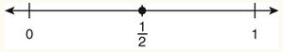

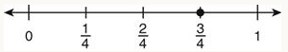

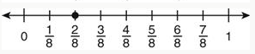

- Which picture shows a fraction that is equivalent to $\frac{6}{8}$?

- Sally is using the number line below to compare two fractions.

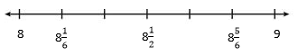
Which inequality correctly compares 8$\frac{2}{3}$ and 8$\frac{1}{2}$?
  - 8$\frac{1}{2}$ = 8$\frac{2}{3}$
  - 8$\frac{1}{2}$ + 8$\frac{2}{3}$
  - 8$\frac{2}{3}$ < 8$\frac{1}{2}$
  - 8$\frac{2}{3}$ > 8$\frac{1}{2}$

- Kathy read more of her magazine that Jaron. Jaron read $\frac{6}{12}$ of his magazine. Which fraction of the magazine could Kathy have read?

  - $\frac{3}{6}$
  - $\frac{3}{4}$
  - $\frac{4}{10}$
  - $\frac{2}{8}$

ANSWER KEY
- D
- C
- D
- A
- C
- D
- A
- C
- D
- B

