Fourth Grade Exit Tickets
Cluster 5 – NC.4.NF.1

1. Decompose the shaded fraction model into smaller units to find the equivalent fraction.
a. ____________
b. 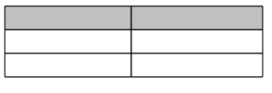____________

2. Draw area models to show the fractions below are equivalent.
a. $\frac{3}{5}$ = $\frac{6}{10}$

b. $\frac{1}{2}$ = $\frac{4}{8}$

c. $\frac{3}{4}$ = $\frac{9}{12}$

4. Which model below is equivalent to the fraction $\frac{2}{3}$?
A. 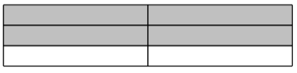 B.
C. 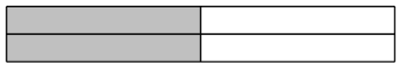 D.
1. Decompose the shaded fraction model into smaller units to find the equivalent fraction.
a. ____________
b. ____________

2. Draw area models to show the fractions below are equivalent.
a. $\frac{3}{5}$ = $\frac{6}{10}$

b. $\frac{1}{2}$ = $\frac{4}{8}$

c. $\frac{3}{4}$ = $\frac{9}{12}$

4. Which model below is equivalent to the fraction $\frac{2}{3}$?
A. B.
C. D.
Answer Key:
1.
a. Students could have 2/6, 3/9, 4/12, 5/15 etc.
b. Students could have 4/12, 6/18, 10/30 etc.
2. a. 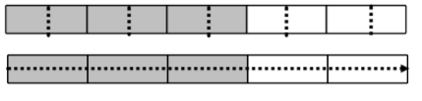
b. 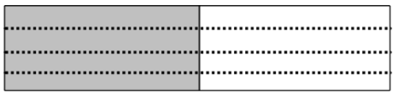
c. 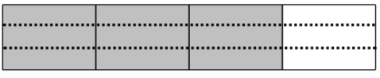
3. A

