NC.4.NF.1
Comparing Ropes
Domain | Number & Operations – Fractions
Cluster | Extend understanding of fractions.
Standard(s) | NC.4.NF.1 Explain why a fraction is equivalent to another fraction by using area and length fraction models, with attention to how the number and size of the parts differ even though the two fractions themselves are the same size.
Materials | activity sheet, pencil, graph paper (optional)
Task | Comparing Ropes  Sally has a piece of rope that is 3/4 of a foot long. Tomas has a piece of rope that is 1/2 of a foot long. Mitch has a piece of a rope that is 1/3 of a foot long. How many inches is each piece of rope? Write a sentence explaining your thinking.  Solutions:  Sally’s rope is 9 inches long.  Tomas’ rope is 6 inches long.  Mitch’s rope is 4 inches long.

Rubric
Level I  Not Yet | Level II  Progressing | Level III  Meets Expectation
The student has not shown a clear understanding about how to find equivalent fractions.  OR  Student does not understand that a foot has 12 inches so is unsure of how to proceed with finding a fraction of a foot. | Answer is correct, but the explanation is unclear.  OR  Work is logically shown, but the student has made a calculation error. For example, a student may say Sally’s rope is 3 inches (thinking of ¼ of the rope) or that Mitch’s rope is 8 inches (thinking of 2/3 of the rope). | The sentence includes a clear explanation about finding equivalent fractions.  AND  Student is able to discuss how to partition the ropes into equal pieces, using the denominator to determine the number of sections in the rope.

Standards for Mathematical Practice
1. Makes sense and perseveres in solving problems.
2. Reasons abstractly and quantitatively.
3. Constructs viable arguments and critiques the reasoning of others.
4. Models with mathematics.
5. Uses appropriate tools strategically.
6. Attends to precision.
7. Looks for and makes use of structure.
8. Looks for and expresses regularity in repeated reasoning.

Comparing Ropes

Sally has a piece of rope that is 3/4 of a foot long.
Tomas has a piece of rope that is 1/2 of a foot long.
Mitch has a piece of a rope that is 1/3 of a foot long.

How many inches is each piece of rope?
Write a sentence explaining your thinking.

Scoring Examples

Not Yet: The student does not demonstrate an understanding of how to use equivalent fractions to solve this problem.
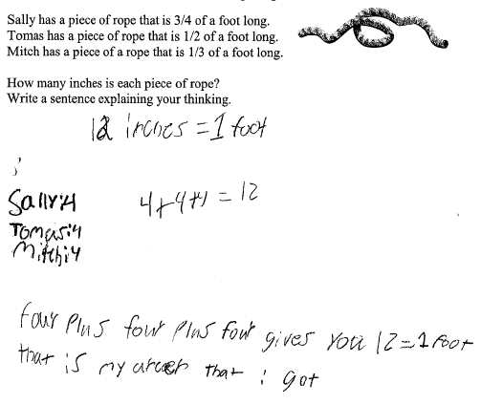

Progressing: This student partitioned a number line into 12 parts and placed the fractions correctly on the number line. The explanation does not clearly demonstrate an understanding of equivalent fractions.

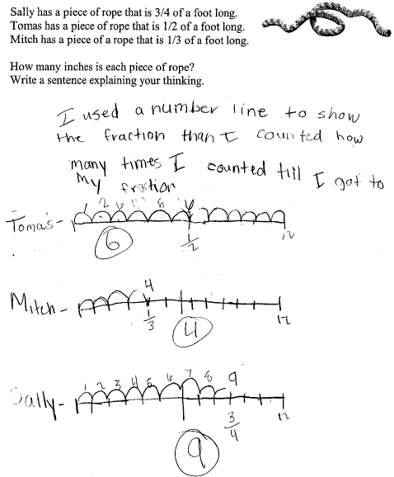

Meets Expectation: This student was able to use models to show how much rope each person has by partitioning the rope based on the denominator in each fraction. The sentence clearly explains the strategy used for finding how many twelfths (or inches) of rope each person has.

