NC.4.NF.2
Enough Soda
Domain | Number and Operation- Fractions
Cluster | Extend understanding of fractions.
Standard(s) | NC.4.NF.2 Compare two fractions with different numerators and different denominators, using the denominators 2, 3, 4, 5, 6, 8, 10, 12, and 100. Recognize that comparisons are valid only when the two fractions refer to the same whole. Record the results of comparisons with symbols >, =, or <, and justify the conclusions by:  • Reasoning about their size and using area and length models.  • Using benchmark fractions 0, ½, and a whole.  • Comparing common numerator or common denominators.
Materials | activity sheet, pencil, graph paper or fraction manipulatives (optional)
Task | Enough Soda  You need 3/4 of a Liter of soda to make punch for a party. Which containers have enough soda in them to make punch? Write a sentence explaining your thinking.  Container A - 2/4 of a Liter  Container B - 2/3 of a Liter  Container C - 5/6 of a Liter  Container D - 11/12 of a Liter  Container E - 7/12 of a Liter  *This task assesses comparing fractions rather than metric measurement. The problem is set in the context of metric measurement; however, students do not need knowledge of metric benchmarks or conversions in order to solve this problem.

Rubric
Level I  Not Yet | Level II  Progressing | Level III  Meets Expectation
The student has not shown the ability to compare fractions using a model, benchmark fractions, or comparing numerators or denominators. Answers are incorrect AND explanation is missing or unclear. | The student is able to compare fractions and finds the correct solutions, but the student’s explanation is unclear.  OR  The student’s explanation is clear and shows the student knows how to compare fractions, but the student made one or more calculation errors. | Answers and explanations are correct. The sentence shows a clear and logical explanation of the student’s strategy.  Solutions: Containers C and D

Standards for Mathematical Practice
1. Makes sense and perseveres in solving problems.
2. Reasons abstractly and quantitatively.
3. Constructs viable arguments and critiques the reasoning of others.
4. Models with mathematics.
5. Uses appropriate tools strategically.
6. Attends to precision.
7. Looks for and makes use of structure.
8. Looks for and expresses regularity in repeated reasoning.

Enough Soda

You need 3/4 of a Liter of soda to make punch for a party. Which containers have enough soda to make punch? Write a sentence explaining your thinking.
Container A - 2/4 of a Liter
Container B - 2/3 of a Liter
Container C - 5/6 of a Liter
Container D - 11/12 of a Liter
Container E - 7/12 of a Liter

Scoring Examples

Not Yet: The student did not demonstrate the ability to compare fractions, and solutions were incorrect.
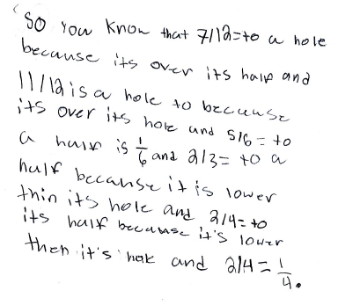
Progressing: The student’s explanation is clear and fractions were compared correctly, but the student made calculator errors.
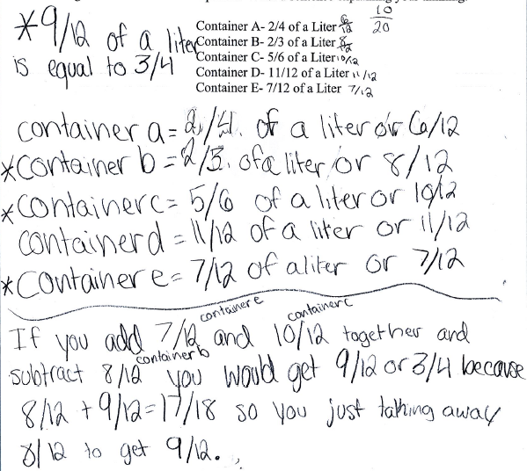

Meets Expectation: The student’s solutions are correct, and explanations demonstrate the strategies the student used to compare the fractions.
