NC.4.NF.1
Patrick’s Patios
Domain | Number & Operations – Fractions
Cluster | Extend understanding of fractions.
Standard(s) | NC.4.NF.1 Explain why a fraction is equivalent to another fraction by using area and length fraction models, with attention to how the number and size of the parts differ even though the two fractions themselves are the same size.
Materials | activity sheet, pencil
Task | Patrick’s Patios  Part 1:  Patrick’s Patio Builders is working on a design for a rectangular patio. Half of the patio is covered with outdoor carpet. The other half of the patio will be created using tiles. There are 4 colors of tile Patrick can use. Each color tile is a different size. Help Patrick determine his options by finding the number of tiles needed to cover the patio in each color. Complete the job sheet below.  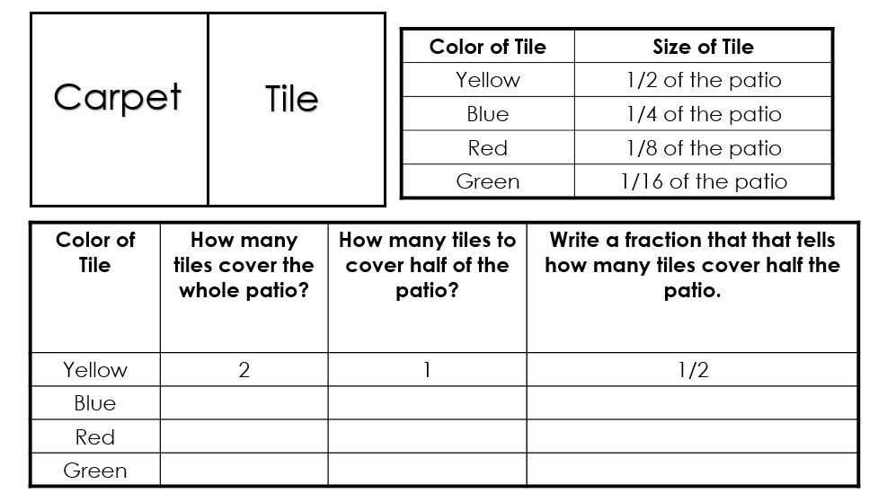  Solutions:  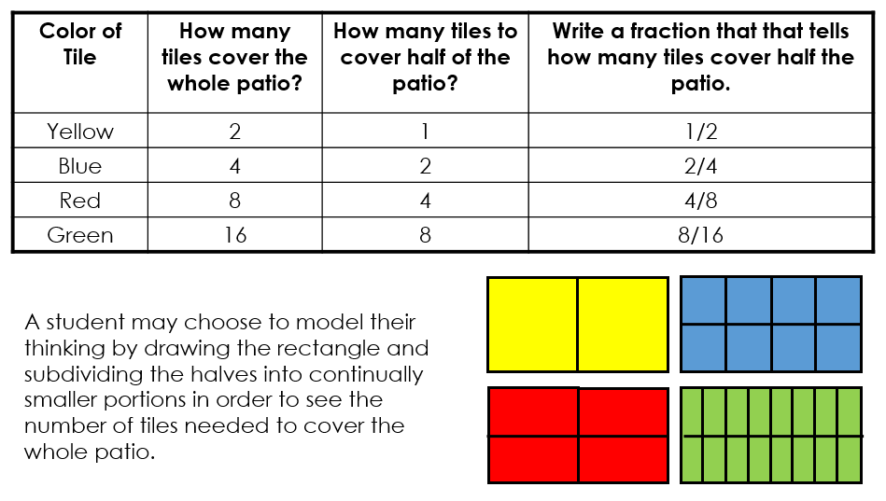  Part 2:  Consider the fractions listed in the table. What patterns do you notice? How does the size of the tiles affect the number of the tiles needed to complete the job?

Rubric
Level I  Not Yet | Level II  Progressing | Level III  Meets Expectation
Student has not shown a clear understanding about how to find equivalent fractions. | Answers are correct, but the explanation is unclear OR work is logically shown but the student has made a calculation error. | Part 1:  Student can determine the number of tiles needed for the whole patio and half of the patio for each color along with the fractions associated with the half.  Part 2:  Student understands that the smaller the denominator, the larger the size of the piece.  AND  Student sees patterns between the fractions, understanding that they are all equivalent to each other.

Standards for Mathematical Practice
1. Makes sense and perseveres in solving problems.
2. Reasons abstractly and quantitatively.
3. Constructs viable arguments and critiques the reasoning of others.
4. Models with mathematics.
5. Uses appropriate tools strategically.
6. Attends to precision.
7. Looks for and makes use of structure.
8. Looks for and expresses regularity in repeated reasoning.

Patrick’s Patios

Part 1: Patrick’s Patio Builders is working on a design for a rectangular patio. Half of the patio is covered with outdoor carpet. The other half of the patio will be created using tiles.

There are 4 colors of tile Patrick can use. Each color tile is a different size. Help Patrick determine his options by finding the number of tiles needed to cover the patio in each color. Complete the job sheet below.

Part 2: Consider the fractions listed in the table. What patterns do you notice? How does the size of the tiles affect the number of the tiles needed to complete the job?

Scoring Examples

Not Yet: The student does not find the correct number of tiles for each color. The student does not accurately explain the patterns created and does not address the changing size of the tiles.
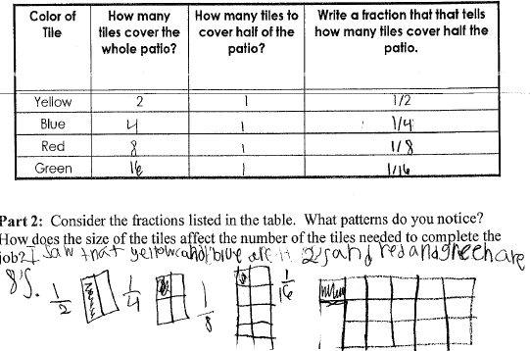
Progressing: The student finds the correct number of tiles for each color. The student partially explains the patterns in the table, but does not completely address how the size of the tile affects the number of tiles needed.
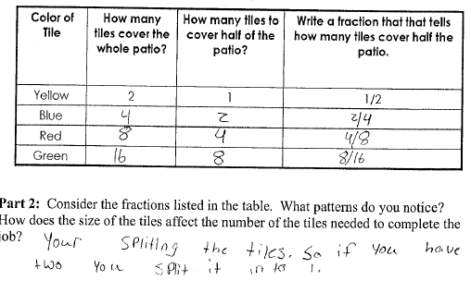
Meets Expectation: The student finds the correct number of tiles for each color. The student can explain the patterns in the table, and the explanation demonstrates an understanding of how the size of the tile affects the number of tiles needed.
