NC.4.NF.2
Pattern Blocks
Domain | Number and Operations - Fractions
Cluster | Extend understanding of fractions.
Standard(s) | NC.4.NF.2 Compare two fractions with different numerators and different denominators, using the denominators 2, 3, 4, 5, 6, 8, 10, 12, and 100. Recognize that comparisons are valid only when the two fractions refer to the same whole. Record the results of comparisons with symbols >, =, or <, and justify the conclusions by:  • Reasoning about their size and using area and length models.  • Using benchmark fractions 0, ½, and a whole.  • Comparing common numerator or common denominators.
Materials | activity sheet, pencil, pattern blocks
Task | Pattern Blocks  Solve the following problems using pattern blocks.  - If a yellow hexagon is one whole, which block represents ½? Which block represents 1/3? Which blocks represent 2/3?  - If a red trapezoid is one whole, which block represents 1/3? Which block represents 2/3?  - If a blue rhombus is one whole, which block represents ½?  - If a blue rhombus is ½ of a whole, what would one whole look like?  - Find one half of a hexagon and one half of a blue rhombus. Write a sentence to explain why they don’t make one whole altogether.  - If a green triangle is 1/3 of a whole, what would one whole look like? How many of these wholes could you make with 3 hexagons?  Solutions:  - Red trapezoid, blue rhombus, 2 of the blue rhombuses  - Green triangle, blue rhombus  - Green triangle  - They aren’t half of the same whole, so they won’t equal one whole when added together.  - Red trapezoid, 6  *Students should be encouraged to find one pattern block to answer questions 1, 2, 3, 4, and 6.

Rubric
Level I  Not Yet | Level II  Progressing | Level III  Meets Expectation
Student solves 0-2 of the problems correctly using pattern blocks. | Student solves 3-8 of the problems correctly using pattern blocks. | Student solves 9-10 of the problems correctly using pattern blocks.

Standards for Mathematical Practice
1. Makes sense and perseveres in solving problems.
2. Reasons abstractly and quantitatively.
3. Constructs viable arguments and critiques the reasoning of others.
4. Models with mathematics.
5. Uses appropriate tools strategically.
6. Attends to precision.
7. Looks for and makes use of structure.
8. Looks for and expresses regularity in repeated reasoning.

Pattern Blocks

Solve the following problems using pattern blocks.

- If a yellow hexagon is one whole, which block represents ½?
Which block represents 1/3? Which blocks represent 2/3?

- If a red trapezoid is one whole, which block represents 1/3?
Which block represents 2/3?

- If a blue rhombus is one whole, which block represents ½?

- If a blue rhombus is ½ of a whole, what would one whole look like?

- Find one half of a hexagon and one half of a blue rhombus. Write a sentence to explain why they don’t make one whole altogether.

- If a green triangle is 1/3 of a whole, what would one whole look like?
How many of these wholes could you make with 3 hexagons?

Scoring Examples

Not Yet: The student solved one problem correctly.

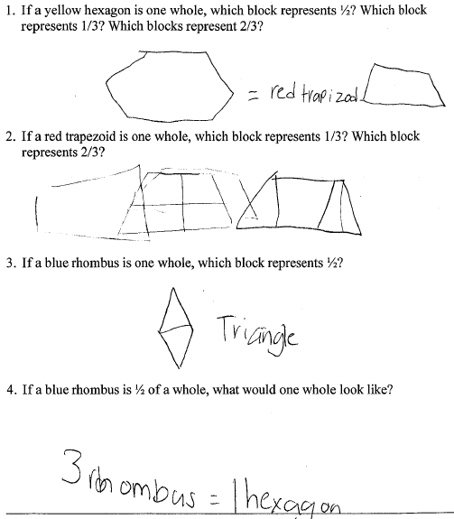
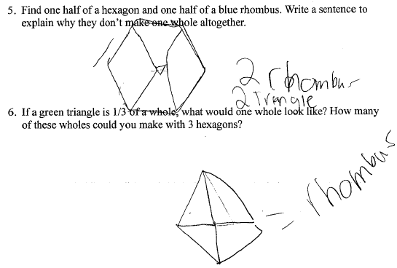

Progressing: The student solved 7 of the problems correctly using pattern blocks.

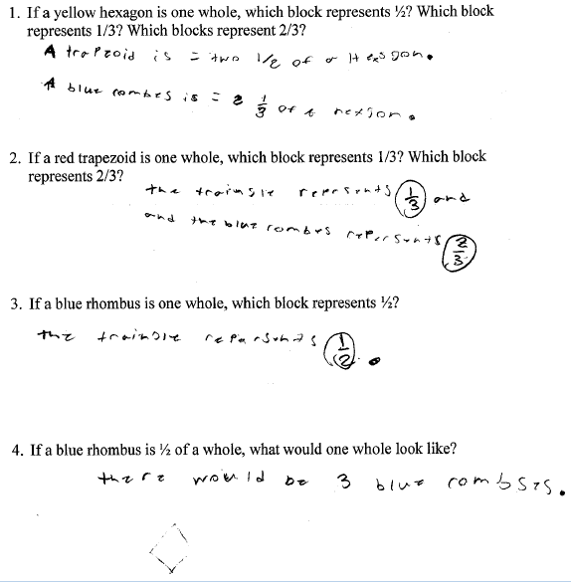
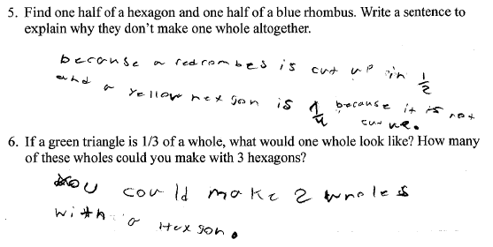

Meets Expectation: The student solved 9 of the problems correctly using pattern blocks.

