NC.4.NF.2
The Whole Matters
Domain | Number and Operations - Fractions
Cluster | Extend understanding of fractions.
Standard(s) | NC.4.NF.2 Compare two fractions with different numerators and different denominators, using the denominators 2, 3, 4, 5, 6, 8, 10, 12, and 100. Recognize that comparisons are valid only when the two fractions refer to the same whole. Record the results of comparisons with symbols >, =, or <, and justify the conclusions by:  • Reasoning about their size and using area and length models.  • Using benchmark fractions 0, ½, and a whole.  • Comparing common numerator or common denominators.
Materials | activity sheet, pencil
Task | The Whole Matters  Task 1:  Two friends each ate ½ of a pizza. Joselin says they must have eaten the same amount, but Donnie says they could have eaten different amounts. Who do you think is correct, and why? Explain your thinking in words, pictures, and numbers.  Possible solution: The two friends could have each eaten half of two different size pizzas. Half of a large pizza is more than half of a medium pizza, because the wholes are not the same size.  Task 2:  Mrs. Johnson and Mrs. Black each gave ½ of their students a pencil. Mrs. Johnson handed out 5 more pencils than Mrs. Black. What can we say about the number of students in each class? If Mrs. Johnson handed out 16 pencils and that was 5 more than Mrs. Black, how many students are in each class?  Possible solution: Mrs. Black must have 22 students in her class. Mrs. Johnson must have 32 students in her class.  Task 3:  Jerry made one gallon of sweetened tea and one half gallon of lemonade for a picnic. If he drank ¼ of each container, how many cups of tea did he drink? How many cups of lemonade? *1 gallon = 16 cups  If Jerry drank 2 cups of lemonade and 2 cups of tea, what fraction of the tea did he drink? What fraction of the lemonade did he drink?  Possible solution:  Question 1: Jerry drank 4 cups of tea and 2 cups of lemonade.  Question 2: Jerry drank 1/8 of the gallon of tea and ¼ of the half gallon of lemonade.  *Connect the three tasks by discussing with students how the size of the wholes matters in each context.

Rubric
Level I  Not Yet | Level II  Progressing | Level III  Meets Expectation
Student is unable to solve Task 1, 2, or 3. In order to progress, students must acknowledge the size of the whole when making comparisons about fractions. | Student can solve 1 or 2 of the 3 tasks correctly with a complete explanation. | Student can solve and explain their answers to all three tasks.

Standards for Mathematical Practice
1. Makes sense and perseveres in solving problems.
2. Reasons abstractly and quantitatively.
3. Constructs viable arguments and critiques the reasoning of others.
4. Models with mathematics.
5. Uses appropriate tools strategically.
6. Attends to precision.
7. Looks for and makes use of structure.
8. Looks for and expresses regularity in repeated reasoning.

The Whole Matters

Task 1:
Two friends each ate ½ of a pizza. Joselin says they must have eaten the same amount, but Donnie says they could have eaten different amounts. Who do you think is correct, and why? Explain your thinking in words, pictures, and numbers.

Task 2:
Mrs. Johnson and Mrs. Black each gave ½ of their students a pencil. Mrs. Johnson handed out 5 more pencils than Mrs. Black. What can we say about the number of students in each class?

If Mrs. Johnson handed out 16 pencils and that was 5 more than Mrs. Black, how many students are in each class?

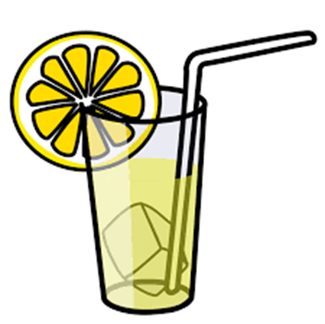
The Whole Matters

Task 3:
Jerry made one gallon of sweetened tea and one half gallon of lemonade for a picnic. If he drank ¼ of each container, how many cups of tea did he drink?
How many cups of lemonade?

*1 gallon = 16 cups

If Jerry drank 2 cups of lemonade and 2 cups of tea, what fraction of the tea did he drink? What fraction of the lemonade did he drink?

Scoring Examples

Not Yet: The student did not answer any of the problems correctly.

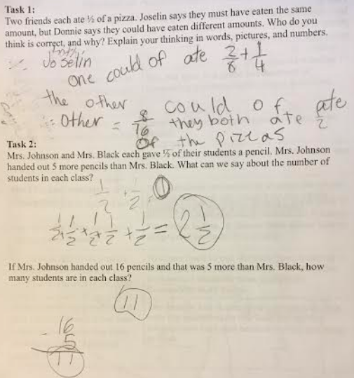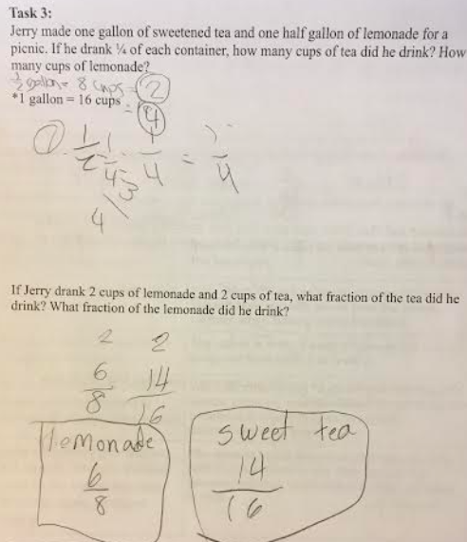

Progressing: The student answered two of the three tasks correctly. Models in part 3 were incorrect.

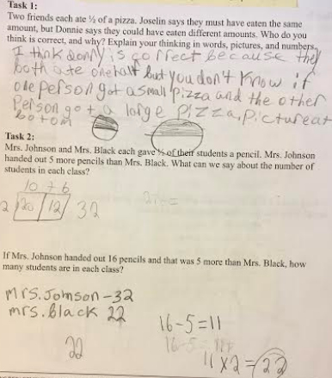
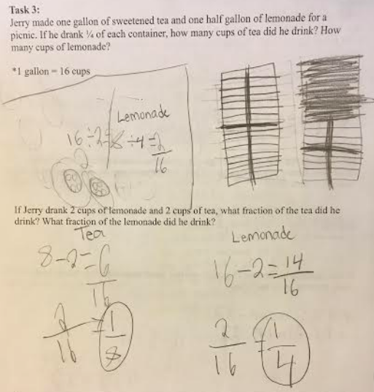

Meets Expectation: The student provided correct answers, models, and explanations for all parts.

