NC.4.NF.2
Tomato Gardens
Domain | Number and Operations - Fractions
Cluster | Extend understanding of fractions.
Standard(s) | NC.4.NF.2 Compare two fractions with different numerators and different denominators, using the denominators 2, 3, 4, 5, 6, 8, 10, 12, and 100. Recognize that comparisons are valid only when the two fractions refer to the same whole. Record the results of comparisons with symbols >, =, or <, and justify the conclusions by:  • Reasoning about their size and using area and length models.  • Using benchmark fractions 0, ½, and a whole.  • Comparing common numerator or common denominators.
Materials | activity sheet, pencil, grid paper
Task | Tomato Gardens  Solve the following problems using grid paper.  Justin planted tomatoes in 1/3 of his 6' x 6' garden. Gina planted tomatoes in 1/3 of her 8' x 6' garden.  - How many square feet of the garden did Justin use for tomatoes?  - How many square feet of the garden did Gina use for tomatoes?  - If each person planted 1/3 of their garden with tomatoes, why did they use a different amount of square feet?  Solutions:  a. 12 square feet  b. 16 square feet  c. Gina’s garden is larger, so 1/3 of it will be a larger amount of square feet.

Rubric
Level I  Not Yet | Level II  Progressing | Level III  Meets Expectation
Student was unable to correctly answer any part of the task. | Student answered one or two parts of the task correctly. | Student answered all three parts of the task correctly, and the explanation showed that 1/3 of the gardens could not be the same amount since the gardens were different in size.

Standards for Mathematical Practice
1. Makes sense and perseveres in solving problems.
2. Reasons abstractly and quantitatively.
3. Constructs viable arguments and critiques the reasoning of others.
4. Models with mathematics.
5. Uses appropriate tools strategically.
6. Attends to precision.
7. Looks for and makes use of structure.
8. Looks for and expresses regularity in repeated reasoning.

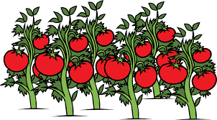
Tomato Gardens

Solve the following problems using grid paper.

Justin planted tomatoes in 1/3 of his 6' x 6' garden. Gina planted tomatoes in 1/3 of her 8' x 6' garden.

- How many square feet of the garden did Justin use for tomatoes?

- How many square feet of the garden did Gina use for tomatoes?

- If each person planted 1/3 of their garden with tomatoes, why did they use a different amount of square feet?

Scoring Examples

Not Yet: The student did not show thirds as equal parts and did not answer any part of the task correctly.

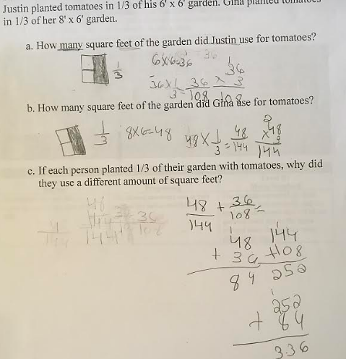

Progressing: The student answered 2 parts of the task correctly, but made a calculation error in Part B. The explanation correctly explained why the gardens could not be the same size.

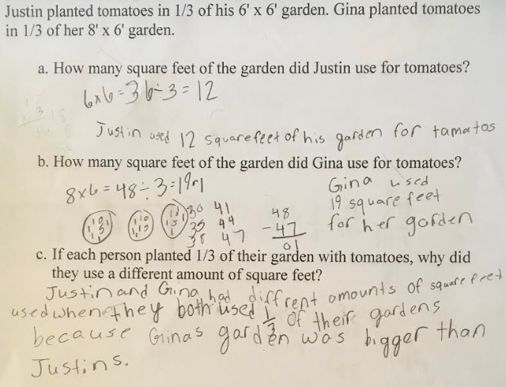

Meets Expectation: The student answered all parts of the task correctly and explained why 1/3 of the gardens would be different sizes.

