NC.4.NF.1
Trading Blocks
Domain | Number & Operations – Fractions
Cluster | Extend understanding of fractions.
Standard(s) | NC.4.NF.1 Explain why a fraction is equivalent to another fraction by using area and length fraction models, with attention to how the number and size of the parts differ even though the two fractions themselves are the same size.
Materials | pattern blocks, activity sheet, pencil  *Online pattern blocks can be found at http://illuminations.nctm.org/ActivityDetail.aspx?ID=27
Task | Trading Blocks  The two yellow hexagons have a value of 1 whole.  Part One:  - What is the fractional value of 3 red trapezoids? What is the fractional value of 1 red trapezoid?  - If you have 3 red trapezoids, how many green triangles would it take to cover the same area? What is the fractional value of the all the green triangles? What is the fractional value of 1 green triangle?  - Write an equation expressing the relationship between the red trapezoids and the green triangles.  Solutions:  - 3 red trapezoids = ¾; 1 red trapezoid = ¼  - It would take 9 green triangles to cover 3 red trapezoids; 9/12 is the fractional value of the all the green triangles; 1 green triangle = 1/12  - 3/4 = 9/12  Part Two:  - If two yellow hexagons have a value of 1 whole, what is the value of 4 blue rhombuses? What is the value of 1 blue rhombus?  - If you have 4 blue rhombuses how many green triangles would it take to cover the same area? What is the fractional value of all the green triangles, remembering that 2 yellow hexagons equal 1 whole? What is the value of 1 green triangle?  - Write an equation expressing the relationship between the number of blue rhombuses and the number of green triangles.  Solutions:  - 4 blue rhombuses = 2/3; 1 blue rhombus = 1/3  - It would take 8 green triangles to cover 4 blue rhombuses; 8/12 is the fractional value of all the green triangles; 1 green triangle = 1/12  - 2/3 = 8/12

Rubric
Level I  Not Yet | Level II  Progressing | Level III  Meets Expectation
The student is able to demonstrate equivalent fractions for 0-3 items in this task. | The student is able to demonstrate equivalent fractions for 4-9 items in this task. | The student is able to demonstrate equivalent fractions for 10-12 items in this task.

Standards for Mathematical Practice
1. Makes sense and perseveres in solving problems.
2. Reasons abstractly and quantitatively.
3. Constructs viable arguments and critiques the reasoning of others.
4. Models with mathematics.
5. Uses appropriate tools strategically.
6. Attends to precision.
7. Looks for and makes use of structure.
8. Looks for and expresses regularity in repeated reasoning.

Trading Blocks
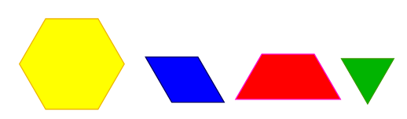

The two yellow hexagons have a value of 1 whole.

Part One:
What is the fractional value of 3 red trapezoids?

What is the fractional value of 1 red trapezoid?

If you have 3 red trapezoids, how many green triangles would it take to cover the same area?

What is the fractional value of all the green triangles?

What is the fractional value of 1 green triangle?

Write an equation expressing the relationship between the red trapezoids and the green triangles.

Trading Blocks
The two yellow hexagons have a value of 1 whole.

Part Two:
What is the fractional value of 4 blue rhombuses?

What is the fractional value of 1 blue rhombus?

If you have 4 rhombuses how many green triangles would it take to cover the same area?

What is the fractional value of all the green triangles?

What is the fractional value of 1 green triangle?

Write an equation expressing the relationship between the blue rhombuses and the green triangles.

Scoring Examples

Not Yet: The student confused the size of the whole and was able to demonstrate understanding of equivalent fractions on very few aspects of the task.
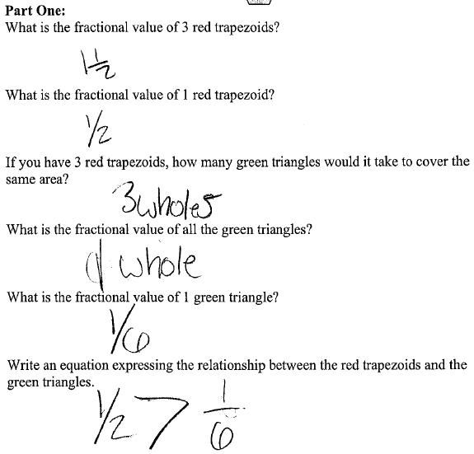
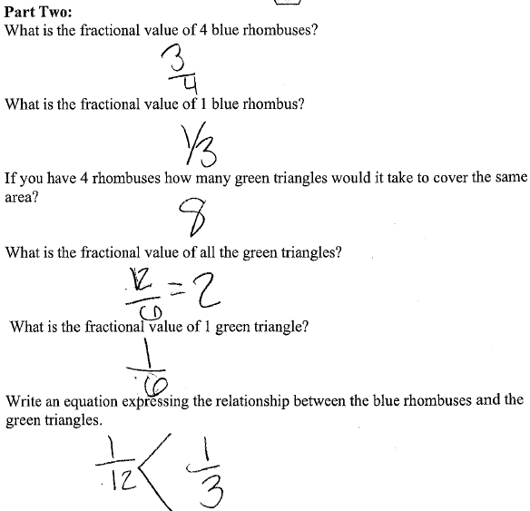

Progressing: This student was able to demonstrate understanding of how to find equivalent fractions for some of the problems. However, the student often lost track of the whole being two hexagons.
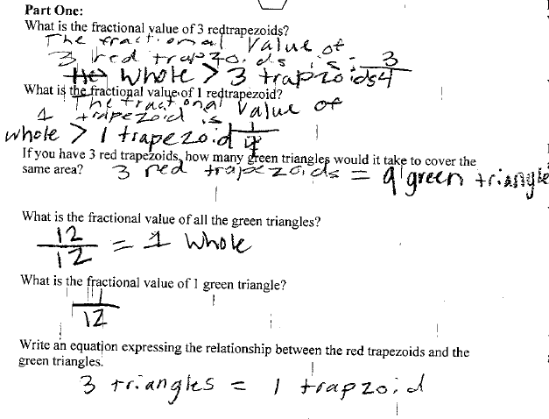
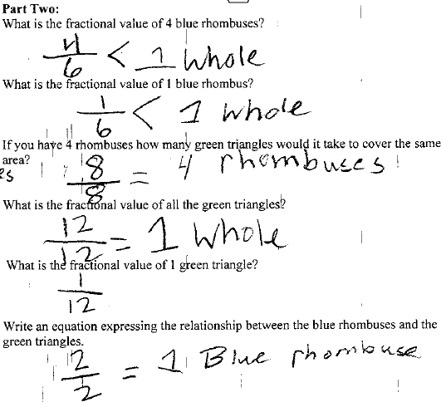

Meets Standard: The student answered all aspects of the task correctly.
