Fraction Buckets
In this lesson, students compare fractions and justify their reasoning with models and/or written explanations.

NC Mathematics Standards:
Number and Operations - Fractions
NC.4.NF.2 Compare two fractions with different numerators and different denominators, using the denominators 2, 3, 4, 5, 6, 8, 10, 12, and 100. Recognize that comparisons are valid only when the two fractions refer to the same whole. Record the results of comparisons with symbols >, =, or <, and justify the conclusions by:
- Reasoning about their size and using area and length models.
- Using benchmark fractions 0, ½, and a whole.
- Comparing common numerator or common denominators

Standards for Mathematical Practice:
3. Construct viable arguments and critique the reasoning of others.
4. Model with mathematics.
5. Use appropriate tools strategically.
6. Attend to precision.

Student Outcomes:
- I can compare fractions and explain my reasoning.
- I can use benchmark fractions and equivalent fractions to help me compare fractions.

Math Language:
- equivalent fractions
- numerator
- denominator
- benchmark
- compare
- greater than/ less than

Materials:
- Fraction Cards , 1 set per partner group
- Fraction Bucket sheets, 1 set per partner group
- Fraction manipulatives such as fraction tiles or strips of paper to create tape diagrams

Advance Preparation:
- Gather materials, cut out fraction cards, make the Fraction Bucket Cards

Launch:
- Introducing Fraction Buckets (5 minutes)
Show the students the fraction buckets. You may use the attached sheets to represent buckets or use three real buckets with labels 0, ½, and 1.

Explain that in a few moments students will be working with a partner to place many different fractions in the correct bucket based on these three benchmarks and where they best fit.

Explore:
- Placing Fraction Cards (15-20 minutes)
Each pair of students should receive a copy of the fraction bucket cards and a set of fraction cards. Students lay out the fraction bucket cards in the correct order. Shuffle the fraction cards and place them face down in front of themselves. Take turns flipping over a fraction card and placing them on the correct bucket. As the card is being placed on the bucket, the student must explain why they are choosing that particular bucket. If the partner agrees with the explanation, another card is flipped and the students continue. If the partner does not agree with the explanation, they get a turn to explain where they think it goes.

Circulate around the room to observe the students at work. Listen to students reasoning as they place a card. Ask student to re-explain why a card is place in a certain bucket. If there is a card that is not agreed upon, listen to both arguments, and help students find other cards that may help them make a final decision. Encourage students to share their strategies with one another and describe how they are placing the fractions.

Purposefully select students and fraction card discussions to present to the class. Look for students who discussed the size of the fraction and how they used the benchmark or another fraction to help. Also look for strategies that will generate discussion to help others move toward a deeper understanding of ordering fractions.

Discuss:
- Discussion of Solutions (10-15 min)
Bring the group back together and have selected students share their strategies for solving the task.
Possible points to address and questions to ask:
- Why did you choose to place that fraction there? What strategy helped you?
- Could we place another fraction using ______’s strategy?
- What is another fraction that could go in that bucket?
- Place a fraction in the wrong bucket and see if students can explain your error.
- Give a fraction that is greater than a whole and ask them where it should go.
After the discussion, ask students to return to their seats and use models and words to tell about how they decided where to place three of their fractions.

Evaluation of Student Understanding:
Informal Evaluation:
- Observe and monitor students as they solve the problem. How are they making sense of the problem? Can they name equivalent fractions? Can they explain why it’s greater or less than a benchmark? Can they draw a model of the fraction?
Formal Evaluation/Exit Ticket:
- Give students blank fraction cards and have them create fractions for their partner to place.

Meeting the Needs of the Range of Learners:
Interventions:
- Suggest that students use manipulatives, models or number lines to help them solve the task and visualize fractions.
Extensions:
- Divide the cards between two students. Place the cards face down. Each student takes their first card and places it in the correct bucket. The student with the largest card takes their opponents card. If a card is misplaced it is automatically forfeited. If there is a tie, a second card is drawn, and the winner takes all the cards.
- In their math journal, write rules for how to know which fractions belong in each bucket.

Possible Misconceptions/Suggestions:
Possible Misconceptions | Suggestions
- Students are incorrectly placing cards.  - Students cannot create equivalent fractions. | - Can you draw a model for that? What is an equivalent fraction of that card that can help us make sense of where I should put the card?  - Using graph paper, start with ½ of a rectangle shaded and explore different ways to create fourths and eighths. You could also start with 1/3 of a rectangle shaded and explore different ways to create sixths.

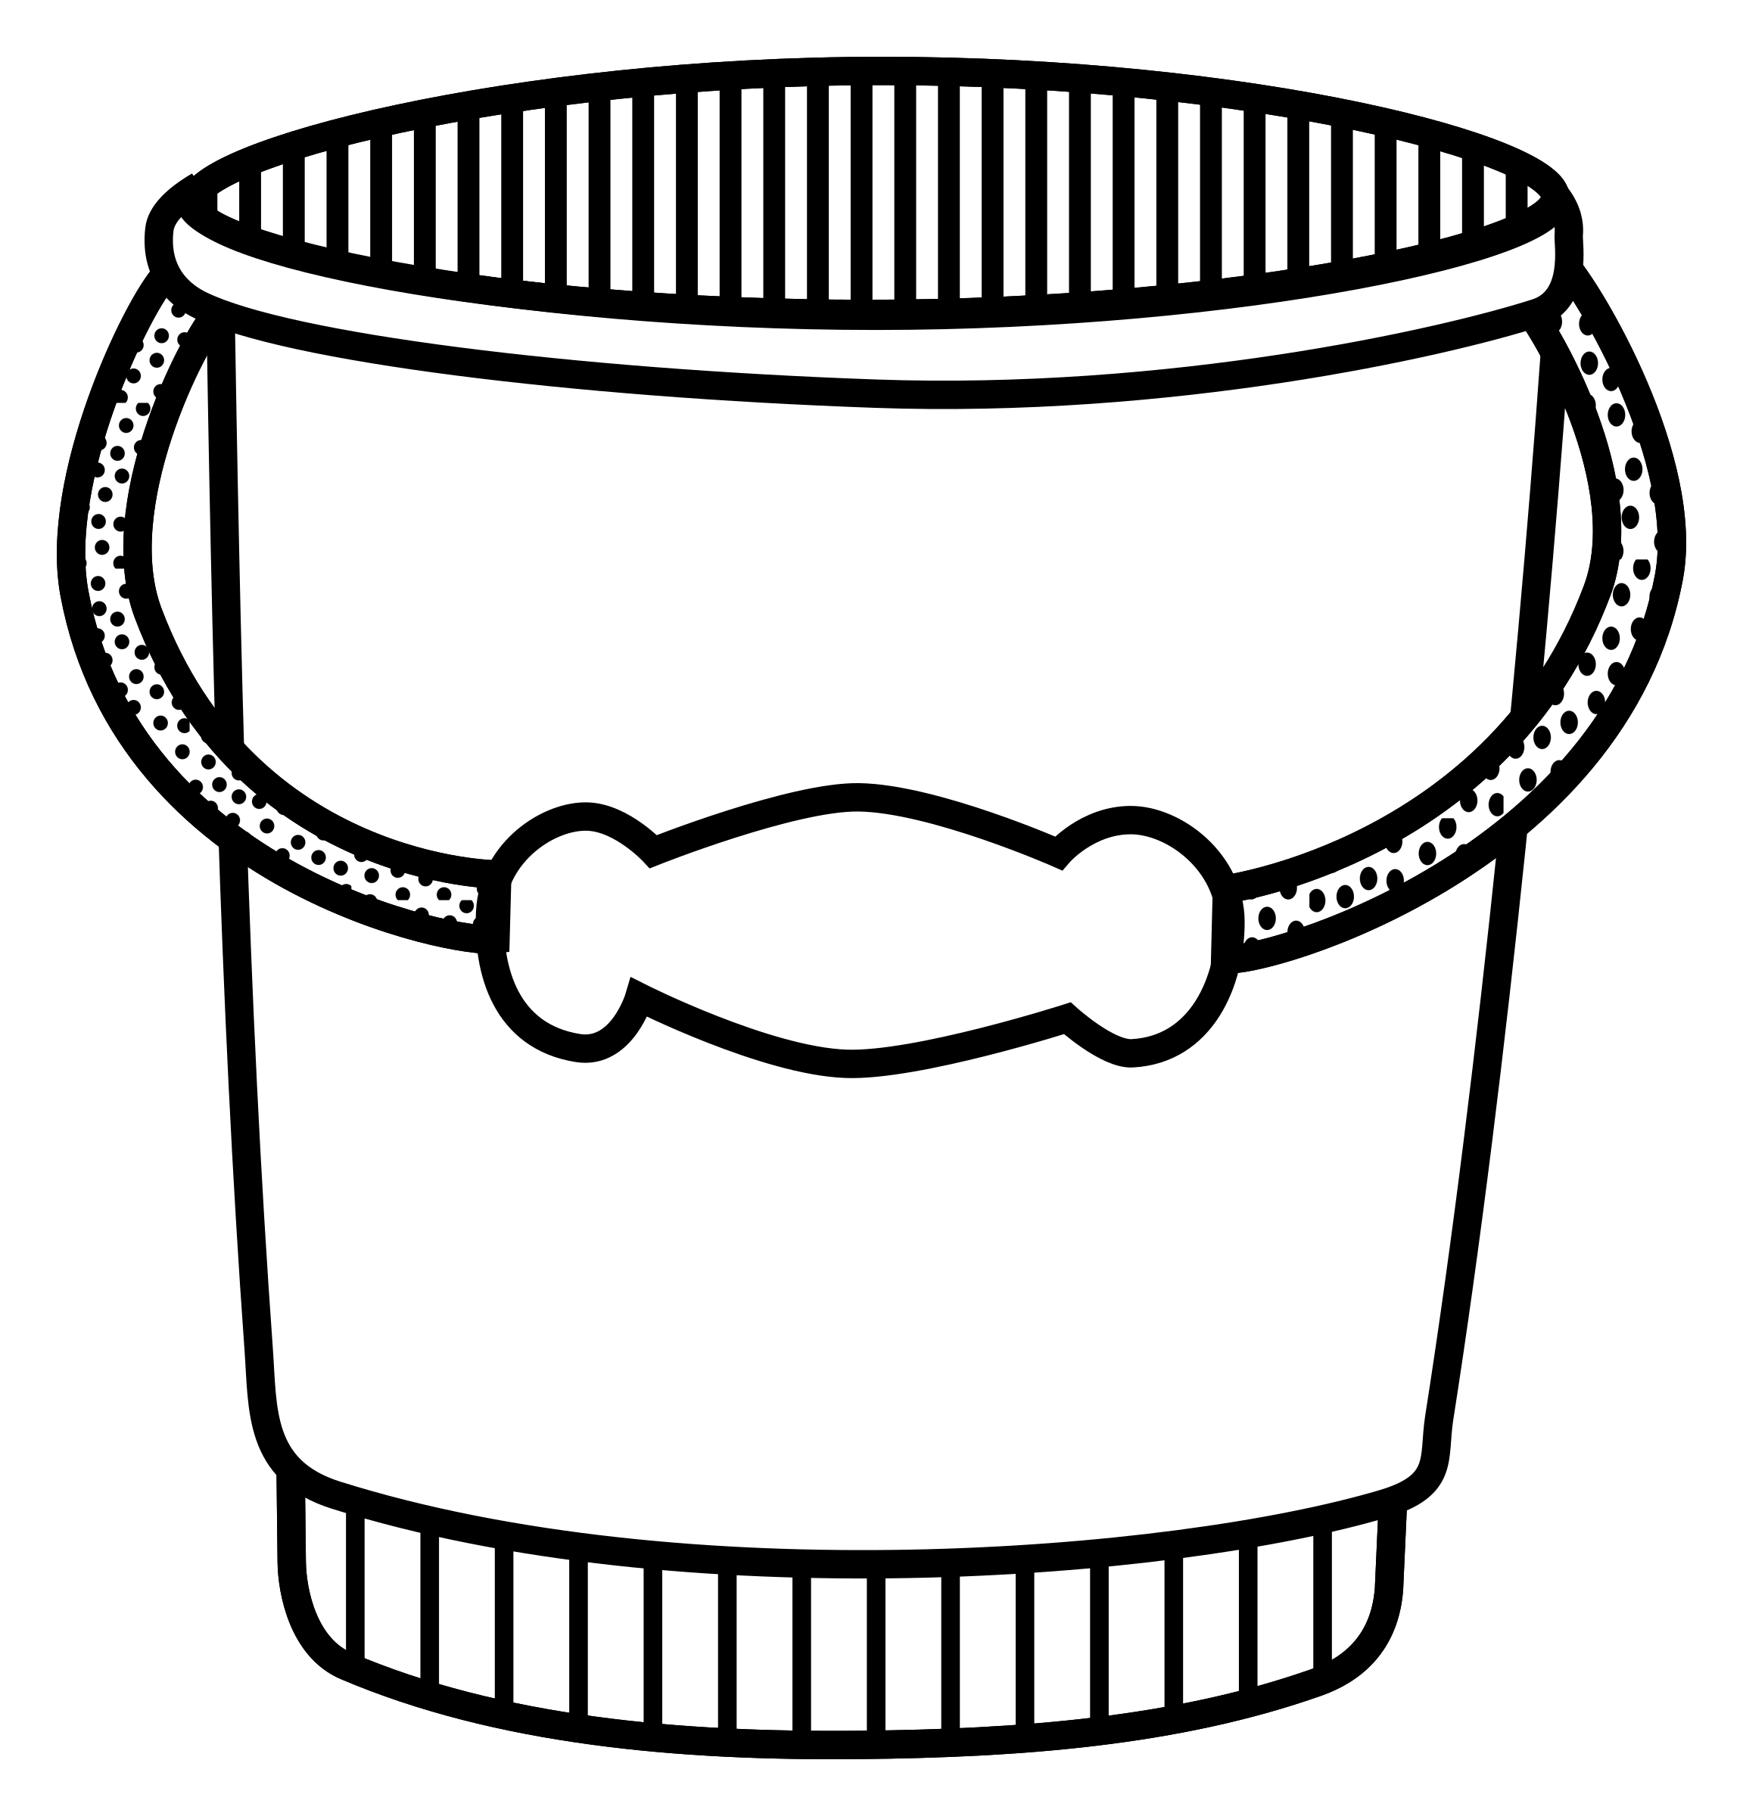
0
1/2
1
1  _____  2 | 3  _____  2 | 5  _____  2 | 1  _____  3
2  _____  3 | 3  _____  3 | 6  _____  3 | 1  _____  4
2  _____  4 | 3  _____  4 | 4  _____  4 | 5  _____  4
1  _____  5 | 3  _____  5 | 4  _____  5 | 5  _____  5
6  _____  5 | 9  _____  5 | 2  _____  6 | 3  _____  6
5  _____  6 | 6  _____  6 | 2  _____  8 | 4  _____  8
5  _____  8 | 8  _____  8 | 11  _____  8 | 3  _____  10
5  _____  10 | 9  _____  10 | 10  _____  10 | 3  _____  12
6  _____  12 | 9  _____  12 | 12  _____  12 | 10  _____  20

