Fractions: Finding Half
In this lesson, students work with geoboards to explore the meaning of halves and fourths.

NC Mathematics Standard:
Number and Operations - Fractions
NC.4.NF.1 Explain why a fraction is equivalent to another fraction by using area and length fraction models, with attention to how the number and size of the parts differ even though the two fractions themselves are the same size.

Standards for Mathematical Practice:
1. Make sense of problems and persevere in solving them.
3. Construct viable arguments and critique the reasoning of others.
4. Model with mathematics.

Student Outcomes:
- I can find fractional parts of a rectangular area.
- I can demonstrate that the same-sized fraction of a whole can be shaped differently.
- I can interpret the meaning of a numerator and the denominator of a fraction.

Math Language:
- half
- fourth
- third
- equal parts
- area
- symmetry

Materials:
- geoboards/rubber bands or laptops and site https://apps.mathlearningcenter.org/geoboard/
- geoboard recording sheet (front and back for Parts 1 and 2) https://www.sgasd.org/cms/lib/PA01001732/Centricity/Domain/692/G2M14_Geoboard_Recording_Sheet.pdf
- colored pencils
- poster of the recording sheet
- rectangle recording sheet

Part I: Showing Half on the Geoboard
Launch:
- Introduce the Task to Students (5 minutes)
Give each student a geoboard, a set of rubber bands, and a recording sheet. Students may also use a virtual geoboard on laptops. Instruct them to create a large square by wrapping a rubber band around the pegs at the edges of the board. Tell students that their challenge is to find as many different ways as possible to show half of the large geoboard square. Tell them that there are many, many ways to show half. They should record each possibility on the recording sheet with a colored pencil.

Explore:
- Solving the Problem (15 minutes)
Give students time to work individually and with a partner to complete the task. As students work, observe to see how they are displaying half on the geoboard. Encourage students to share their strategies with one another and describe how they know it is half.
Observe:
- How do students create half on the geoboard?
- What misconceptions do they have?
- What are the different ways they can create half on the geoboard?

Questions:
- Is there another way that you could show half on the geoboard?
- Can you show half without just one straight line?
- How do you know or how can you prove that you have created half?
- Even though your geoboard looks different from your partner’s, how do you know they both show half?

Purposefully select students to present to the class. Look for students who modeled half on the geoboard in different ways and demonstrate an understanding of half. Be sure to select unique examples that challenge students’ misconceptions about half.

Discuss:
- Discussion of Solutions (15 minutes)
Bring the group back together and have the selected students share how they created half on the geoboard. Begin by showing the typical responses – divided horizontally, vertically, and diagonally. Discuss why each of these displays represents half. Students will often say they look the same, they are cut in the middle, they show the same amount, or the shapes can be folded to make the same (congruent) shape (symmetry).

Next, select an unusual representation of half (like the example below). Have students explain why this represents half of the geoboard.
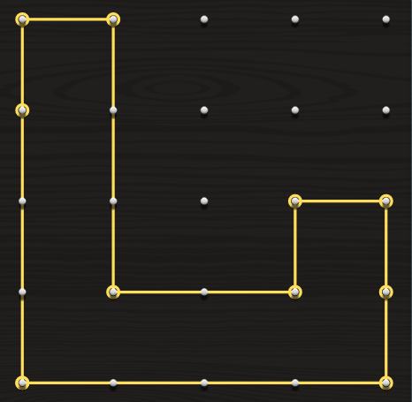
Through the discussion, you want students to learn that half is not always represented by congruent shapes, but rather by equal areas. This example does not look like the “typical” representation of half. Students need to move beyond congruent shapes and look at equal areas. Students should count the square units or area of figure, realizing that both the figure and the outer region have an area of 8 square units.
Continue to have selected students share how they created half. Encourage students to explain and justify why their geoboard displays half of the square using area and square units. Additional points to address during the discussion:
- The meaning of half
- Ways to prove half (folding, symmetry, counting the area)
- Same-sized fraction of a whole can be shaped differently
- Fraction notation, unit fractions (amount formed by one of the parts)
- Denominators and numerators
- Numerator: The counting number. It tells how many shares or parts of a certain size are being counted.
- Denominator: Tells fractional part being counted. The number of equal parts into which the whole is partitioned; parts or shares of the whole
- Equivalent fractions

If needed, allow students to return to their seats after the discussion to continue showing half of the square in multiple ways. Display unique examples and have students justify their answers.

Part II: Changing the Fraction (20-30 minutes)
Launch:
- Introduce the Problem
Tell students that now they are going to use the same process to try to find different ways to make fourths on the geoboard. They should record each possibility on the recording sheet with a colored pencil.

Explore:
- Solving the Problem
Have students explore different ways to make one fourth on the geoboard just as they did with one half. Continue to observe strategies students are using to find fourths (counting area, folding, etc.)
Questions:
- Is there another way that you could show one fourth on the geoboard?
- How do you know or how can you prove that you have created a fourth?
- How does your work with making one half help you know that you have one fourth?
Select a few students to share how they created fourths.

Discuss:
- Discussion of Solutions
Bring the group back together and have the selected students share how they created fourths on the geoboard. Use some of the questions above to continue to guide discussion. Encourage students to explain and justify why their geoboard displays fourth of the square. How does finding fourths compare to finding half? Discuss any unusual examples.

Ask students to reflect in their journals about the following questions:
If you were asked to find eighths on the geoboard, what process would you use?
What important things did you discover about fractions today?

Evaluation of Student Understanding:
Informal Evaluation:
- Observe and monitor students as students are working on the geoboards. How are students creating fractional amounts?
Formal Evaluation/Exit Ticket:
- Give students a handout of 4x6 rectangles. Have them show one half as many ways as they can with the different whole.

Meeting the Needs of the Range of Learners:
Interventions:
- Students who are struggling may work better with geoboards with fewer squares. You may be able to find some online, but you can also draw two by two squares/rectangles to work with before moving to the larger area.
Extensions:
- Changing the Whole: Display a 4 x 6 rectangle and have students identify and color half (third, fourth, etc.) of the rectangle. Instruct students to color several examples on a handout of 4 x 6 rectangles to show the fractional amount you give them. What other fractions could they display on the 4 x 6 rectangles?

Possible Misconceptions/Suggestions:
Possible Misconceptions | Suggestions
- Students only think of one half as cutting down the middle.  - Students don’t understand that one half is two equal parts. | - Give students multiple representations of objects that they can rearrange or lay on top of each other to prove that they are half.  - Discuss “fair sharing” half meaning equal pieces.

Special Notes:
Many students will divide the geoboard down the middle when initially making half and not think outside of the box to find other ways. You may need to bring the group together during the explore time to discuss the typical examples such as drawing the line down the middle. Discuss why these examples are half and then send them off to explore again to find other ways to make half. Wait time is critical. Allow students time to productively struggle and think creatively about this task.

Possible Solutions:
Here are some unique ways that students could show one-half using the geoboard. These were created at https://apps.mathlearningcenter.org/geoboard/.
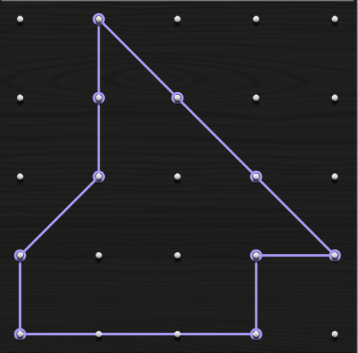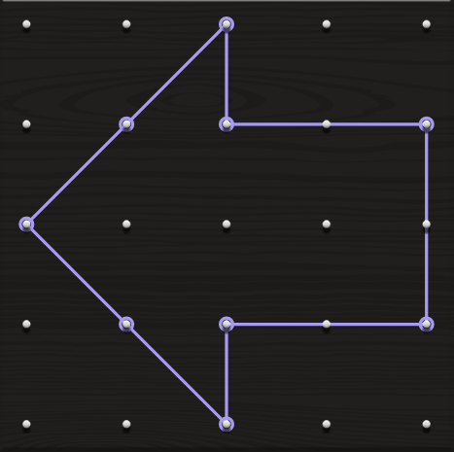
Rectangle Paper Recording Sheet

