Place the Fraction

In this lesson, students will use various comparison strategies, including benchmark fractions, to sort a set of fraction cards into three categories: less than ½, equivalent to ½, and greater than ½.

NC Mathematics Standards:
Number and Operations - Fractions
NC.4.NF.2 Compare two fractions with different numerators and different denominators, using the denominators 2, 3, 4, 5, 6, 8, 10, 12, and 100. Recognize that comparisons are valid only when the two fractions refer to the same whole. Record the results of comparisons with symbols >, =, or <, and justify the conclusions by:
- Reasoning about their size and using area and length models.
- Using benchmark fractions 0, ½, and a whole.
- Comparing common numerator or common denominators.

Standards for Mathematical Practice:
1. Make sense of problems and persevere in solving them.
2. Reason abstractly and quantitatively.
3. Construct viable arguments and critique the reasoning of others.
4. Model with mathematics.
6. Attend to precision.

Student Outcomes:
- I can use benchmark fractions to compare fractions.
- I can find fractions equivalent to one-half and one-whole.

Math Language:
- benchmark fraction
- less than, greater than, equal to
- equivalent
- numerator/denominator
- number line

Materials:
- Fraction Cards (one set per pair)
- Work Mat/Recording Sheet (one per pair)

Advance Preparation:
- Make fraction cards (one set per pair).
- Arrange the labels (0, 1/2, 1) on a number line so that students can see and access them.
  - A number line can be created with yarn or string and hung across the board or other central location. Clothes pins or paper clips can be used to attach index cards or paper plates to the number line.
- Create an anchor chart with three different groups (less than a half, equivalent to a half, greater than a half).

Launch:
- Introduction of Task (10 minutes)
Post a number line at the front of the room with the benchmarks 0, ½, 1 labeled on the number line. Introduce the term “benchmark fractions” to students and relate to 0, ½, and 1. Benchmarks are common numbers (such as 0, ½, or 1) that help us judge or determine the size and relationships of fractions.

Give each pair of students a set of fraction cards and a work mat. Explain to students that they will be using the fraction cards and sorting them into three categories (less than ½, equivalent to ½, greater than ½). Encourage students to use a variety of strategies (including benchmark fractions) to determine where the fractions should be placed on the chart.

Explore:
- Sorting Fractions (15 minutes)
Walk around and monitor students as they work on the task with their partners. Remind students to explain their thinking and use precise language as they justify the placement of each fraction. Listen for vocabulary such as numerator, denominator, greater than, less than, equal to, equivalent, and benchmarks. If students are finished early, have them justify their answers in writing, explaining each fraction and why they placed it where they did.

Question students as they are working on the task.
Possible questions:
- What do you know about the fraction ____?
- What is the relationship between the numerator and denominator?
- Do you think this fraction is closer to 0, ½, 1? Why?
- What strategies can you use to determine whether fractions are closer to 0, 1/2, or 1?
- How do you know where this fraction should be placed? Why?
- What is your strategy for placing these fractions?
- Which benchmark fraction helped you place the fraction into the correct category?

Select specific students to share their ideas about different fractions; where and why they placed them on the work mat. (Example: Student A believes 6/8 is more than a half because one-half would be 4/8, and 6/8 is 2/8 more than 4/8, making it a larger fraction than one-half.) Select students based on specific strategies you would like to highlight or common misconceptions you would like to discuss. Strategies may include the use of models or manipulatives, using benchmark fractions, or comparing common numerators or common denominators.

Discuss:
- Discussion (15 – 20 minutes)
After students have had time to sort the fractions, come back together and have a discussion about each fraction. Have preselected students share the different strategies they used to sort the fractions. Use the class number line to show the placement of the fraction and reinforce student reasoning. Together, create a classroom chart and record each fraction on the chart as students discuss their strategies. Discuss any misconceptions or difficulties students had when sorting the fractions.

When discussing the fractions 3/6, 5/10, and 3/3, review the word “equivalent”. What does equivalent mean? How can you prove these fractions are equivalent to one-half (or one-whole)? What other fractions are equivalent to one-half and one-whole? How do you know?

Return to the learning targets or “I Can” statements of the day. (I can use benchmark fractions to compare fractions. I can find fractions equivalent to one-half and one-whole.) Have students reflect (verbally or in writing) on how they were able to determine which fractions were equivalent to a half, greater than a half, and less than a half. Review the term “benchmark fraction” and have students explain how benchmark fractions can help them compare fractions.

Evaluation of Student Understanding:
Informal Evaluation:
- Observe and monitor students as they complete the task. How are students sorting the fractions? What strategies are they using to sort the fractions? How are they using benchmark fractions to help them determine the placement of each fraction?
Formal Evaluation/Exit Ticket:
- At the end of the lesson, give students several fractions to place on their work mats or the class number line. (Ex. 6/6, 9/8, 3/10, 5/12, 10/12) Ask students to discuss where they would place the fraction and justify their reasoning (verbally or in writing).

Meeting the Needs of the Range of Learners:
Interventions:
- Provide students with fraction tiles, towers, or circles. Using the manipulatives will allow students to visually see each fraction compared to ½ and 1 whole. For example, if they are having difficulty understanding that 7/12 is less than ½, using the fraction tiles will allow them to see that 6/12 is equivalent to one-half, so 7/12 will be bigger than one-half.
- Use fraction tiles to create a model of one-half and one-whole. Have students create each fraction using the fraction tiles and then line them up under the one-half or one-whole tile. This will help students visualize and compare the size of each fraction.

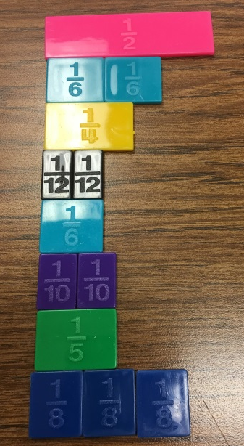
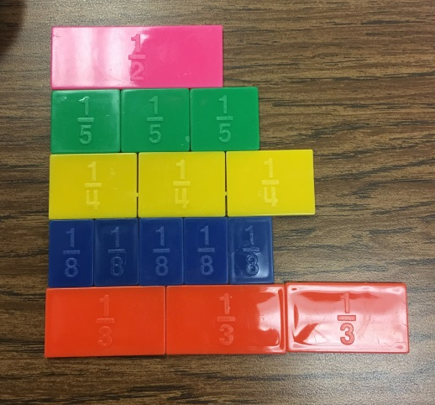

Extensions:
- Provide additional fractions for students to sort such as 2/8 or 1/4. Discuss where to place these fractions. Why are these fractions more difficult to place on the chart? What other fractions might be difficult to decide where to place on the chart? (Examples: 3/4, 6/8)
- Encourage students to create their own fractions to place on the chart. Provide students with blank cards or sticky-notes. After creating a card, have them place it on the chart and defend the placement.
- Have students take a look at the fractions they placed in the greater than ½ category. Which fractions are equivalent to one-whole? Which fractions are greater than a whole? How do you know? How do the numbers that are greater than a whole or equivalent to a whole compare? Why are they greater than a whole? Can you create more fractions that are greater than one-whole?
- Have students pick a few fractions and write them as inequalities (ex. 2/10 < 1/2).

Possible Misconceptions/Suggestions:
Possible Misconceptions: | Suggestions:
Students place fraction cards in the wrong column. | - Have students discuss and find equivalent fractions for 1/2 and 1, which will help students to determine which benchmark fractions are closer to (e,g., 5/8 is closer to 1/2, since 1/2 = 4/8).  - Use manipulatives such as fraction tiles, towers, or circles to help students visualize the size of the fraction.  - Have students draw or create their own number line to help them determine the answers. Encourage students to use the representation to help them make sense of which benchmark fraction the fraction is closer to.

Special Notes:
- Fourths were intentionally omitted from this activity since 1/4 is exactly halfway between 0 and 1/2. As a class you can pose 1/4 and 3/4 to students and discuss which benchmark it is closest to.
- One option is to have students glue their fractions to the work mat and attach their written justifications to the chart.

Solutions:
Less than ½ | Equivalent to ½ | Greater than ½
2/12, 1/6, 2/10, 1/5, 3/8, 2/6 | 3/6, 5/10 | 5/8, 5/6, 7/6, 3/3, 9/10, 4/5, 2/3, 3/5

Place the Fraction Task Sheet
Directions: Place the fraction cards where they belong on the chart. Be sure to explain your reasoning.
Less than ½ | Equivalent to ½ | Greater than ½
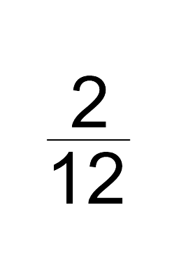 | 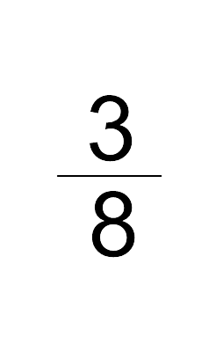 | 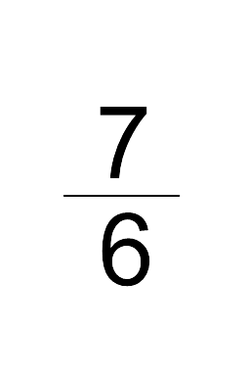 | 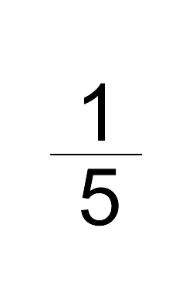
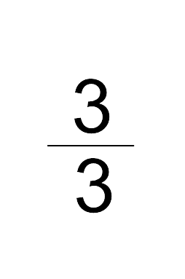 | 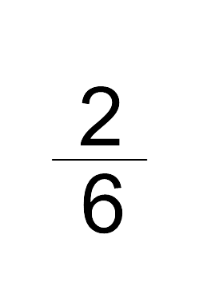 | 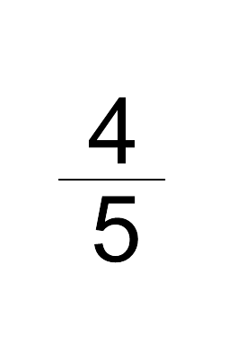 | 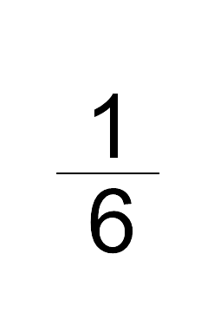
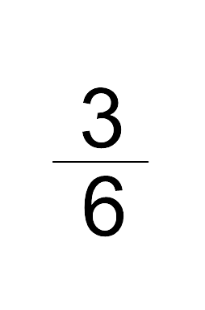 | 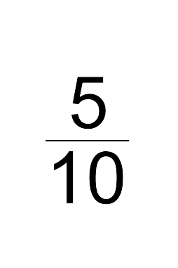 | 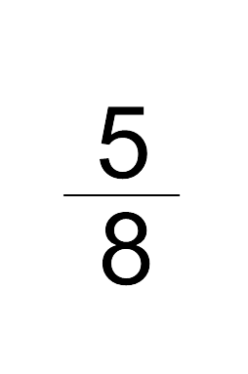 | 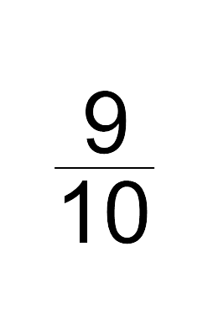
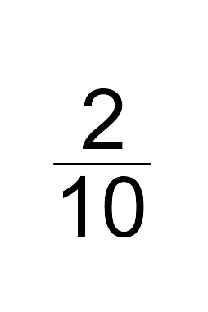 | 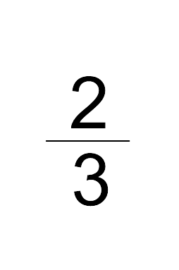 | 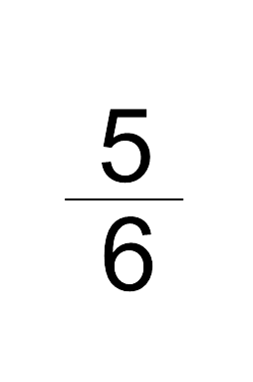 | 