Addition
and Subtraction
Family Math Night
Cluster 3

Addition and Subtraction
Family Math Night

- Overview…………………………………Pages 3
  - Summary
  - Target Audience
  - Focus Area

- Preparation Packet………………………Pages 4-5
  - Preparation Checklist
  - Advertisement Flier or Letter

- Event Packet
  - Sign-In Sheet
  - Agenda and Materials Checklist
  - NC.3.NBT.2 Close Enough
  - NC.3.NBT.2 Rolling Addition
  - NC.3.NBT.2 Rolling Subtraction
  - Parent Evaluation

Overview
Summary: Addition & Subtraction Family Math Night is an opportunity for families to collaborate using 3rd grade math objectives to solve real world problems. Parents interact with the child’s teacher and other school staff, as well as receive resources to use at home with their child. This parent night focuses on centers with the content from cluster 3. Prior to beginning, parents will receive the cluster 3 parent letter from www.Tools4NCTeachers.com.

Target Audience: Third Grade Parents

Focus:
Cluster 3
NC.3.NBT.2
Add and subtract whole numbers up to and including 1000.
- Use estimation strategies to assess reasonableness of answers.
- Model and explain how the relationship between addition and subtraction can be applied to solve addition and subtraction problems.
- Use expanded form to decompose numbers and then find sums and differences.

NC.3.OA.8
Solve two-step word problems involving addition, subtraction, and multiplication, representing problems using equations with a symbol for the unknown number.

Preparation Checklist
- If parents do not already have, print cluster 3 parent letter from www.Tools4NCTeachers.com.
- Send out invitations or flyers a few weeks prior to the event to the parents.
- Advertise on email, phone messages, or the marquee at school.
- Prepare and print a sign-in sheet.
- Print the directions for each center and gather necessary materials.
- Print and send a reminder before the day before event.
- Write list of the addition & subtraction centers on the board as well as where in the classroom each center is located.
- Consider displaying recent student work on current cluster for parents to see.
- For the Close Enough game, the teacher should print the game board and have pencils & paper clips with each set as well as copies of the recording sheet. (print front & back)
- For the Rolling Addition game, the teacher should print the directions, recording sheet, and group dice in containers.
- For the Rolling Subtraction game, the teacher should print the directions, recording sheet, and group dice in containers.

Join Us for Addition & Subtraction Family Math Night
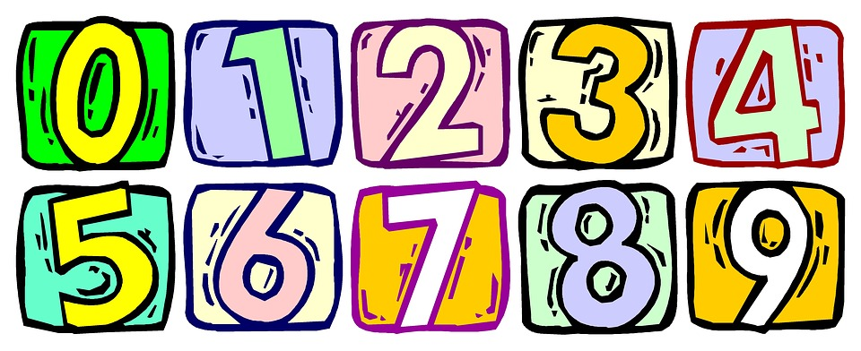
When: (Insert Date & Time Here)
Where: (Address Here)
Come out and learn third grade math strategies while having a great time with your child. There will be special fun activities for you to learn with your child. We look forward to seeing you at this exciting educational event!

Join us for Addition & Subtraction Family Math Night

When: (Insert Date & Time Here)
Where: (Address Here)
Come out and learn third grade math strategies while having a great time with your child. There will be special fun activities for you to learn with your child. We look forward to seeing you at this exciting educational event!

Addition & Subtraction Family Math Night
Sign-In
Family Member(s) | Student Name

Addition & Subtraction Family Math Night Agenda

As students and families drop in, hand out the parent letters and provide explanations for the centers listed on the board.

Throughout the time of the event, students will participate in the centers with their families in order to foster addition & subtraction understanding of cluster 3 standards. Below are the centers along with the list of required materials.

  - NC.3.NBT.2 Center- Close Enough
Materials: Spinner (pencil and paper clip), base ten blocks (ones, tens, and hundreds), recording sheet

  - NC.3.NBT.2 Center- Rolling Addition
Materials: Three dice (green, yellow, red) & recording sheet

  - NC.3.NBT.2 Center- Rolling Subtraction
Materials: Three dice (green, yellow, red) & recording sheet

NC.3.NBT.2 Center
Close Enough Directions

Materials needed:

- Spinner (pencil and paper clip), base ten blocks (ones, tens, and hundreds), recording sheet

- A player spins and takes either that number of ones, tens, or hundreds blocks.

- The player records the number on their recording sheet. Example: a spin of 4 may be recorded as 4, 40, or 400.

- Players take turns spinning, collecting blocks, and recording their numbers.

- After six spins, the player with the total closest to 1000, but not more than 1000, wins the game.
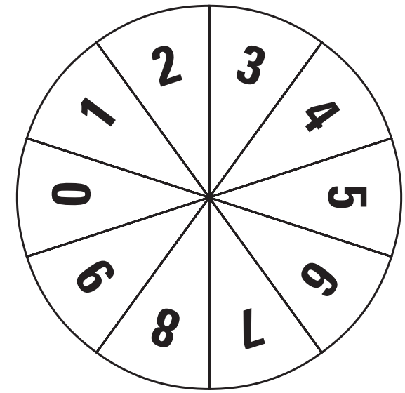

Player 1
Spin | Number
1)
2)
3)
4)
5)
6)
Total
Player 2
Spin | Number
1)
2)
3)
4)
5)
6)
Total
Player 3
Spin | Number
1)
2)
3)
4)
5)
6)
Total
Player 4
Spin | Number
1)
2)
3)
4)
5)
6)
Total

NC.3.NBT.2
Rolling Addition Directions

Materials needed:

- Three dice (green, yellow, red), & recording sheet

- Player 1 rolls the dice and creates a three-digit number (green=hundreds, yellow=tens, red=ones) each player records the number.
- Player 2 rolls the dice and creates a three-digit number (green=hundreds, yellow=tens, red=ones) each player records the number.
- Players then find the sum of both addends using the strategy of their choice.
- Players should compare their answers. If there is a discrepancy, students should swap work & see if they can determine the error. (If students are not successful in determining the error, use the calculator!)

Player 1 | Player 2
1st Addend | 2nd Addend
Equation:
Work:
Player 1 | Player 2
1st Addend | 2nd Addend
Equation:
Work:

Player 1 | Player 2
1st Addend | 2nd Addend
Equation:
Work:

NC.3.NBT.2
Rolling Subtraction Directions

Materials needed:

- Three dice (green, yellow, red), & recording sheet

- Player 1 rolls the dice and creates a three-digit number (green=hundreds, yellow=tens, red=ones) each player records the number.
- Player 2 rolls the dice and creates a three-digit number (green=hundreds, yellow=tens, red=ones) each player records the number.
- Create a subtraction equation with the two players’ numbers. (Remember the larger number should come first)
- Players then find the difference of both numbers using the strategy of their choice.
- Players should compare their answers. If there is a discrepancy, students should swap work & see if they can determine the error. (If students are not successful in determining the error, use the calculator!)

Player 1’s Number | Player 2’s Number
___ ___ ___ | ___ ___ ___
Equation:
Work:

Player 1’s Number | Player 2’s Number
___ ___ ___ | ___ ___ ___
Equation:
Work:

Player 1’s Number | Player 2’s Number
___ ___ ___ | ___ ___ ___
Equation:
Work:

Thank you for attending our
Addition & Subtraction Family Math Night!
We value your feedback.

- What was your favorite part of Family Math Night?

- What would you change about our Family Math Night?

- What did you learn from Family Math Night?

- Additional Comments:

Thank you for attending our
Addition & Subtraction Family Math Night!
We value your feedback.

- What was your favorite part of Family Math Night?

2. What would you change about our Family Math Night?

3. What did you learn from Family Math Night?

4. Additional Comments:

