Third Grade Addition and Subtraction Anchor Chart Examples

- Teachers and students work together to generate anchor charts on specific mathematical concepts.
- These anchor charts are then displayed in the classroom for students to refer to throughout lessons.
- Parents can also benefit from these anchor charts, as they are snapshots of vital information their child is learning.
- Teachers can include photos of anchor charts in newsletters, emails, and any other communications they have with parents.
- Anchor charts are not posters, created by teachers and then posted in the classroom for reference. They are co-created and represent learning shared among the class.
- Below, there are pictures of anchor chart examples. These are not comprehensive for the content in these standards. They are included for teachers get an idea of how some anchor charts for the content in this cluster may look.

NC.3.NBT.2
NC.3.NBT.2 Add & Subtract whole numbers up to & including 1,000.
- Use estimation strategies to assess reasonableness of answers.
- Model & explain how the relationship between addition & subtraction can be applied to solve addition & subtraction problems.
- Use expanded form to decompose numbers & then find sums & differences.

NC.3.OA.8 Solve two-step word problems involving addition, subtraction, and multiplication, representing problems using equations with a symbol for the unknown number.

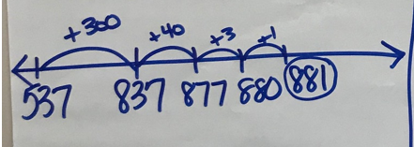
Addition
Example: 537 + 344 = ____

Adding in Parts on the Number Line

Addition Representations
Example: 537 + 344 = ____

Adding by place value:
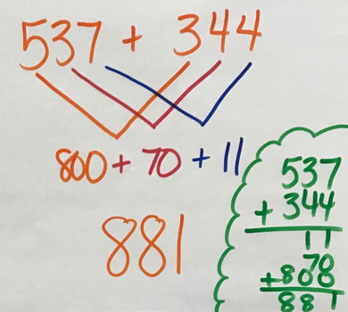
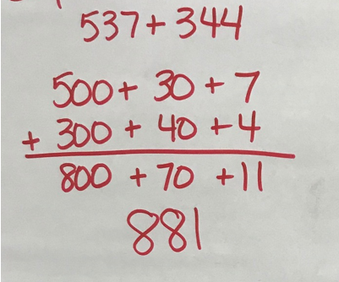

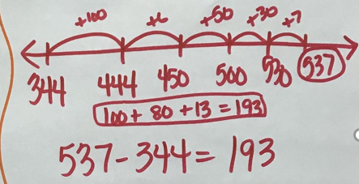
Subtraction
Example: 537 – 344 = ___

Adding Up on the Number Line
Student starts at 344 and adds up to 537.

Using Place Value to Subtract:

