NC.3.NBT.2
Cafeteria Lunch Orders
Domain | Number and Operations in Base Ten
Cluster | Use place to add and subtract.
Standard(s) | NC.3.NBT.2 Add and subtract whole numbers up to and including 1,000.  • Use estimation strategies to assess reasonableness of answers.  • Model and explain how the relationship between addition and subtraction can be applied to solve addition and subtraction problems.  • Use expanded form to decompose numbers and then find sums and differences.
Materials | Cafeteria Lunch Orders handout, paper, pencils
Task | Distribute the Cafeteria Lunch Orders handout to teachers.  Read: The cafeteria organized student lunch orders on this chart.  Ask:  - On what day was the number of hot lunches about the same as the number of cold lunches? Explain your solution using pictures, numbers, or words.  - On what day was the number of cold lunches about 20 more than the number of hot lunches? Explain your solution using pictures, numbers, or words.  - About how many hot lunches need to be ordered this week? Explain your solution using pictures, numbers, or words.

Rubric
Level I  Not Yet | Level II  Progressing | Level III  Meets Expectations
- Student’s response is incorrect, incomplete, or off task. | Student does 1-2 of the following:  - Student states that on Wednesday the numbers of hot lunches and cold lunches were about the same.  - Student states that on Friday about 20 more cold lunches were ordered that hot lunches.  - Depending on how student estimates, he/she finds that around 1400 lunches need to be ordered.  - Some solutions are explained. | - Student states that on Wednesday the numbers of hot lunches and cold lunches were about the same.  - Student states that on Friday about 20 more cold lunches were ordered that hot lunches.  - Depending on how student estimates, he/she finds that around 1400 lunches need to be ordered.  - All solutions are explained using pictures, numbers, or words.

Standards for Mathematical Practice
1. Makes sense and perseveres in solving problems.
2. Reasons abstractly and quantitatively.
3. Constructs viable arguments and critiques the reasoning of others.
4. Models with mathematics.
5. Uses appropriate tools strategically.
6. Attends to precision.
7. Looks for and makes use of structure.
8. Looks for and expresses regularity in repeated reasoning.

Cafeteria Lunch Orders

The cafeteria organized student lunch orders on this chart.
Number of Cafeteria Lunch Orders
Day | Hot Lunches | Cold Lunches
Monday | 248 | 257
Tuesday | 362 | 143
Wednesday | 292 | 288
Thursday | 301 | 226
Friday | 217 | 239

Use information from the chart to answer each question.

- On what day was the number of hot lunches about the same as the number of cold lunches? Explain your solution using pictures, numbers, or words.

- On what day was the number of cold lunches about 20 more than the number of hot lunches? Explain your solution using pictures, numbers, or words.

- About how many hot lunches need to be ordered this week? Explain your solution using pictures, numbers, or words.

Scoring Examples

Not Yet: This student received a Level 1 (Not Yet) because she did not show understanding of what the questions were asking and therefore has solved all of the problems incorrectly. She did show understanding of adding all of the hot lunches together for the solution to problem 3, and found the exact answer instead of estimating.

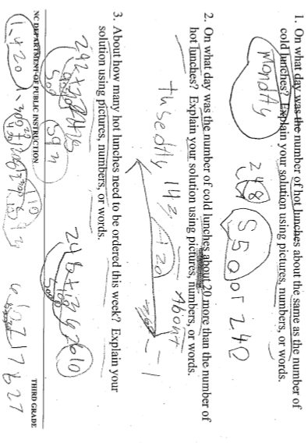
Progressing: This student received a Level II (Progressing) because she shows understanding of estimation ideas in the first two problems. The solutions are correct and explanations include evidence that student understands the concept of estimation by using “close to” in her explanation. The solution to Problem 3 is incorrect.
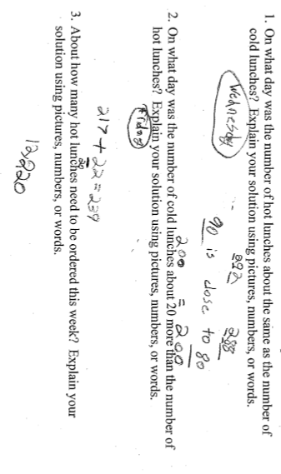
Meets Expectations: This student received a Level III (Meets Expectations) because he shows clear understanding of estimation, addition, and subtraction. All solutions are correct and explanations show understanding of the concepts. It is important to note that this task does not fully assess NC.3.NBT.2. The focus of this task is using estimation strategies.
