The Number Line – A Visual Representation
Addition and Subtraction

In this lesson, students solve addition and subtraction problems and represent strategies and solutions on a number line.

NC Mathematics Standard(s):
Use place value to add and subtract.
3.NBT.2 Add and subtract whole numbers up to and including 1,000.
- Use estimation strategies to assess reasonableness of answers.
- Model and explain how the relationship between addition and subtraction can be applied to solve addition and subtraction problems.
- Use expanded form to decompose numbers and then find sums and differences.

Standards for Mathematical Practice:
- Make sense of problems and persevere in solving them.
- Reason abstractly and quantitatively.
- Construct viable arguments and critique the reasoning of others.
- Model with mathematics.
- Use appropriately tools strategically.
- Attend to precision.
- Look for and make use of structure.
- Look for and express regularity in repeated reasoning.

Student Outcomes:
      - I can solve addition problems on an “open” number line by adding up.
      - I can solve subtraction problems on an “open” number line by adding up or subtracting back.
      - I can decide on the numbers I want to use as I solve subtraction and also addition problems on a number line.
      - I can learn from other students as they share different strategies on a number line.
      - I can sometimes solve problems by picturing the empty number line in my head.

Materials:
      - Pencils, colored pencils
      - Handouts
      - Rulers for drawing number lines

Advance Preparation:
      - Students have had experiences using rulers and tape measures to measure distances from zero.
      - Students have used the “Open or Empty” number line to solve addition and subtraction problems in grade 2.

Teacher Notes:
      - The empty or open number line is a visual representation and allows students to record and share their thinking strategies during the process of mental computation. These are number lines with no numbers or markers.
      - After lots of experiences using the open number line, the number line will become a model for student to think about strategies using mental math.
      - Students are free to choose the type of jumps they will use for addition and subtraction. One of the interesting things about mental calculations is that we do not all think the same way.
      - The empty number line allows students to see the variety of ways that the same question or problem can be solved.
      - It is important that students “see” the strategy and then explore more than one way of finding the result. Working with partners and sharing strategies in teams or whole class supports student understanding. Students should be encouraged to share different strategies and discuss which strategy is the most efficient.
      - Use of the empty number line also increases students’ confidence in their ability to use numbers flexibly which leads to further development in their understanding of number sense.

Questions to Pose:
Before:
        - What strategies do you use to find the answer to an addition problem? A subtraction problem?
During:
        - What do you know about using a number line to solve problems?
After:
        - Can you describe a strategy you might use to solve a problem on a number line?

Possible Misconceptions/Suggestions:

Possible Misconceptions | Suggestions
Students may see subtraction as “taking away” or “adding up”. They may not see subtraction as a distance between two numbers. | Beginning with one digit and 2 digit problems, work with students in small groups or individually with addition and subtraction problems. Subtraction problems can be solved by “adding up” or “subtracting back”.

Various handouts included for your convenience.

Exploring Number Lines for Addition and Subtraction

Addition or Subtraction Problem
- Mark has 157 comic books. His friend gave him 36 more comic books. How many comic books does Mark have now?

Study the solution of the problems below using a number line to find the answer.

Solution A: Notice the arrows. The first jump: 157 to 187. Above you see this was a jump of 30. Find the second jump of +6.
How many comic books does Mark have now? Where did you find the answer on the number line?

Solution A Solution B
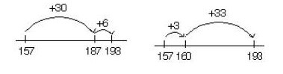

Solution B
How is Solution B different from Solution A?

Describe what happened first in Solution B? Discuss your solutions with a partner or in a small group.

- Tonya has 253 beads. She gives 131 beads to her friend. How many beads does she have now?

Discuss with a partner how you might solve the problem.
  - Would you add up from 131 to 253 to find the answer?

  - Would you subtract back from 253 to 131 to find the answer?

Tonya has 253 beads. She gives 131 beads to her friend. How many does she have now?

Sydney’s strategy: Describe the strategy with a partner.
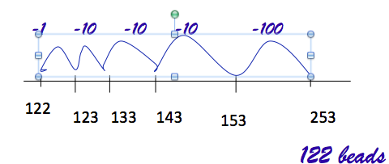

What do the numbers under the number line stand for?

What is the answer to the problem?

Where do you find the answer when looking at the number line?

Subtraction Problem
Looking at the arrows, was the solution found by adding up or subtracting back?
Find the difference or how far it is between two numbers. The numbers are 127 and 73. Which number would be first on a number line? Why?

What is the difference from 73 to 127?

Describe how you find the answer?
+2
+5
+10
+10
+27
73 75
80
90
100
127

Subtraction Problem:
There are 543 students in Woodland Elementary School. The students learned that 387 of the students are girls. How many students are boys?
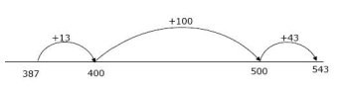
- Brad solved the subtraction problem by “adding up” from 387 to 543. Where did Brad get the numbers on the bottom of the number line?

Where did Brad get the numbers on top of the number line? Explain

How many students were boys?

- Marvin solved the same problem using a number line. Marvin jumped 100 to get to 487.Next Marvin jumped 3 to get to 490. Next Marvin jumped 53 to get to 543.

Draw a number line. Show Marvin’s jumps on top and show how far he jumped on the bottom of the number line as he is getting closer to 543.

- Andy decided to subtract back to solve the problem. Andy’s first jump was from 543 to 500. The numbers under the number line shows where Andy landed each time.

The first jump from 543 to 500 shows Andy jumped back 43 on the number line. Record his jumps until you get to 387.

43
387
390
400
500
543

- There are 813 students in Forest Hills School. Today there are 768 students present. How many students are absent?

Use a number line to solve the problem.

768
813

Compare your solution with a partner or a small group.

